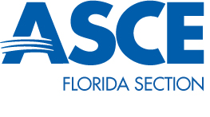
Institute Chapter President: David Konz (SEI-West Coast Branch)
ASCE West Coast Branch President: Jessica McRory

Quarterly Report 9/17/14
Vice-chair Matt Depin (Bracken Engineering) has been an integral part in the success of SEI-West Coast Branch. An employment transfer will send him out of our region, but we are grateful for his efforts and enthusiasm for the past two years. His position with be filled by Sarah Tsang (Bracken Engineering).
6/26/14 Structural Solutions using Expanded Polystyrene was presented by Nico Sutmoller of Insulfoam (1.0 PDH, $25, 15 registered).
7/18/14 a free site visit was also arranged for the $215 million I-275 design build and was attended by 20 people. The event was so well received that signups maxed out within 20 minutes. A repeat event has been schedule for January 2015. Photo below.
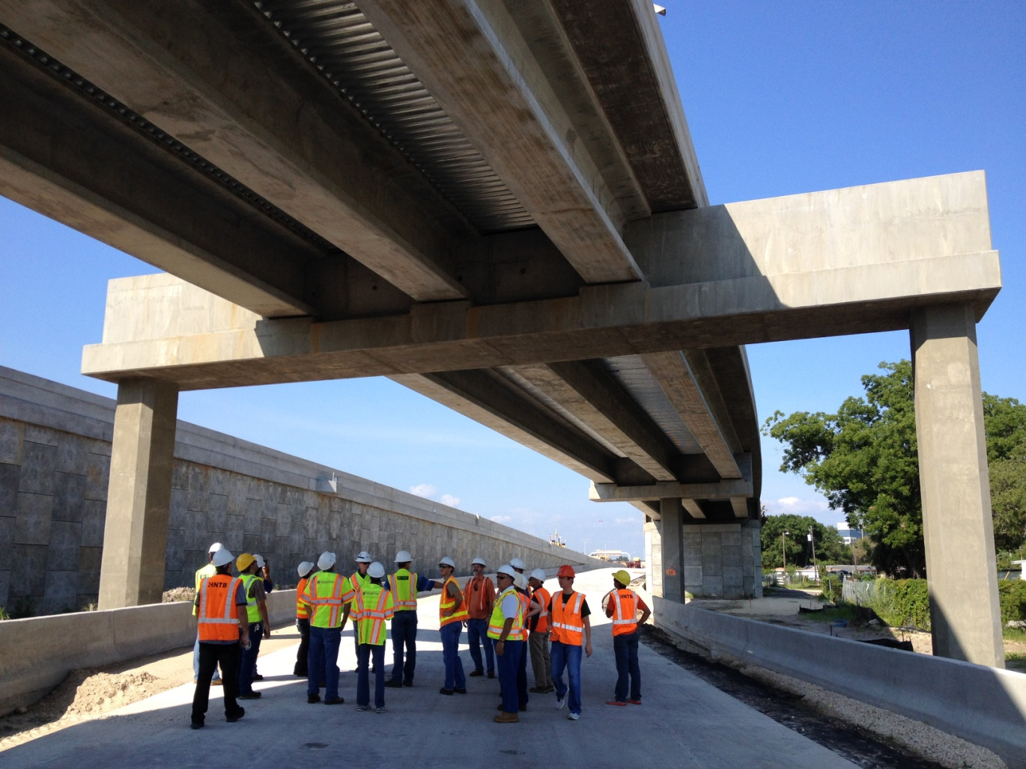
7/24/14 ASCE webinar "Aging Infrastructure, Risks and Making Tough Decisions" was hosted by ATKINS North America. The event was used as a fundraiser where SEI charged $15 to cover the cost of food and raise $170 for future social event (1.0 PDH, $15, 18 registered). Photo below.
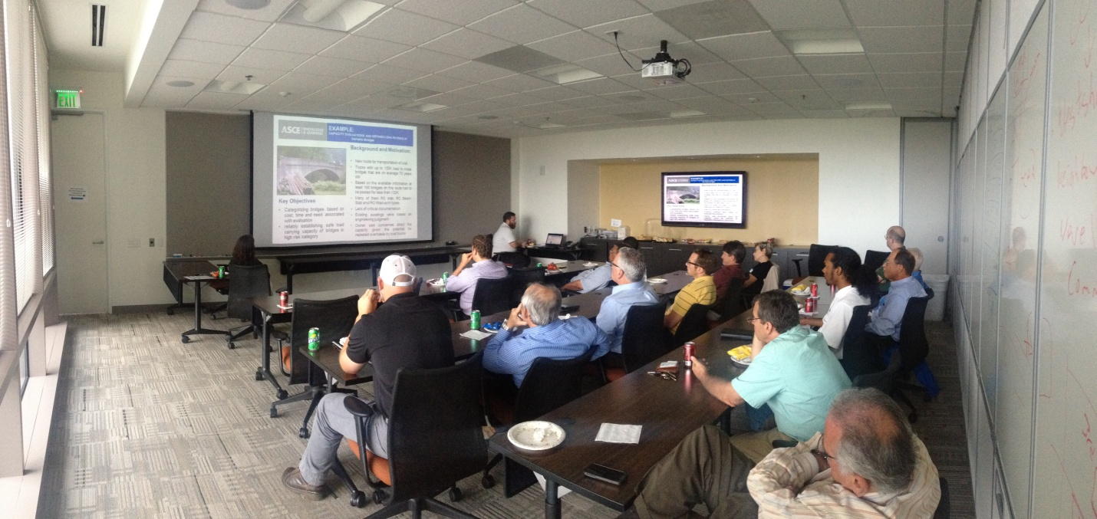
8/7/14 a joint Happy Hour was hosted by SEI and the local chapter of Florida Structural Engineering Association (FSEA). The event was sponsored by Munyan Painting & Restoration and was attended by over 40 people.
8/28/14 Site Visit of 5-story light frame, luxury apartment complex in Tampa with 350 units. The event was free and 11 people attended, including two college students. Photo below.
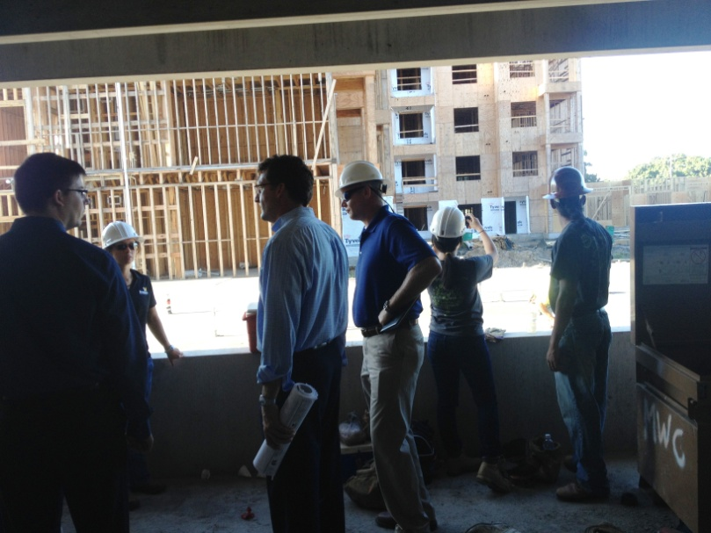
Chair David Konz was a committee member for the Florida Board of Professional Engineers Committee for Structural Engineering Licensure where proposed legislation was drafted for submittal to the state government. Several professional organizations were represented on the committee with Mr. Konz representing ASCE/SEI. The committee has adjourned and the draft verbiage has been forwarded.
Chair David Konz assisted the University of South Florida Chapter by teaching two session of the PE Review course that is used as a fundraiser for the student chapter. Mr. Konz taught the structures breadth and depth sessions in September of 2013 and scheduled for the same event in 2014.

