Generalized Internal Predisposition of Women & Men Engineers

INTP Personality Type –

The “Engineer”

Introverted (I), Intuitive (N), Thinking (T) and Perceiving (P)
INTPs direct their energy inward. They are energized by spending time alone. They are private and typically not socially inclined. Engineers are Intuitive. They are focused on the future and see endless possibilities. They are inventive, imaginative and complex. Their thought process is theoretical and abstract. INTPs are Thinkers that make decisions with their head. They are impersonal, objective and logical. INTPs are carefree and spontaneous. They dislikes routine and rules. Engineers like to keep their options open. Their style is relaxed and flexible.
Engineers are acutely autonomous. They do not like feeling controlled. Traditional roles often seem debilitating since their focus is always on their intellectual pursuits. They respect people who are genuine. They are willing to sacrifice and are supportive in relationships they care about as long as their independence is respected. Relationships are on their radar but are not always of first importance.
- Typical Strengths
- Laid back and easygoing
- Handles criticism well
- Not demanding
- Enthusiastic about their interests
- Imaginative and creative

- Possible Weaknesses
- Not good at managing money
- Can be explosive
- Not good at communicating feelings
- Distrusting of others

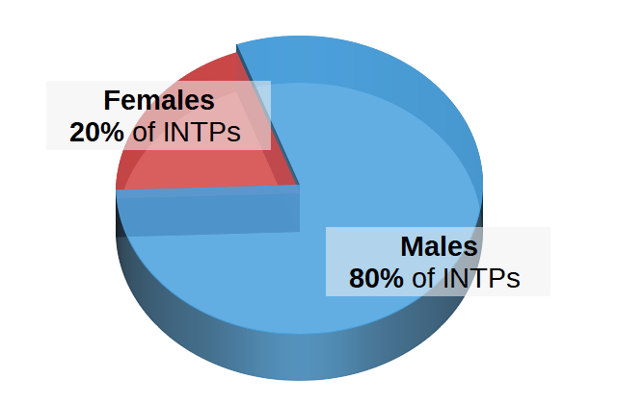

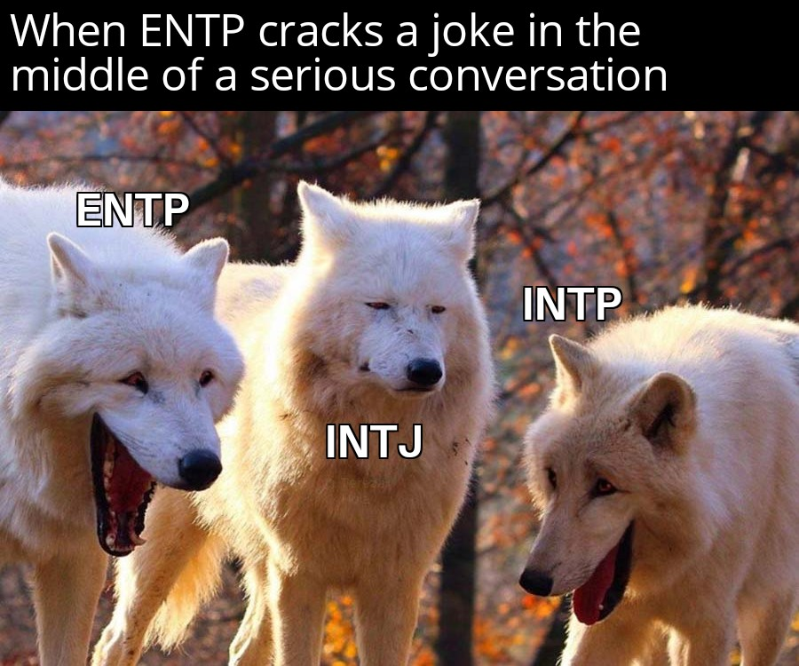

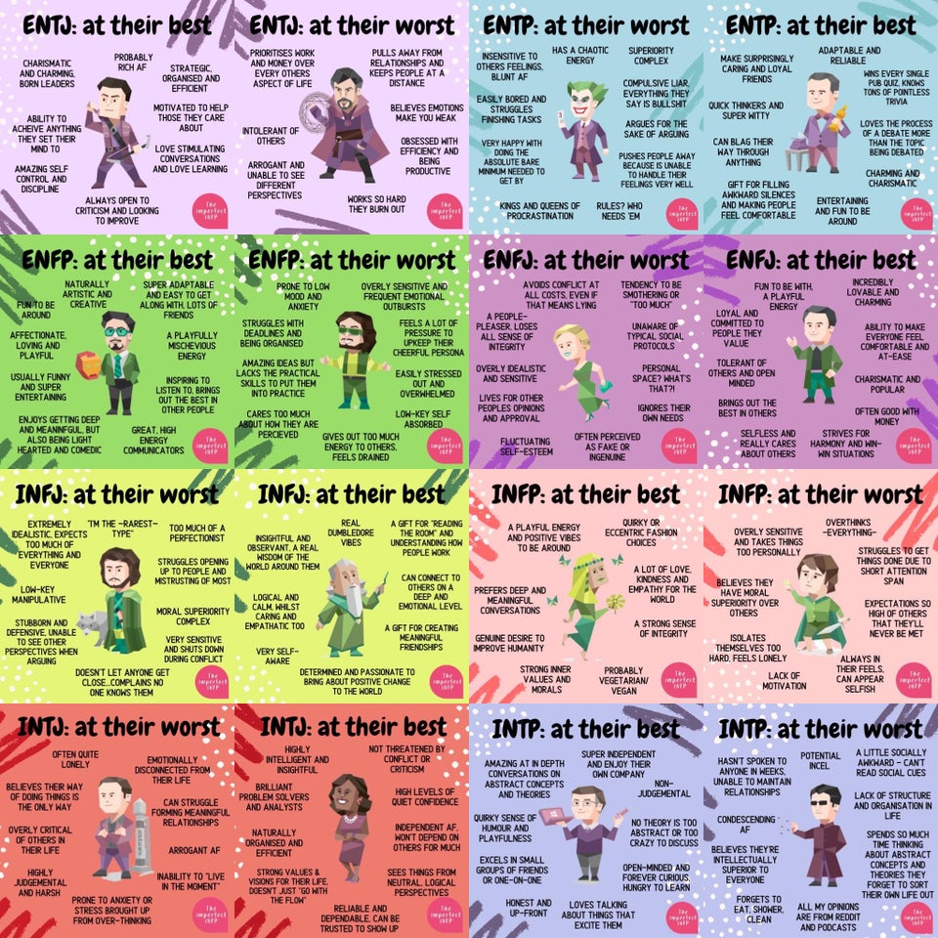

- The “best and worst” of every intuitive (zoom in to see your type)

https://personalitymax.com/personality-types/intp-engineer/ downloaded 22JUL2020
https://www.reddit.com/r/mbti/comments/hfuwnt/the_best_and_worst_of_every_intuitive_zoom_in_to/

