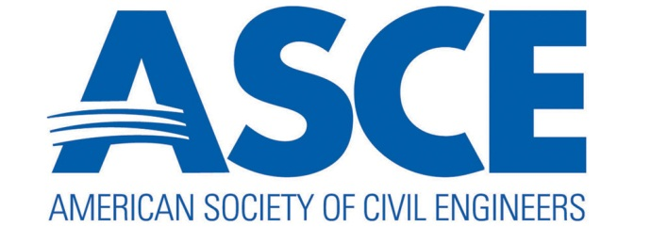
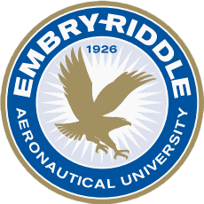

Embry-Riddle Aeronautical University Student Chapter
Of American Society of Civil Engineers
Fall Quarterly Report

Embry-Riddle Aeronautical University has done the following things during the past quarter:
- Has been recognized as an official East Central Branch Student Chapter.
- Attended one of the local branch meetings
- Raced our 2014 Concrete Canoe and placed 3rd in an event called “Anything That Floats Competition” in Deland, Florida
- Began biweekly meetings for our Student Chapter
- Recruited 13 new members to bring our member count to 35 members
- Started research and designs for both the Steel Bridge and Concrete Canoe
- Finalized hull design for the Concrete Canoe
In the upcoming quarter, Embry-Riddle Aeronautical University ASCE has the following items planned:
- A social event to recruit members outside of the Civil Engineering department. This social event will be held by both the ASCE Student Chapter and the Civil Engineering department to celebrate “20 Years of Civil Engineering at Embry-Riddle Aeronautical University”
- Have guest speakers from local companies around the Daytona Beach area
- Hold mini team building competitions to promote civil engineering and teach the underclassmen about working as an engineering unit to design and build something
- Finalize the Concrete Canoe mix design and construct the mold
- Finalize Steel Bridge designs

Embry-Riddle Aeronautical University Student Chapter
American Society of Civil Engineers
Student Chapter President: Stephanie Cleary
Email: clearys@my.erau.edu

