**Quarterly Report (July 2014 – October 2014)**

**Prepared for:** **Prepared by:**

ASCE Florida Section Board of Directors Meeting Chapter President Franki Vallejo

October 4, 2014

Florida Section Student District Representative: Shawn Brown

**Executive Summary______________________________________**

To ensure success in all tasks, three main things are to always be kept at the top of priority list; Schedule, Planning & Organization. It is with these key principles that the Executive Board decided to take on the task of assuring the ASCE USF student chapter continues to grow and aim for higher successes and achievements. Prior to the beginning of the fall 2014 semester, the Executive Board, consisting of: The President, Vice President, Secretary, Treasurer and Vice President of Activities, met up bi-weekly to plan out and begin coordination of all immediate plans and events for the semester. Seven total dates for the semester’s chapter meetings and locations were all planned and scheduled.

Our first chapter meeting of the semester revealed promising numbers with 70+ members and about half of that being new members. Many of them eagerly ready to take on leadership roles as mentors or even captains for upcoming competitions at the southeastern conference in Chattanooga, Tennessee.

The Concrete Canoe Team has remained busy since the beginning of the summer term with weekly paddling practices and concrete material testing. The team recently received donations from an aggregate supplier of some new material that they are hopeful will be the pivotal item to help with the success of competition in conference.

Steel Bridge holds weekly meetings to discuss designs ideas and plan out new welding sessions to take place for the newer members to get exposure to newer trades and skills.

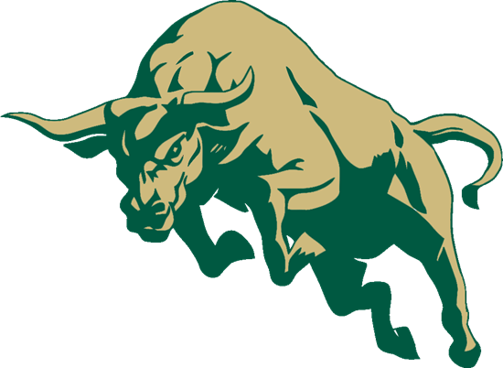 As a fundraising event, the chapter has chosen to continue the efforts through Aramark concessions at the Raymond James Stadium during NFL, NCAA football games and other events taking place in the stadium. This fundraiser has proven to be successful if student participation takes place. After just the first two weekends of participation, the chapter has earned an estimated $1,250. We are very hopeful to continue having success with the events planned throughout the remainder of the football season and events calendar.

Please see below for details on chapter meetings and events that have taken place. Thank you!

Franki Vallejo



ASCE USF Student Chapter President

University of South Florida, Department of Civil and Environmental Engineering

**Fall Semester Overview______________________________________**

**Meetings**

1. The Executive Board has had bi-weekly meetings from Early July to Mid-August; once school began (August 25th), board meetings have been held weekly.
2. Chapter Meetings
   1. September 3rd
      1. 71 members in attendance
      2. Introduction/Welcome of new members
      3. Trophy presentations by Shawn Brown and Justin Bowen
      4. Expressed the importance of student involvement
      5. Reached out for captains and chairpersons
      6. Aramark Fundraiser
      7. Engineering Block Party (9/8/14): USF Engineering 50th Anniversary
      8. Keep Tampa Bay Beautiful Clean-Up event: (9/21/14)
   2. September 17th
      1. 45+ members in attendance
      2. Welcome members to meeting
      3. Sam Chiu, ASCE YMG President
         1. Introduce and discuss to the members the two scholarships that ASCE West Coast Branch offers
         2. Discuss the weekend’s clean up event
      4. Award Member of the Month Danielle Peterson for the month of August
      5. Award certificate of appreciation to volunteers for the Raymond James Stadium Concessions
      6. Discuss upcoming tours
      7. Announce upcoming election for VP of Activities to take place October 1st, 2014
   3. Remaining Fall 2014 Chapter meetings
      1. October 1st 
         1. Atkins Engineering will present about ACE Program and ask for mentors from our student chapter.
      2. October 15th
         1. Brian Henze from Cemex to discuss ACI competitions and give presentation on pervious concrete.
      3. November 5th
      4. November 19th
      5. December 3rd
3. West Coast Branch Meetings
   1. August 30th, 6:00pm at USF
      1. Budget
      2. Upcoming events
         1. Golf Tournament
         2. WISSA Lecture
         3. Future Cities
   2. September 29th, 6:00pm at AREHNA

**Events**

1. PE Review Sessions
   1. Money Raised: TBD
   2. September 17th was the first session kicking off with Environmental & Water Resources
2. Smart Start Lecture Outreach (8-19-2014)
   1. President, Franki Vallejo, gave a formal 15 minute presentation to upcoming freshmen engineering students about ASCE in efforts to inform the student the importance of getting and staying involved.
3. Bulls Go Green (8-28-2014)
   1. Event to help spread the word to students about the importance of being environmentally friendly.
   2. Concrete canoe 2014 *Festibull* on display
   3. 7 new members signed up for ASCE
4. Engineering Block Party (9-8-2014)
   1. ASCE Team set up a display consisting of the concrete canoe and the steel bridge
   2. New member sign ups
5. Keep Tampa Bay Beautiful Coastal Clean Up (9-20-2014)
   1. 22 sign ups from USF
   2. Social after at Whiskey Joe’s
6. Tampa Steel Erecting Company Facility Tour (9-27-2014)
   1. 30 members have signed up to attend a tour of the steel fabrication facility
   2. Great way to help students gain interest in structural engineering and steel bridge competition

**UPCOMING EVENTS**

1. I-275 Interstate widening project with Skanska USA (10-11-2014)
2. CEMEX concrete batch plant tour (TBD)
3. Tailgate Social USF vs UCF Football (11-28-2014)

**Issues/Concerns/Questions**

1. UTC is to host Southeast Conference 2015; when will they be releasing conference information and details? I sent an email September 10th and have yet to receive a response.