**About the meeting:**

|  |  |  |  |
| --- | --- | --- | --- |
| **Subject:** | ASCE Upper Peninsula Branch Q2 2021 Meeting | | |
| **Date:** | June 15, 2021 | **Time:** | 12:00 – 1:00 pm |
| **Call in:** | <https://ohm-advisors.zoom.us/j/92929844391?pwd=L3NnaXhqeVk2SjZ0bHgxL3pOUEJhdz09&from=addon> PW: 066530 | | |

|  |  |
| --- | --- |
| **Time slot:** |  |
|  | * Welcome * ASCE News |
|  |  |
|  | * **CEU Presentation: Mass Timber Construction: Products, Performance and Design** * Closing Remarks |

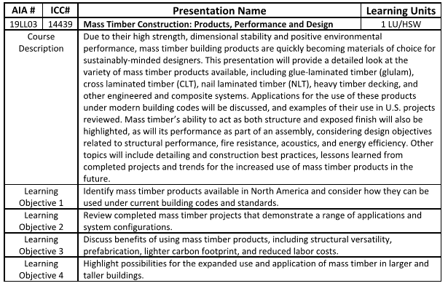

**Mark Your Calendars!**

Next Meeting Date: August 24th, 2021 - This will be our Ethics Presentation for the year – tell your friends!

|  |  |
| --- | --- |
| You’ve been invited to a scheduled Zoom meeting. | |
| [Join Zoom Meeting](https://ohm-advisors.zoom.us/j/92929844391?pwd=L3NnaXhqeVk2SjZ0bHgxL3pOUEJhdz09&from=addon) | |
| Password: | 066530 |
| Phone one-tap: | [+13017158592,,92929844391#](tel:+13017158592,,92929844391) |
| Meeting URL: | <https://ohm-advisors.zoom.us/j/92929844391?pwd=L3NnaXhqeVk2SjZ0bHgxL3pOUEJhdz09&from=addon> |
|  |  |
| **Join by Telephone** | |
| For higher quality, dial a number based on your current location. | |
| Dial: | +1 301 715 8592 |
| Meeting ID: | 929 2984 4391 |
| Password: | 066530 |
| **Skype for Business (Lync)** | |
| <https://ohm-advisors.zoom.us/skype/92929844391> | |