Global Warming and CO2 – Illuminated by Empirical Scientific Evidence Larry Von Thun, Civil Engineer, P.E.

I appreciated Civil Engineering publishing the two letters to the editor on alternative climate change perspectives in the Civil Engineering March 2020 edition. I believe it is critically important that there be an open and objective analysis and discussion of this topic, especially by Civil Engineers, as trusted, rational, and objective technical professionals and as responsible contributors to the well-being of our society. It is imperative that the facts and actual data and evidence concerning the role of human source CO2 emissions on global warming and its accreditation to extreme climate events be understood and accurately communicated and properly accounted for in civil works. Claimants of CO2 emissions being the primary driver of global warming use climate models as the mainstay of their “settled science”. Regrettably the evidence to the contrary available from analyzing the relationship of the actual data, (temperature records vs CO2 emissions data since 1880) has essentially been ignored. The unproven, suppositional narrative of planetary destruction from carbon emissions, never vetted by the scientific method, is pushed forward and become nearly universally accepted via “conventional wisdom”. Modeling has its place in many disciplines, including weather, climate and civil engineering, but modeling that uses subjective / judgment inputs cannot and should not supplant actual data.

It is clearly evident and well documented that global warming is occurring. The current global warming trend has been in effect since about 1700-1750. But, as will be presented below there is clear, unequivocal, empirical scientific evidence that shows CO2 emissions are not demonstrably responsible for driving the ongoing global warming. Temperature records from 1880 to the present show that despite CO2 human source emissions increasing worldwide nearly tenfold since the end of WWII, the global warming rate has not significantly changed. Further, there is no empirical, scientific evidence to show that reducing CO2 emissions would change the course of global warming.

I have been a Civil Engineer, environmental advocate and an ASCE member for 56 years. About 30 years ago, alarms concerning human source CO2 emissions and global warming were being widely sounded. The correlation of rising global temperatures during the period of 1979 to 1998 and the recognized accelerated and sustained higher level of CO2 emissions since around 1950 led to the understandable and logical hypothesis of “anthropogenic global warming”. That is, we were causing global warming via the burning of fossil fuels, deforestation and more!

Almost all articles in my environmental magazines forsook concern and attention to the known pollutants from fossil fuels and other important environmental concerns and began focusing all most all of their attention on “CO2 emissions”. I was aware the cycles of glaciation followed by warmer, interglacial intervals. Thus, although a CO2 -temp causation seemed reasonable it was not proven and I was concerned, from an environmental standpoint, about a potential “backlash” against the environmental/sustainability movement if the theory and associated claims concerning CO2were to prove untrue. Thus, I began to study the issue in earnest.

The last glacial period began about 120,000 years ago and reached a glacial maximum about 21,000 years ago. Average global temperatures dropped about 10-12 degrees centigrade (C) over that period (Antarctica ice coring data). Then, rapid warming began. Over the next 15,000 years sea levels rose about 400 feet (122 meters) and the temperatures rose about 10 deg. C. Then a sustained, warmer interglacial period began. The warmer interglacial period, in which we now live, has lasted for over 10,000 years and compared to the glacial period, global temperatures and sea levels are relatively stable. However, even in this “stable” period there are warmer and colder periods of significance. Prior to our Current Warm Period (CWP), the last four of these periods, are termed the Roman Warm Period (RWP), the Dark Age Cool Period (DACP), the Medieval Warm Period (MWP), and the Little Ice Age (LIA). Historic records confirm sea level changes and movements of people in these periods of warming and cooling within our current interglacial period. In fact, natural climate variations within our current interglacial (the Holocene) has produced nine “much less intense than glaciation” cycles of warming and cooling. Currently, we are, based on the historic record still on our way up, temperature wise. We emerged from the Little Ice Age around 1700-1750 and have moved into our current “Modern Warm Period”. These historic interglacial climate variations are well documented and they took place prior to any significant influence from human source CO2 emissions.

We also know that the planet has experienced much higher CO2 levels than at present. For example, during the Mesozoic Era (Triassic, Jurassic and Cretaceous), atmospheric CO2 ranged from 1,000 to 2,500 ppm.

Some of the important, clearly evident, readily available and credibly documented global warming / environmental / CO2 emission facts are:

(1) global warming is currently ongoing, (2) fossil fuel burning emits serious air pollutants including particulates, sulfur oxides, carbon monoxide, nitrous oxides, and hydrocarbons, (3) CO2 emissions worldwide accelerated after WWII (1950) and have continued, consistently at that higher pace. (4) The United States contributes about 15% of global CO2 emissions, and like the European Union countries, United States CO2 emissions are now below their 1995 levels. China currently contributes about 30% of global CO2 emissions. Their emissions have steadily risen since 1995 and continue to rise., and (5) There is no empirical evidence or testing data to confirm the assertion on the efficacy of reducing global warming by reducing carbon emissions, because it has been impossible to do so. Human source carbon emissions have been on the rise since 1880, and especially since post WWII, so there has not been an opportunity to observe / test the effect of reducing CO2 emissions. However, a full scale “global” test on the effect of increased CO2 emissions on temperature is possible since the global temperatures have varied during this period of record keeping.

Thus, from a technical, empirical “engineering” analysis standpoint, the strongest, clearest, and most telling information on the lack of a significant, much less primary, influential relationship between CO2 and global warming comes from a comparison of the NASA global temperature record beginning in 1880 (Fig. 1) with the record of carbon emissions (Fig. 2) over the same period.

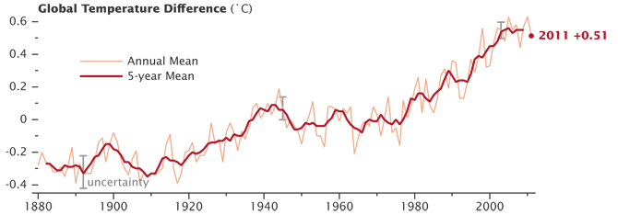

Figure 1 - NASA global surface temperature data plot **– (***NASA Headquarters release No. 12-020 - now archived****)***

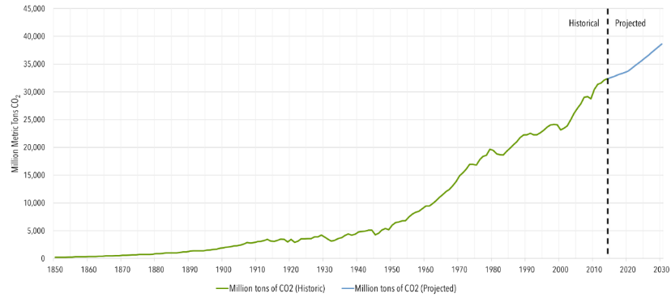

Figure 2 - Global Carbon Dioxide Emissions, 1850–2030 – Source - Center for Climate and Energy

The NASA temperature record from 1880 shows the continued, but non-uniform, advancement in global warming (initiated at the end of the Little Ice Age) and, just as within the interglacial period, this temperature record shows periods of warming and cooling. Juxtaposing the information from this temperature record with the history of human source CO2 emissions, (Fig. 2), which showed a dramatic increase after 1950, and then making a detailed analysis of the global temperatures recorded for each year reveals the following key facts concerning the lack of a primary relationship between global temperatures and CO2 emissions:

1. From 1944 to 1979 CO2 annual emissions quadrupled from 5000 Million Metric Tons (MMT) to 20,000 MMT but during that period the annual global mean temperature **never exceeded** the 1944 temperature value and after 34 years was still 0.05 0C less than 1944’s annual mean temperature – (examine Fig 1). Strikingly, in opposition to the hypothesis that CO2 emissions produce increased global warming, the data show that for 35 years, right after CO2 emissions significantly ramped up, global temperatures were lower. In fact news outlets were predicting the onset of a new ice age during this period.
2. From 1917 to 1944, when CO2 emissions were yet to reach significant increased levels, the global mean temperature rose + 0.68 0C (a rate of +0.025 0C per year). The next sharp increase in global temperatures occurred from 1979 to 1998 and was + 0.47 0C (also a rate of increase of +0.025 0C per year). These two periods happened to show identical rates of global warming increase despite the fact that in the latter period there had been 462,000 MMT of CO2 emissions and the cumulative CO2 emissions (since 1950) had reached 864,205 MMT. This latter global warming period (1979-1998) triggered the upsurge in concern over a CO2 / global warming relationship. This earlier history of global temperature rise (1917-1944) from natural climate variability, when CO2 emissions were minor, has been ignored by those advocating a CO2 driven global warming narrative. Looking at this past warming history, and the empirical evidence does not support anthropogenic global warming. The record of these periods of comparable warming (1917-1944) and (1979-1998) and the 34 years of cooling (1944-1979) while CO2 emissions quadrupled, belies the mass delusion (blaming CO2) that has been promulgated.
3. Since 1998 the annual and accumulative CO2 emissions in the atmosphere have continued to rise worldwide, despite no increase in emissions from the US and the EU. By 2015, annual CO2 emissions reached 32,000 MMT, cumulative human source CO2 emissions had reached 1,350,000 MMT and atmospheric CO2 levels had reached 405 ppm (over 100 ppm higher than experienced in the last 420,000 years). Despite these great increases in human source CO2 emissions, global temperatures from 1998 to 2013 did not increase. There was a net drop of 0.06oC based on NASA surface temperature data and from 1998 to 2015 the UAH satellite temperature data for the lower atmosphere [Fig 3] recorded a net drop of 0.30oC in the 13-month running avg. temperature. Currently, the global temperature 13-month running average is about 0.2oC cooler than in 1998. Does this mean that global warming is no longer occurring? – certainly not! – but it does show that the continued, large quantity of CO2 emissions are not driving the temperatures up as postulated. Rather, global warming is continuing due to natural variability essentially as observed in the interglacial record as well as in the modern (since 1880) data.

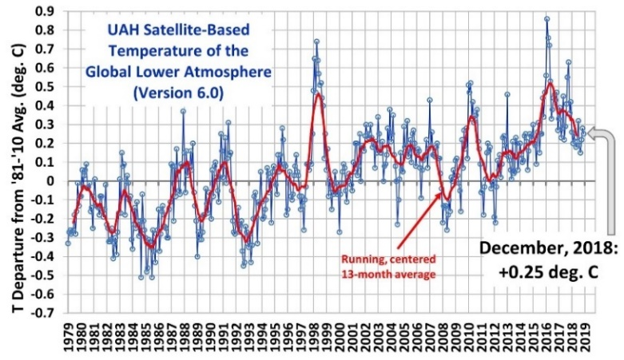

Figure 3 – UAH global Satellite data began 1979

The above simple, straightforward examination of the readily available data and information from official, credible sources clearly shows that the large increases in human source CO2 emissions post 1950 has not and is not discernably influencing global temperatures. There certainly is some global temperature effect due to CO2 as well as methane, as they are greenhouse gases and they have some effect. Their effects however are just not discreetly measurable within the range of natural variability and certainly CO2 is not the primary driver of global warming as is being claimed. This observation is based on empirical, scientific data and facts, not on opinion or on inferences drawn from subjective climate model projections. These data dispel the claim that CO2 is the primary driver of the global warming being experienced and of the “climate change” events.

The discourse on this topic has been closed and shuttered. Those expressing opinions differing from the United Nations International Panel on Climate Change (IPCC), have been aggressively shamed and ridiculed. The “science” represented by climate modeling, under the auspices of the IPCC, has reigned supreme in producing and promulgating a narrative of anthropogenic global warming. The scientific method incorporating the steps of observation, hypothesis, test/experiment, observe results, and draw conclusions was by-passed. The IPCC was commissioned with the charge “to show the degree to which human activity was cause of global warming”, not to investigate whether or not the hypothesis was true. This “human caused” global warming narrative was picked up and promoted politically, academically, and by the media to the essential exclusion of alternative empirical scientific evidence has resulted in its adoption as conventional wisdom and has spread fear to an unsuspecting populous.

My interest in this issue is for the facts to be known and disseminated such that: (1) millions of people do not live in fear and labor under the false assertion that CO2 emissions are responsible for global warming, (2) time, energy, thinking and resources are spent in addressing the potential adverse effects of global warming on “civil works” rather than on futile CO2 mitigation efforts and (3) those who care about the environment can focus their attention on true environmental problems such as the known pollutants from the burning of fossil fuels and from the presence of over 5 trillion pieces of plastic in the oceans.

Civil Engineers need to research the facts concerning Global Warming, natural variability and the relationship with CO2 for themselves and then appropriately advise their clients regarding the truth of the situation and what actions/mitigation efforts are appropriate. There are many authoritative resources who’s works can provide insight on this subject, including (1) climatologist Dr. Roy D Spencer (web site - drroyspencer.com ) and his associate Dr. John Christy who operate the University of Alabama Huntsville (UAH) Satellite-Based Temperature of the Lower Global Atmosphere, (2) Geologist Gregory Wrightstone (author of Inconvenient Facts), and (3) climatologist Dr. Judith Curry, former chair of the School of Earth and Atmospheric Sciences at the Georgia Institute of Technology. My paper, “An Objective Analysis of Global Warming and a Possible Carbon Tax in the US” (3/31/2019) gives considerably more detail and information on my analyses of this subject that I could not include in this “letter to the editor” version above that I prepared for Civil Engineering. If you would like a copy please contact me at lvonthun@aol.com.

Thank You for reading this paper. Best regards, Larry Von Thun, Civil Engineer, PE

In the interest of space in your publication I ended my letter above – however there is much more on the subject of key importance presented below for your edification and could be presented as well if there was space and opportunity.

*****************************************************************

Addendum

There are three other important observations that obviate the claims and pronouncements of the supposed “settled science” claiming CO2 as the primary current global warming and “climate change” culprit, these are:

1. The corollary to the theory that CO2 emissions are causing global warming is that reducing CO2 emissions will reduce / stop / reverse global warming and its adverse effects. However, from a “scientific method” standpoint there is no evidence to support this assertion. This is because CO2 emissions have continually increased since 1880 and especially rapidly after 1950 and thus there has never been the possibility of globally, scientifically testing and observing the effect of a decrease in emissions that would allow the claim to be proved or disproved. Only the empirical evidence that the great increase in CO2 emissions has not resulted in a significant change in the rate and pattern of global warming provides insight on this matter. And that insight, as documented earlier (above), is that there is not a distinct correlation between CO2 emissions and global temperature rise. Thus, a decrease in emissions would not be expected to correlate with lowering global temperatures.
2. Similarly, and in concert with the IPCC claims that CO2 emissions are causing global warming, are assertions that a reduction in emissions is necessary to reduce / stop / reverse global warming and its effects. An “ultimatum” time line (12 years?) and requirements of such reductions and the consequential effects if not met is now being widely disseminated. However, the time line is not factual but simply an artifice of subjective climate models. Indeed, if anthropogenic global warming due to CO2 emissions was true, it can logically be shown from CO2 emission data and global temperature history that the opportunity to affect change has long since passed.

Here is the analysis:

Based on the abrupt rise of CO2 emissions post 1950 and NASA’s post 1880 global temperature history, an anthropogenic CO2 effect would logically have had to have begun with the sharp rise in the global temperatures after 1979. Considering CO2 emissions as causative of enhanced global warming before that time would not make sense because global temperatures had remained below the 1944 level for the preceding 34 years. So, adopting the anthropogenic global warming CO2 emissions theory / scenario, it would follow that by 1979 enough human source CO2 emissions had been introduced into the atmosphere (quadrupling between 1944 and 1979 and raising the atmospheric CO2 level to about 330 ppm) for them to become the primary driver of the observed steady rise in global temperatures from 1979 to 1998. This was the very period of temperature rise that generated and sustained wide spread global warming concerns. The quantity of post-1917 CO2 human source emissions by 1979 was on the order of 400,000 MMT (million metric tons). Thus, adopting the theory of anthropogenic warming, one could deduce that when CO2 emissions reached this cumulative total of around 400,000 MMT their effect overtook the natural global temperature variability factors and became the primary driver of global warming. Continuing with that logic and recognizing that the cumulative effect of the portion of the CO2 emissions once they reach the atmosphere remain there for over 100 years, two corollaries follow: (1) Continued accumulation of CO2 emissions post 1979, which as of 2018 had reached 1,450,000 MMT, would have not just sustained but accelerated the annual rate of global warming, and (2) most importantly, with respect to curtailing the continuing anthropogenic increase in global warming effect due to CO2 emissions, ostensibly the quantity of CO2 emissions in the atmosphere **would have to be reduced to the level below the “initiating” level existing in 1979** (i.e. 402,000 MMT). Since the current human induced CO2 emissions now stand at 1,450,000 MMT and are increasing at a rate of 33,000 MMT per year and the current atmospheric level of CO2 in the atmosphere is at 410 ppm, accomplishing such a task is unreasonable to fathom. It would mean not only reducing worldwide emissions to minimal values but somehow removing from the atmosphere the portion of the over 1,000,000 MMT of CO2 emissions added over the last 40 years. Thus, if CO2 emissions > 330 ppm in the atmosphere did indeed trigger the current global warming beginning in 1979, that ship has sailed and turning it around now is a virtual impossibility. Fortunately, as described above, there is clear empirical evidence that **natural climate variability** and not CO2 remains at the helm of the global warming advance, as it has since 1750.

1. Finally, not only has history been ignored in the “assignment of CO2 responsibility to global warming”, the factual history has been passed over in favor of exploitation of current events with respect to the mass delusion of “climate change” and the attribution of blame for nearly every weather phenomenon on CO2 emissions. A factual review of available historical records (Wrightstone, **Inconvenient Facts**, 2017) shows that the trends for climatic related events (hurricanes, drought, forest fires) have decreased during the period of the large increases in CO2 emissions, circa 1950. It should be recognized that CO2 is not a pollutant but rather a vital component of supporting a productive earth. At its lower concentrations, Carbon Dioxide is an influential and essential greenhouse gas that makes life on earth possible. However, at increasing concentrations the CO2 greenhouse gas effect decreases asymptotically. As clearly illuminated by geologist Gregory Wrightstone, more CO2 means more plant growth, more food for people worldwide, moister soil and the greening of the planet. Since 1961 worldwide grain production has increased from 9 million metric tons to 27 million metric tons, correlating well with the increased CO2 levels during the period.

The United Nations IPCC (International Panel on Climate Change) was formed and charged in 1988 to show, the extent of human caused effects on Climate Change. Their first assessment report in 1990 (and subsequent assessments), based primarily on climate models formulated by various researchers, satisfied that charge by concluding that CO2 emissions (largely from the burning of fossil fuels) were primarily responsible for and would, if not abated, cause catastrophic global warming effects. This narrative was what was expected and what, for various reasons, was hoped for and has been reinforced and promulgated by the media, environmental groups, politicians, alternative energy promoters and anti-gas and oil advocates. Anyone objecting to this narrative (technically or otherwise) were regarded variously as “deniers”, self-serving, anti-environment, anti-alternative energy and anti-science. They have been ridiculed, bullied and condemned to the point that a reasonable discussion or technical debate on the validity of anthropogenic global warming did not take place and has yet to take place. As a result of the sole “acceptable”, “non-evil” point of view being that CO2 emissions were primarily responsible for the potential ensuing catastrophe, and that the false, but highly publicized statement that 97% of scientist ascribed to it, there has been near total acceptance of this claim as fact. So, as has happened several times throughout history, there has been **a mass delusion of the populous**. The truth about the relationship between CO2 and its impact on Global Warming, and the uncertainty about the relationship, is known, and has been written about and published by many recognized experts in climatology, in meteorology, in geology, and in engineering. (e.g. Judith Curry, John Christy, Roy D. Spencer, Gregory Wrightstone) But these voices are overwhelmed by people in power and authority (media and politicians) who know not, but know not that they know not, and continue to present the false narrative of CO2 emissions culpability. And consequently, more and more people believe it is true and become concerned. Thus, wide social / political support for aggressively and inanely addressing the issue via a promised cure that is unrealistic, futile, unverified and unverifiable goes on. This “mass delusion and hysteria” about CO2 emissions culpability in the current global warming was fostered by the totally false assertion that 97% of scientists agree with that assertion. That claim is demonstrably false (see **Why Scientist Disagree About Global Warming** - Heartland Institute).

In recent issues of Civil Engineering there were leadership editorials and other articles on the value and merits of designing for sustainability and for development of alternative energy sources. Each of these pieces cited “climate change” as a principal reason for these actions. I am all for development and implementation of alternative energy sources and for sustainable designs. These laudable activities have been encouraged in our country and in our profession for years, and especially since the environmental awakening in the late 1960’s and early 1970’s. Such encouragement was prior to the onset of concern about global warming, in fact at that period of time we were in the midst of an extended global cooling period (1944-1976) and the beginning of an “ice age” was being predicted by some. The attribution of the current “Modern Warming Period” within the Holocene interglacial, primarily to human source CO2 emissions, was a reasonable hypothesis to make based on the dramatic and sustained increase in CO2 emissions post WWII (1950). However, the hypothesis has not been demonstrated to be valid and indeed is scientifically unsupportable by the empirical data and evidence on the relationship of temperature and CO2 in the short range (i.e. since 1750), mid-range (last 10,000 years) and long range (geologic history). The wealth of information in the historical (and modern) record has been disregarded in favor of subjective climate models which (1) supported the original hypothesis, (2) have incorrectly predicted future temperature extremes, and (3) have been used to guide United States and world-wide government public policy on a response to global warming.

Note: This white paper lays out only a few of the key facts associated with the question of anthropogenic climate change. I have written several more complete papers on the topic – e.g. “An Objective Analysis of Global Warming and a Possible Carbon Tax in the US”, March 2019 and “The Carbon Dioxide Emissions Obsession - Time to End It” (and get back to fighting pollution and protecting the environment) – 2016 As well as some “primers” on the topic that are readily available that I could send you if you wish a more in depth examination of the subject.

At the Bureau of Reclamation, in 1968, before the EPA, I co-founded BEAT Pollution (The Bureau Action Team on Pollution) an informal employee group working to reduce water, air, noise, and solid waste pollution through education and positive action in the work place and community. I have continued to stay abreast of environmental issues, such as the current great environmental concern of plastics in the oceans.