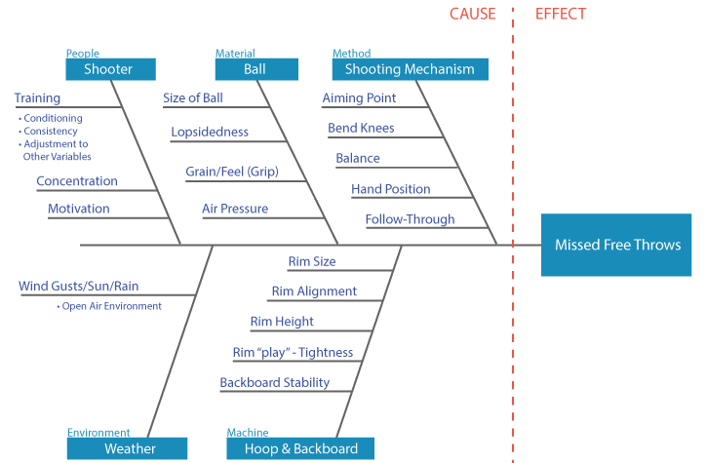

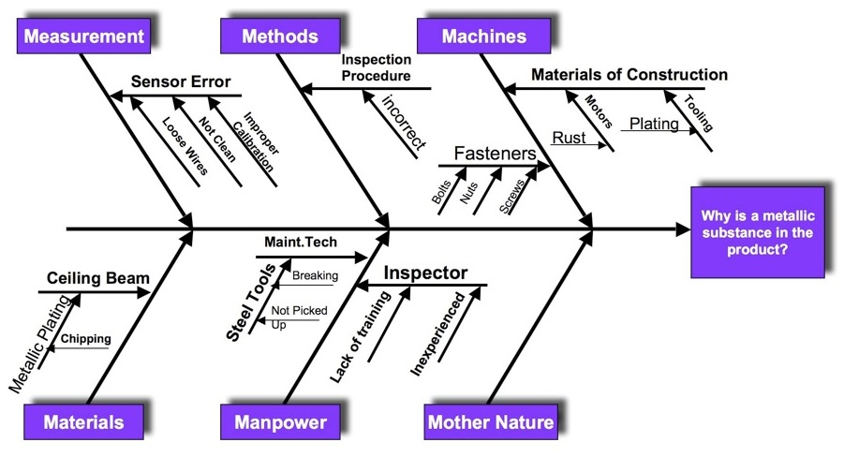

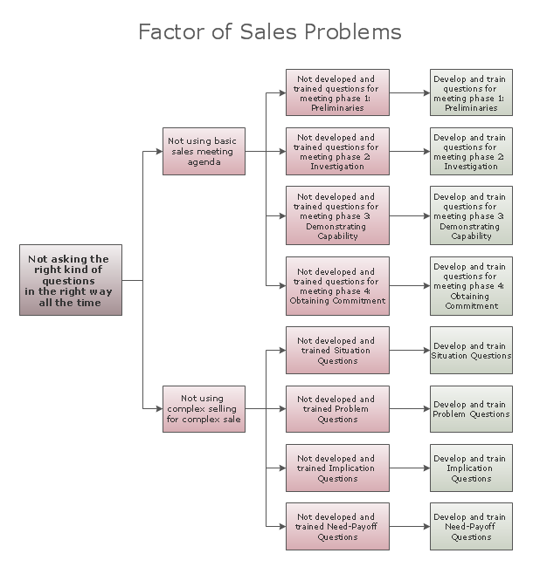

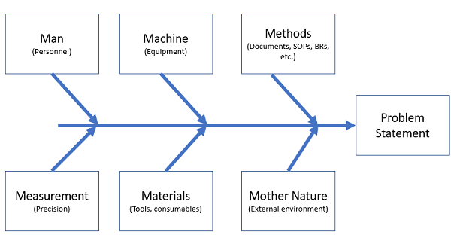

- Kaoru Ishikawa’s Most Memorable Scribble

YOU MAY ALSO LIKE...

“Human Error” Deviations: How You Can Stop Creating (Most Of) Them
In the time it takes you to read this article, the industry will generate (conservatively) about 115 new process deviations, and about 65 of them will be misclassified as having something related to...

Use These 7 Tools For Breakthrough Quality And Performance In 30 Days
In this sixth installment on the selection and use of quality improvement tools in your organization, Ben Locwin wraps up theseries with atreatise on the 7 Tools of Quality.

Fault Tree Analysis: Uncovering The Root Causes Of More Complex Problems
A refreshed approach to fault tree analysis can be an incredibly helpful addition to your problem-solving armamentarium. Having the confidence to begin using it — or begin using it more often...

“Work Harder” — And Other Ways To Completely Miss The Mark On Quality
Why does “Quality” seem like such a slippery, elusive term? The answer is easy: It’s because the people who claim to know it really don’t. And everyone seems to go along with...

How To (Better) Identify And Analyze Manufacturing Trends In Your GxP Organization
This is the first in a five-part article series:
Identifying And Resolving Errors,
Defects, And,
Problems Within Your Organization.
This article will enhance your understanding and prime you for visual...

How To Drive Powerful CAPAs With Lean Six Sigma

6 Reasons You Don’t Use Market Research

Analytical QbD at Teva: Knowledge Is Power Only When You Share It

A 6-Step Process To Assess Risk And Benefit In ICH Q9 Decision Making

Super Quality Accidental Collisions at BIO 2015

Are You (Inadvertently) Teaching Your Personnel To NOT Think?

Where Do Ideas Come From? Sometimes, From Places You'd Least Expect

https://www.pharmaceuticalonline.com/doc/when-to-use-a-fishbone-diagram-and-why-you-should-do-it-more-often-than-you-think-0001
https://www.pharmaceuticalonline.com/doc/fault-tree-analysis-uncovering-the-root-causes-of-more-complex-problems-0001

