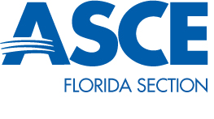
Student Chapter President Joey Hereau

Quarterly Report October 2014

With the start of the fall semester in full swing Florida Institute of Technology’s ASCE has seen a surge in interest from new and old members. With three general meetings under our belt and a fundraising event put on by our local professional ASCE branch, our members are gaining invaluable experience and networking opportunities.
Both the Concrete Canoe and Steel Bridge teams are in full swing now that both rule sets have been released. The Steel Bridge team has begun to build 3-D models of their bridge designs as well as including new members in the design process. The Canoe team has taken new members out paddling to introduce them to what the work done all year builds up to and has begun extensive modeling of canoe hull designs.
Over the next quarter we plan to work together with Florida Tech’s ABC Student Chapter, as well as with our local professional branch, on community service projects such as Habitat for Humanity. We also plan on hosting a beach clean-up day to act as both a team building exercise as well as a way to give back to the community.

