Quarterly Report Photos (July 2014 – October 2014)
Prepared for: Prepared by:
ASCE Florida Section Board of Directors Meeting Chapter President Franki Vallejo
October 4, 2014

Florida Section Student District Representative: Shawn Brown

Events Photos
________________________________________________________________________________________________________
Bulls Go Green Event
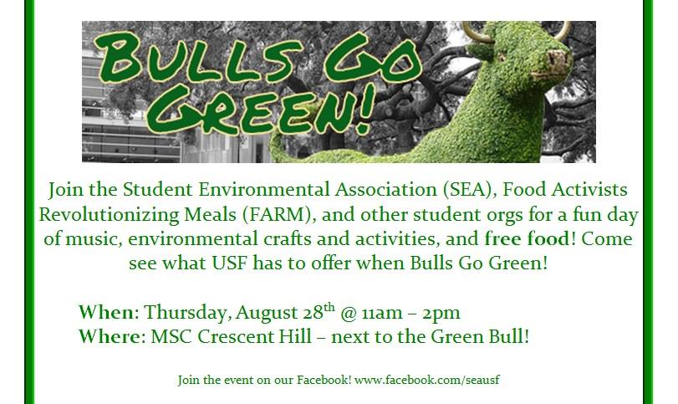
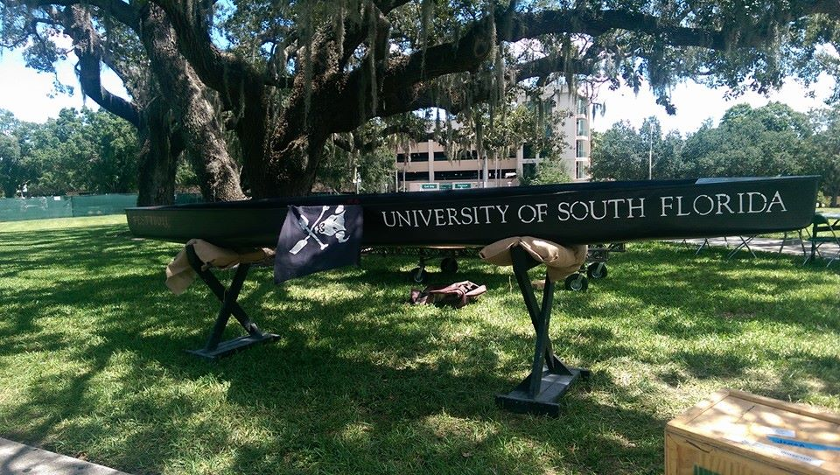

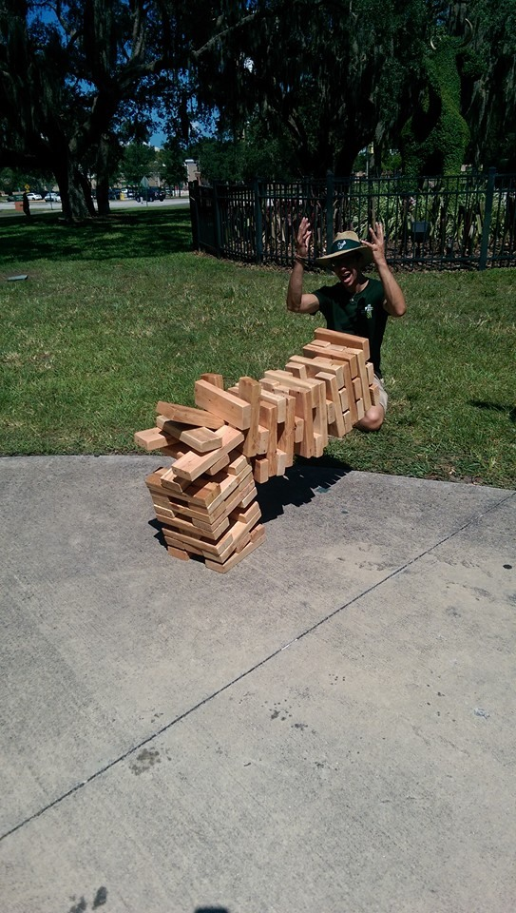

Engineering Block Party
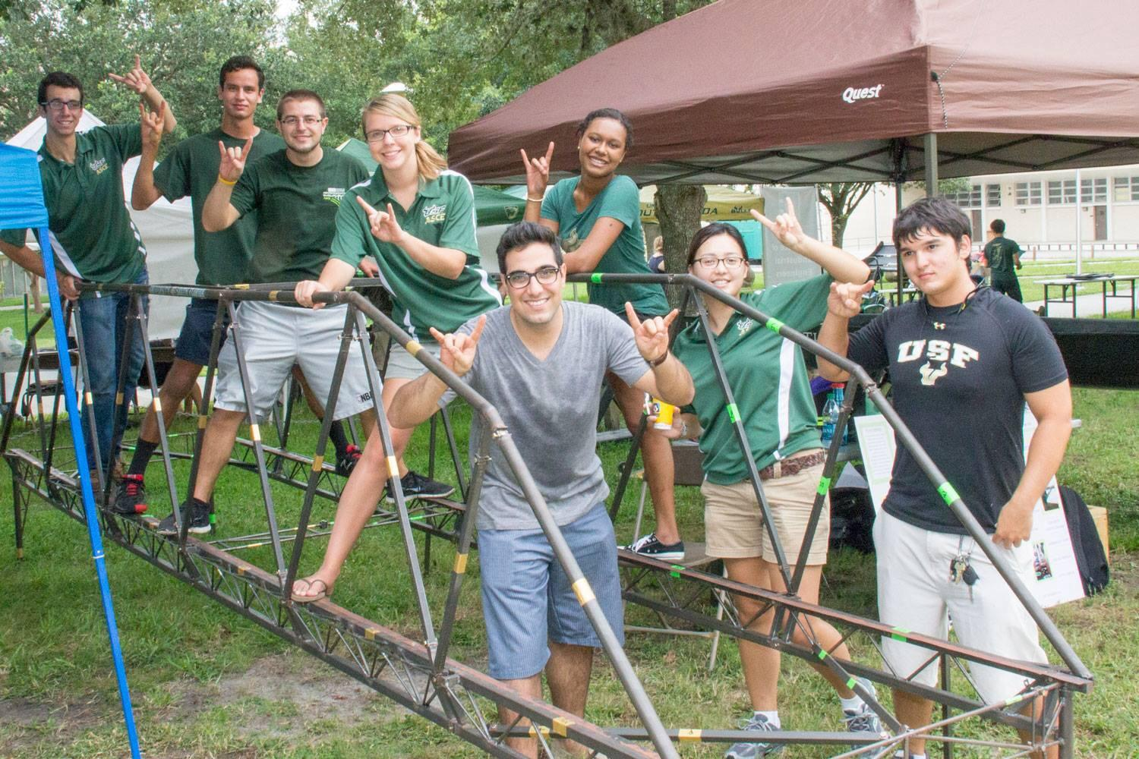
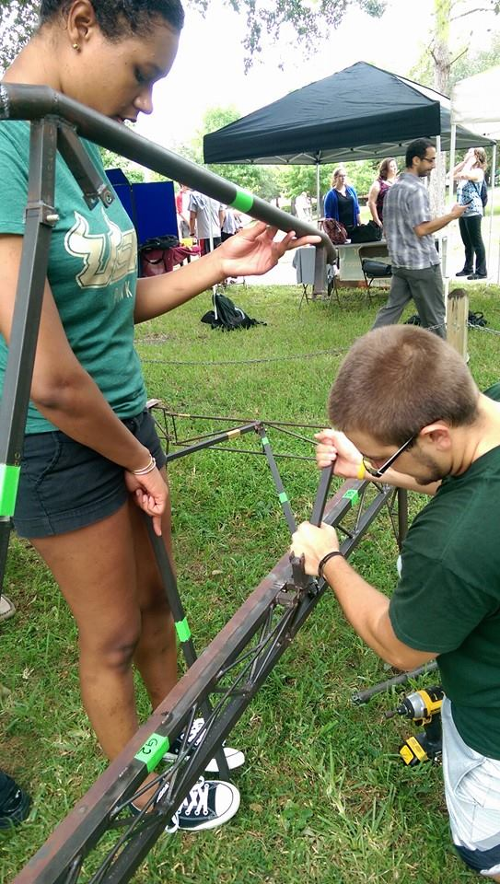

ASCE Southeast Conference 2014 – 3rd Place Overall Trophy Presentation
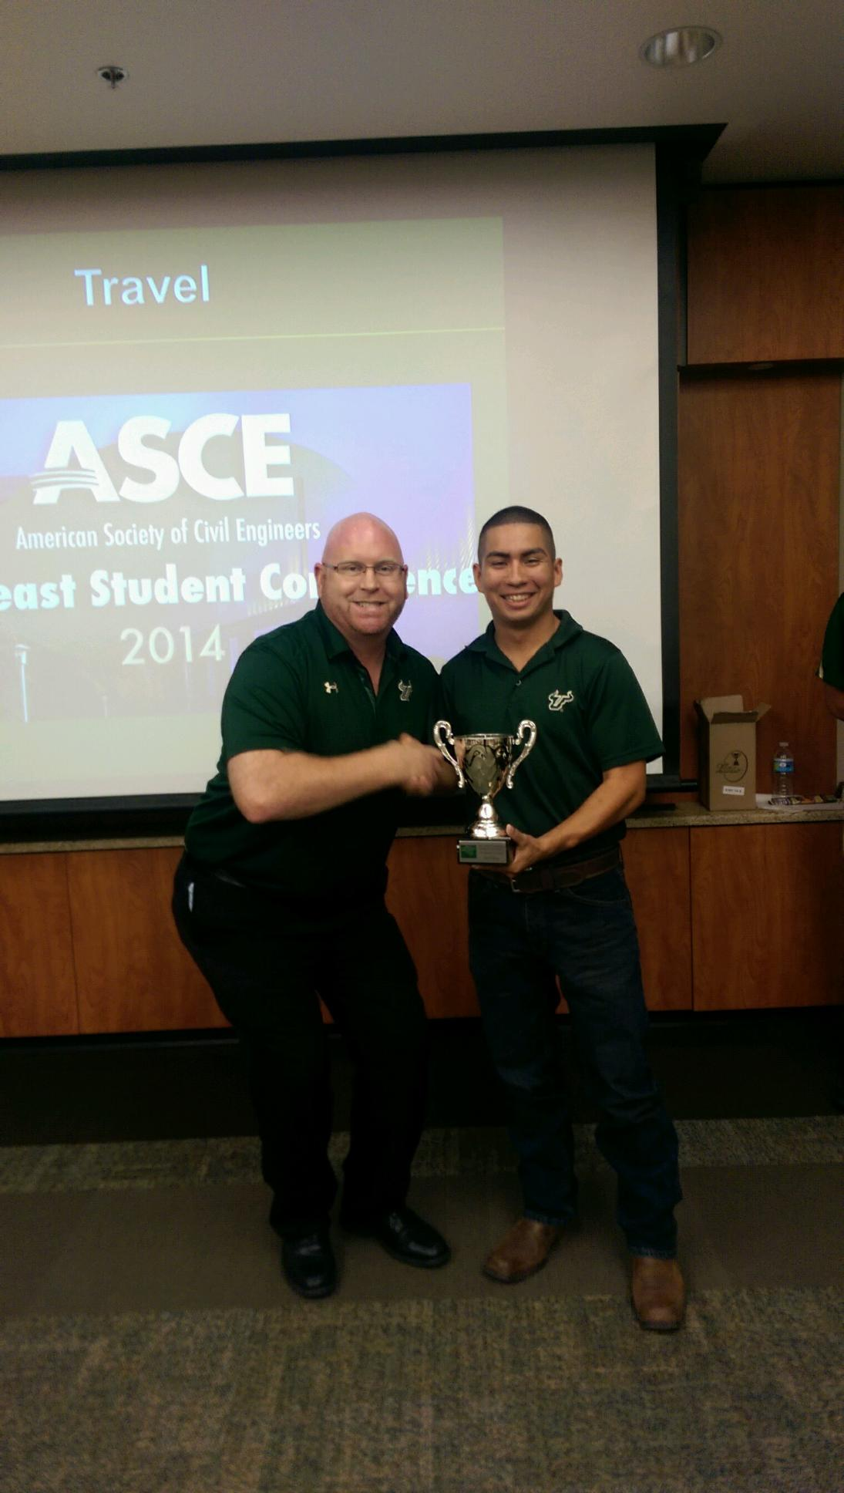

Keep Tampa Bay Beautiful Coastal Clean-Up
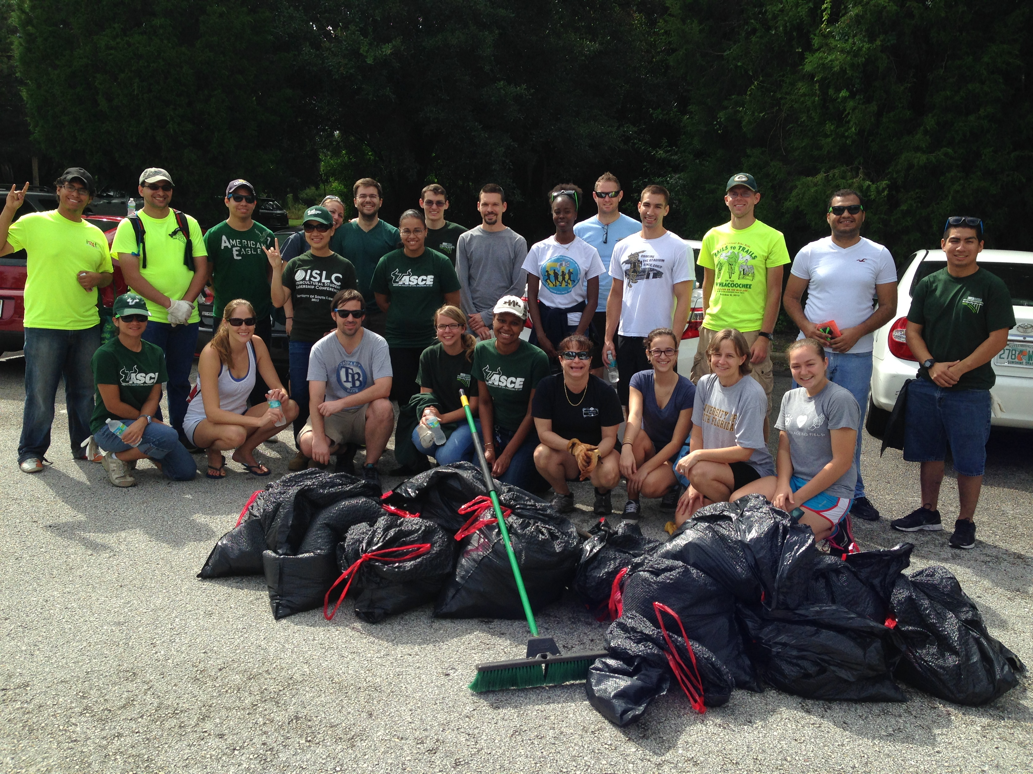
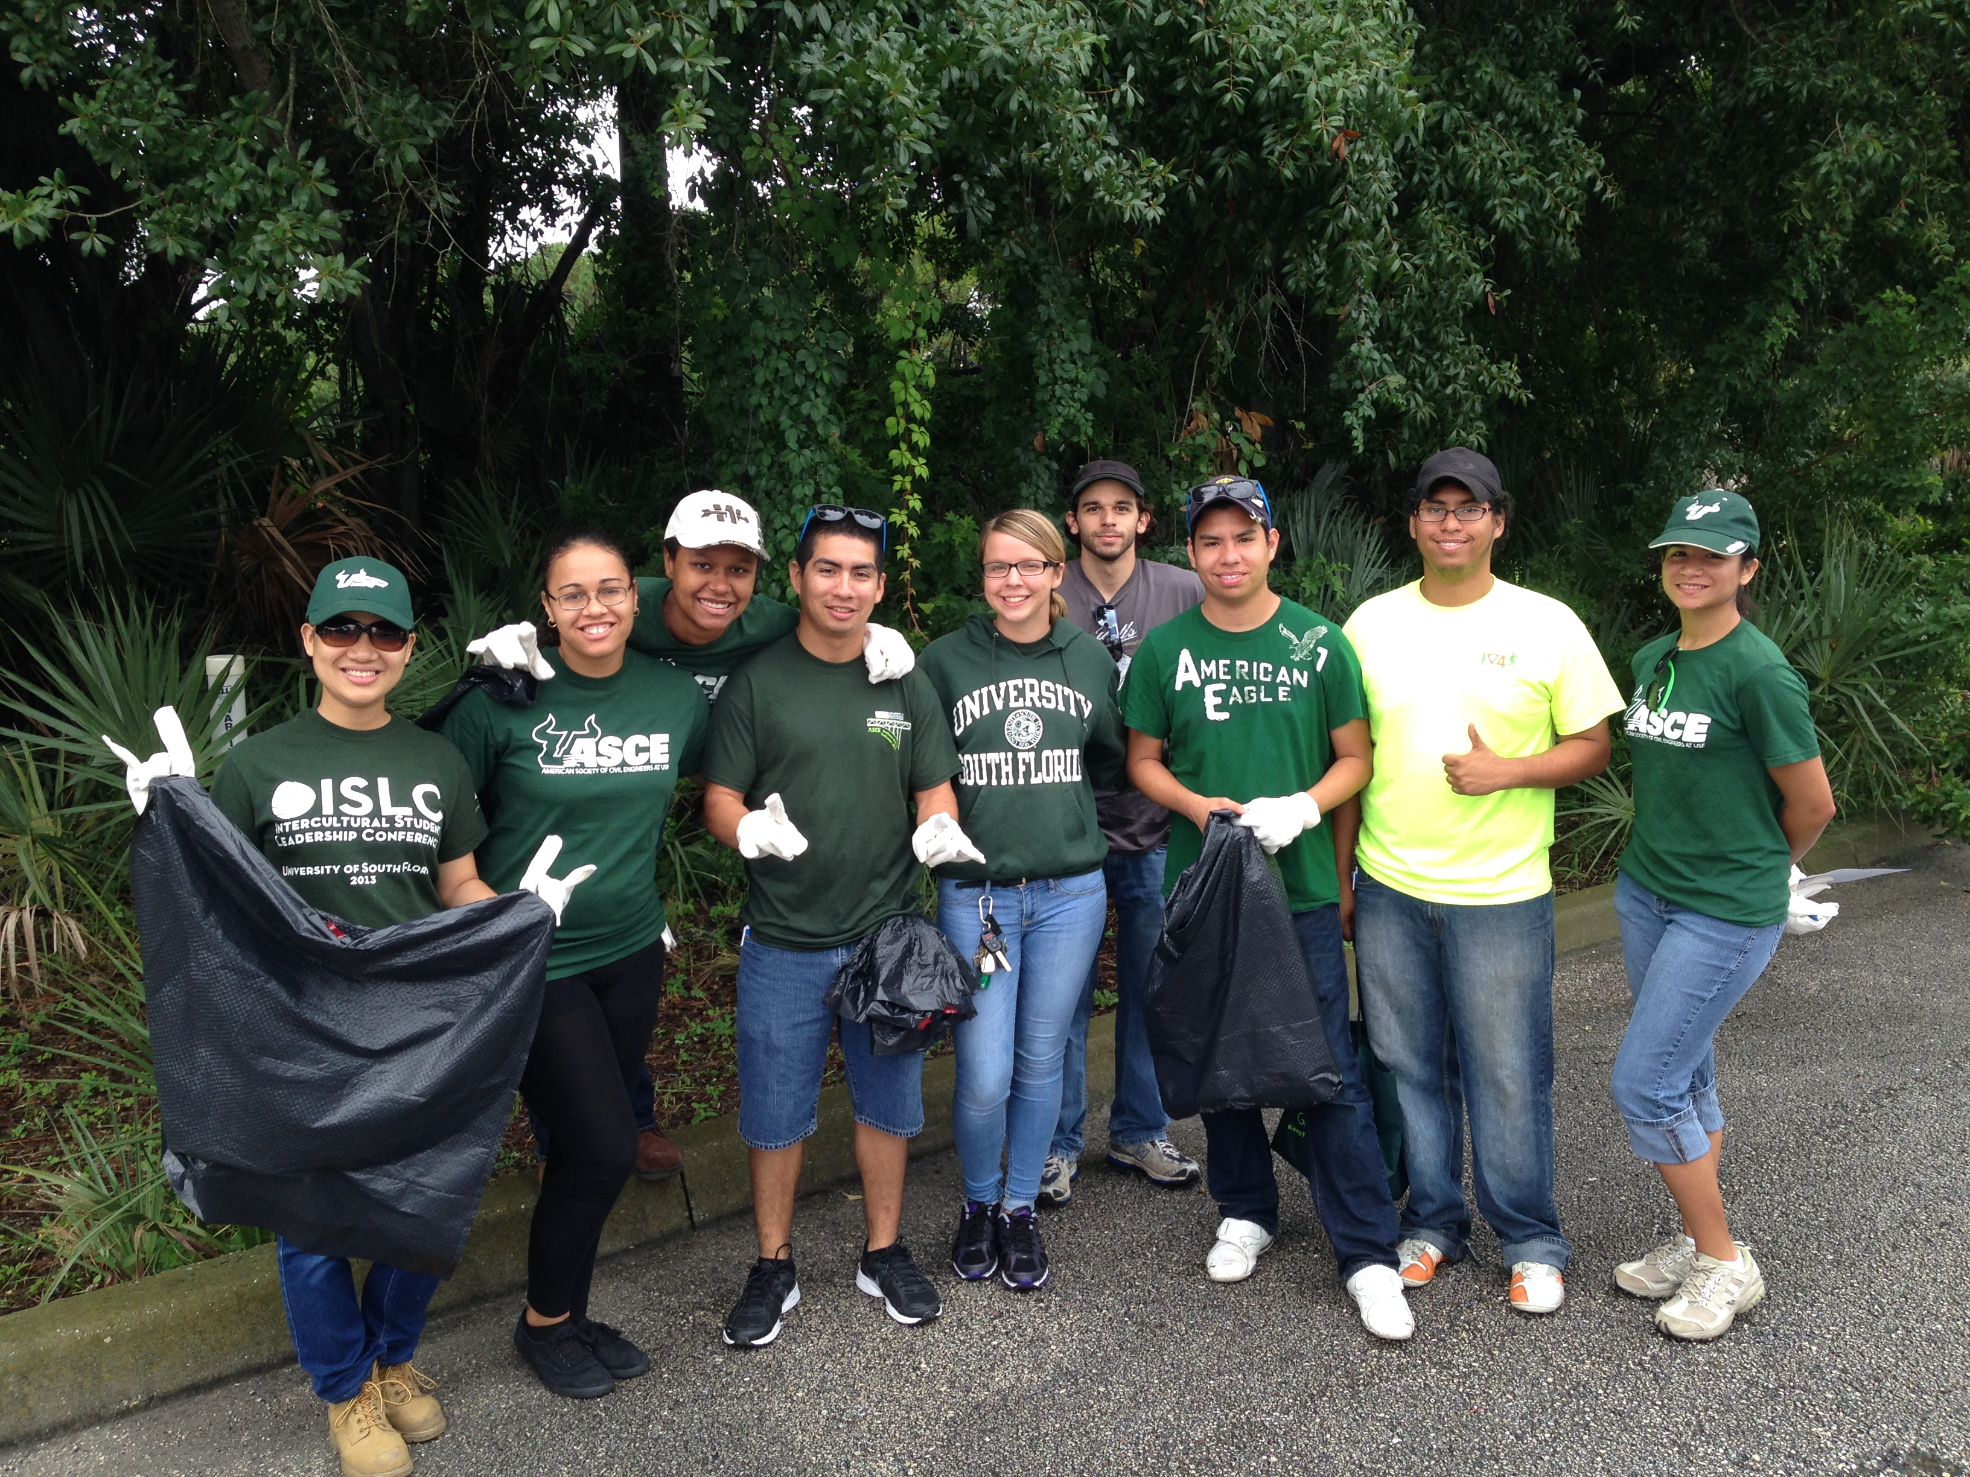

Aramark Fundraising
