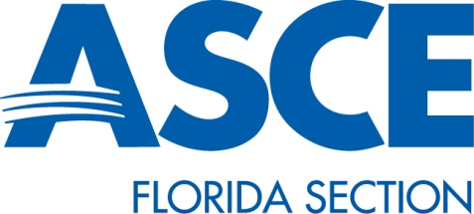
Request to Use Florida Section ASCE Employer Identification Number
______________________________________ requests to use the Florida Section ASCE’s EIN for the
(Name of Branch/Institute/Student Chapter/YMG)

fiscal year _____________________________. We understand the following:

- That this request is made one month prior to the beginning of the upcoming fiscal year;
- That this request will be made annually;
- That the Branch, and any of its subsidiary organizations with separate bank accounts – Institutes, Student Chapters and Younger Member Group, must complete this same agreement and agree to its terms;
- That all questions regarding this and the use of the EIN, will be directed to the Florida Section ASCE.

Terms
- Upon approval of the Florida Section, this agreement is valid for one year only.
- Request must be made every year by the Branch and its subsidiary organizations – Institutes, Student Chapters and/or Younger Member Groups.
- Any group using the Section’s EIN must complete the “Branch Revised Schedule.” Institutes, student chapters and YMGs must complete the schedule and return it to the Branch, which in turn rolls those figures into its own schedule that gets turned in to the Section by the due date given by the Treasurer at the October Board of Directors meeting. This form must be completed even if there is zero activity for the year.
- The Branch checking account, as well as those of the Institutes/Student Chapters/Younger Member Groups, will be named:
American Society of Civil Engineers Florida Section Branch/Institute/Student Chapter. Checking accounts using the Section’s EIN that do not match the above, will be subject to IRS tax withholding if the account is not named in this manner.

Submitted on this date by,

____________________________________ _______________________________________
Student Chapter President Student Chapter Treasurer

___________________________________ ______________________________________
Email address Email address

