ASCE Informz - Best Practice Guide
Credentials
Local leaders should maintain their own, individual login for the platform. You can request login information. All groups have an unlimited number of credentials available. Please contact Tirza Austin at taustin@asce.org if you do not receive credentials in a timely manner.
Recommended Browser Settings
If you have issues logging in the vendor has a few recommendations. Also, incognito mode will render errors as well.
The information is below, we recommend doing the following within the web browsers:
1. Clear cache and cookies for ALL Time
Google Chrome:
a. To prevent saved passwords/saved sign-in data from being removed:
i. Click Advance Tab
ii. Change Time Range to "All Time"
iii. Check the boxes for "Browsing History", "Download History", "Cookies and Other Site Data" and "Cached Images and files". Leave all other boxes unchecked.
iv. Click Clear Data
Mozilla FireFox:
a. To prevent saved passwords/saved sign in data from being removed:
i. Click "Manage Data
ii. Remove all for the informz.net website
2. Enable 3rd Party Cookies
3. Disable any/all Ad Blocker Software on the laptop.
4. Check Google Extension (Puzzle Piece Icon)
a. Remove/Disable the following extensions:
i. DuckDuckGo Privacy Essentials
ii. Brave
iii. Privacy Badger
***Note: Recommended Web browsers are Google Chrome or Mozilla Firefox.
Building Lists
ASCE has created five lists for each Section and Branch that are integrated with ASCE’s database. These lists update upon each send.
Lists include the following:
Region – Section – Branch = This is the general membership list
Region – Section – Branch – YM = This is a list of younger members in your local group
Region – Section – Branch – S = This is a list of students in your local group
Region – Section – Branch – Welcome = This is a list of members who have joined your local group in the past 30 days.
Region – Section – Branch – First Arrears = This is a group that has not paid dues this year after the three-month grace period in March has ended.
****Informz and ASCE Collaborate drop members after the first year that dues are not paid. The lists you receive from membership include individuals in double arrears that have not paid for two years.

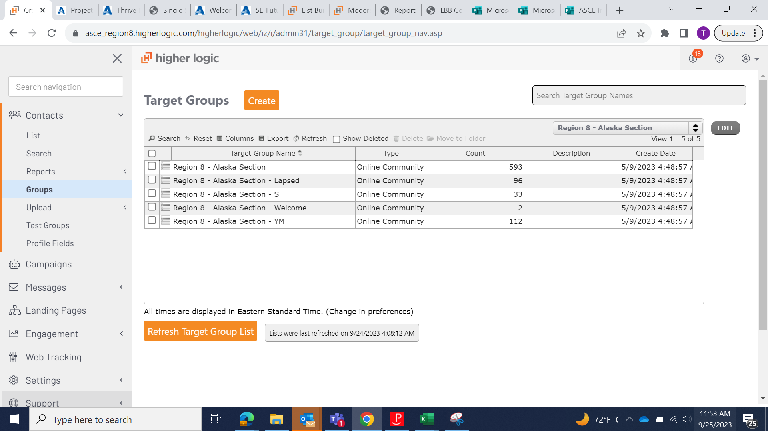

Manually refreshing
If you are going to view or export the lists, we recommend resyncing the lists to receive the most current data. You can do this by hovering over the calendar icon > select info > resync now. See screenshots below.
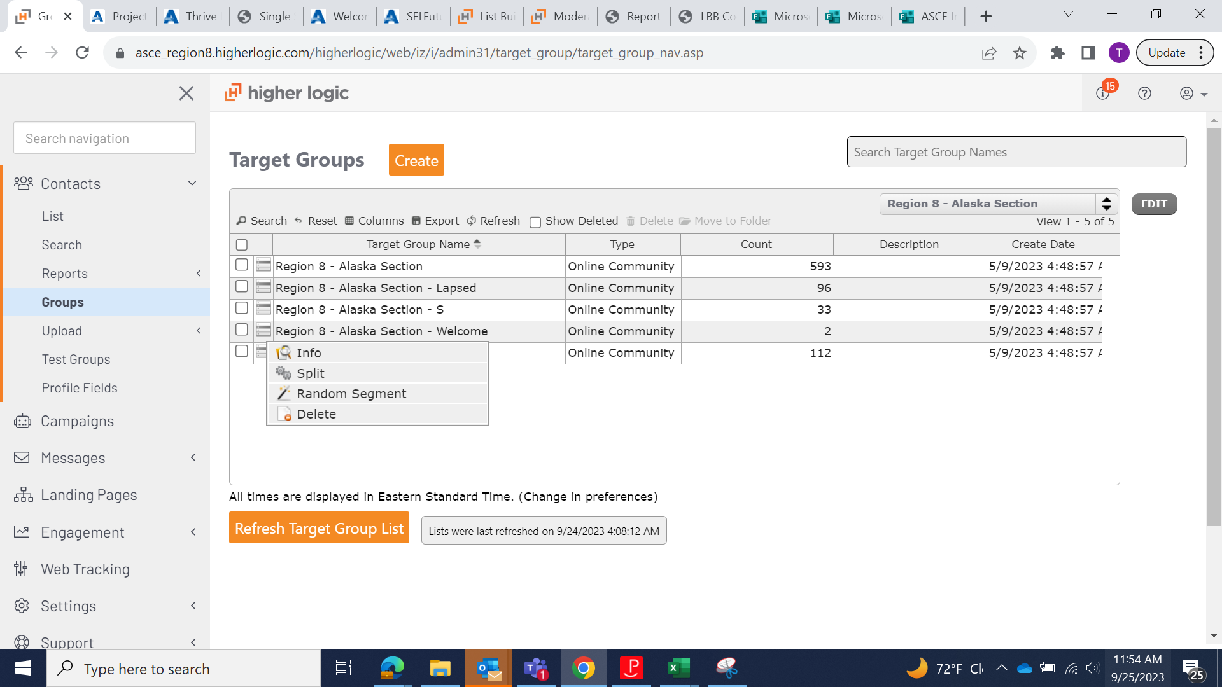
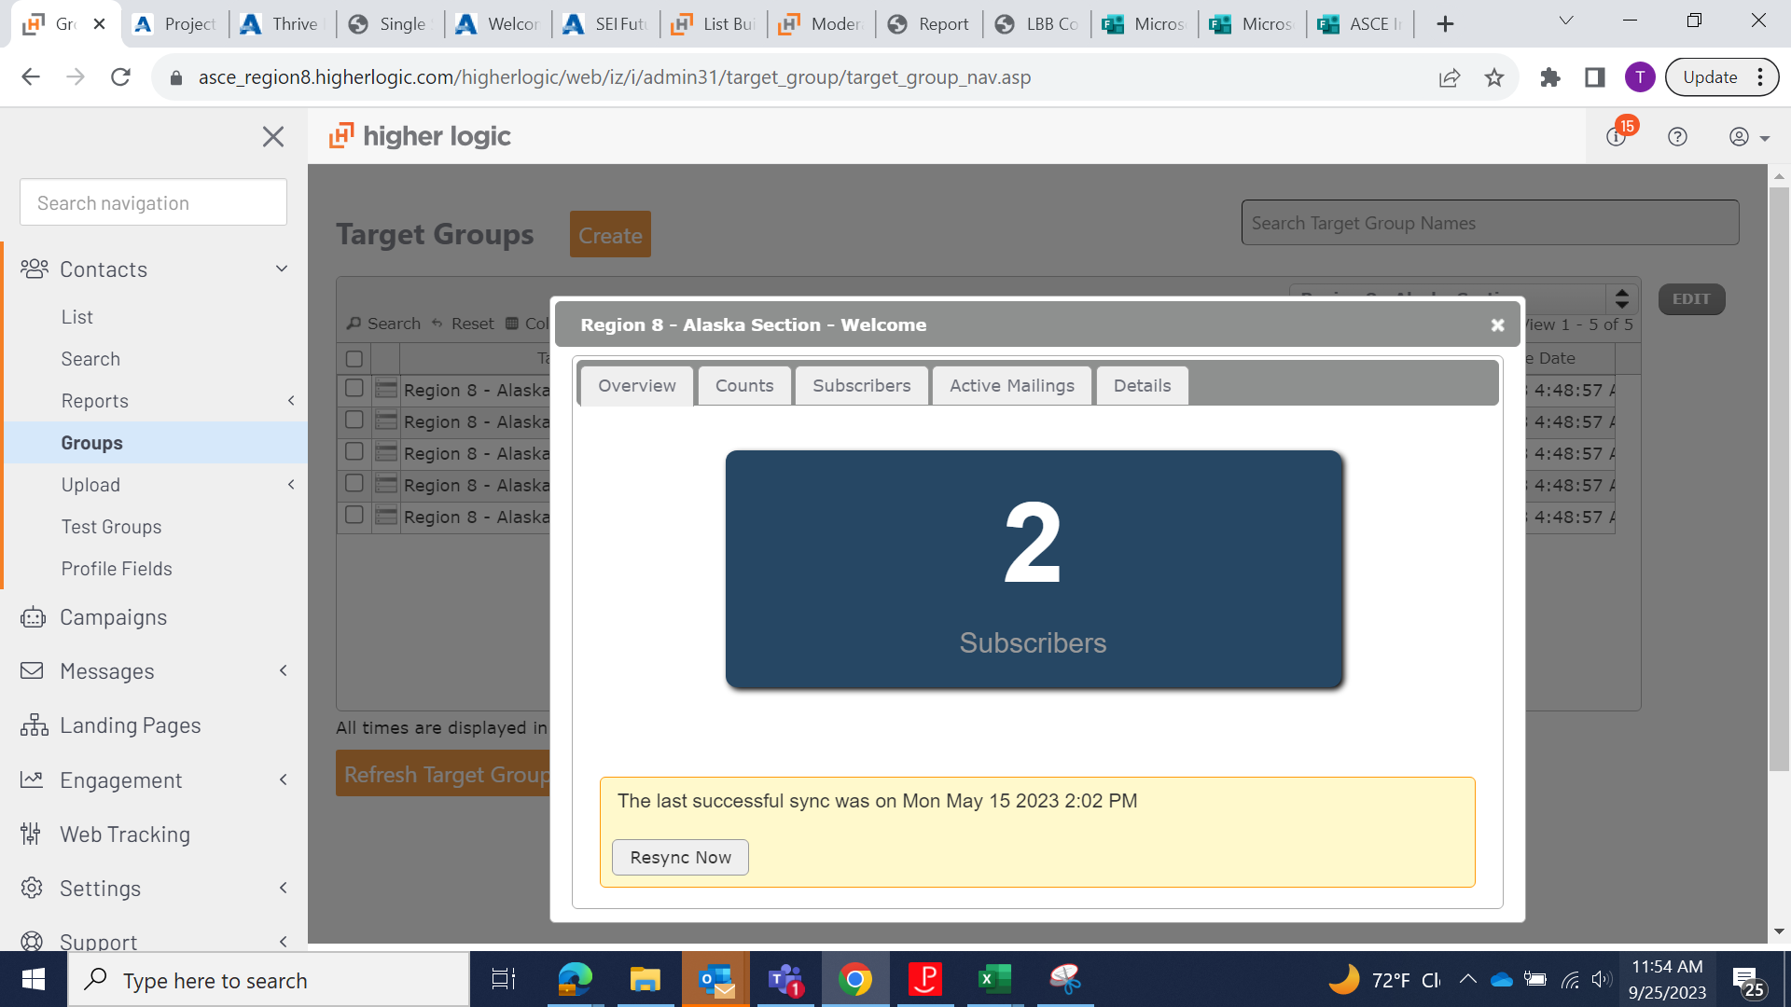

Institutes lists
Institute lists can be requested. We have best practices for Institute Management in a PowerPoint and video recording.
Best practice is requesting an Institute Chapter Community and Lists. It is also recommended to set up folders that are Institute Chapter Specific.

Managing Unsubscribes
Users are managing their subscriptions through the ASCE EPC https://info.asce.org/section-branch-email-preferences
There are subscription eligibility lists that need to be compounded when you send. You can create compound lists to streamline this process as well. Documentation here.
You first need to create a compound group to include your integrated list with the eligible subscriber list that is being populated through ASCE’s Email Preference Center. This is a necessary element for you and ASCE to maintain email compliance.
Go to Contacts > Groups > Create.
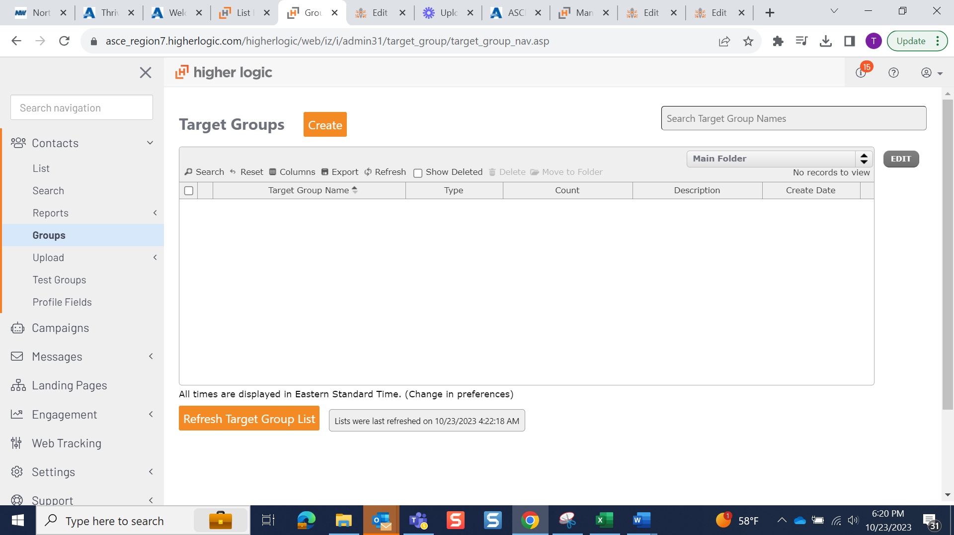
Select Compound Group from the dropdown menu.
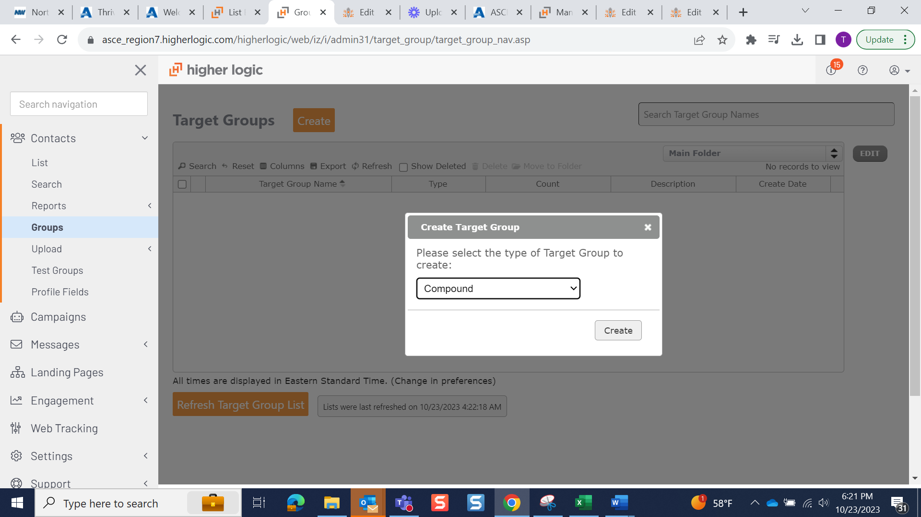
Select your integrated list from your Section/Folder. Click include.
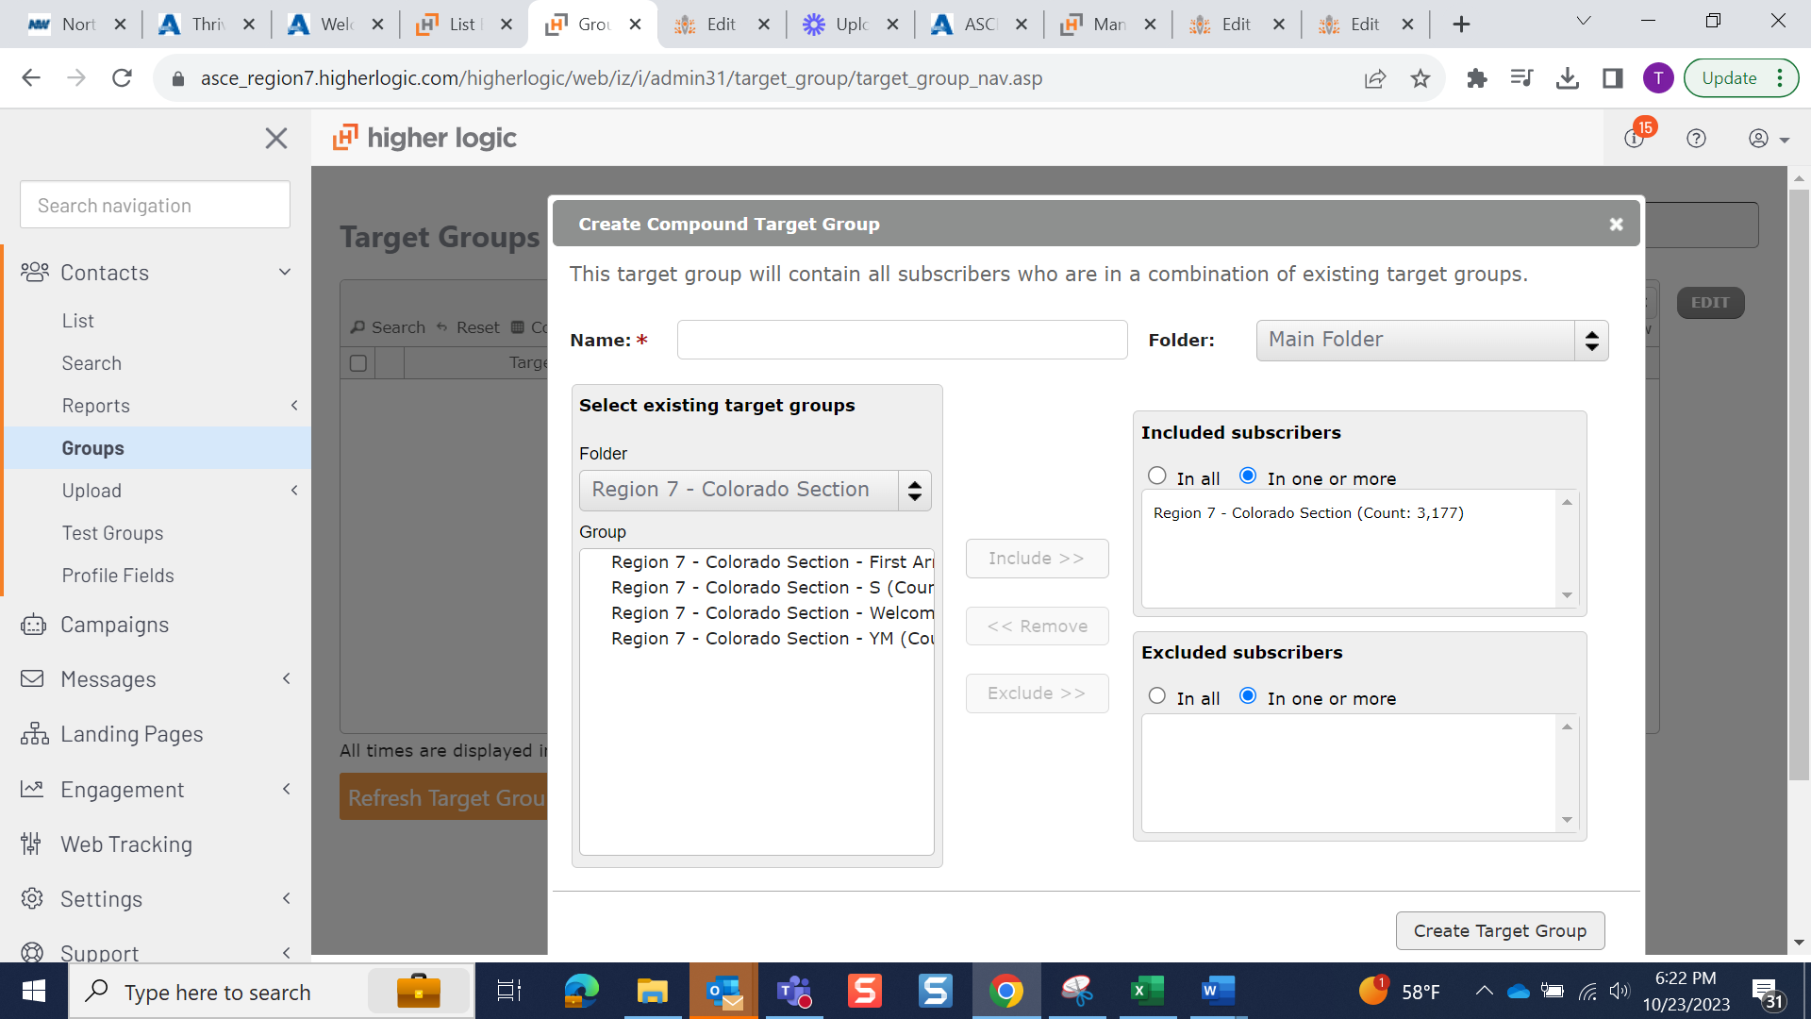
Go to the subcriber folder and select the appropriate subscriber list. Here it is Section Communications. Click “in all.” This logic means subscribers will need to appear in both lists to be a subscriber. In one or more means that it sends to every individual in both lists.
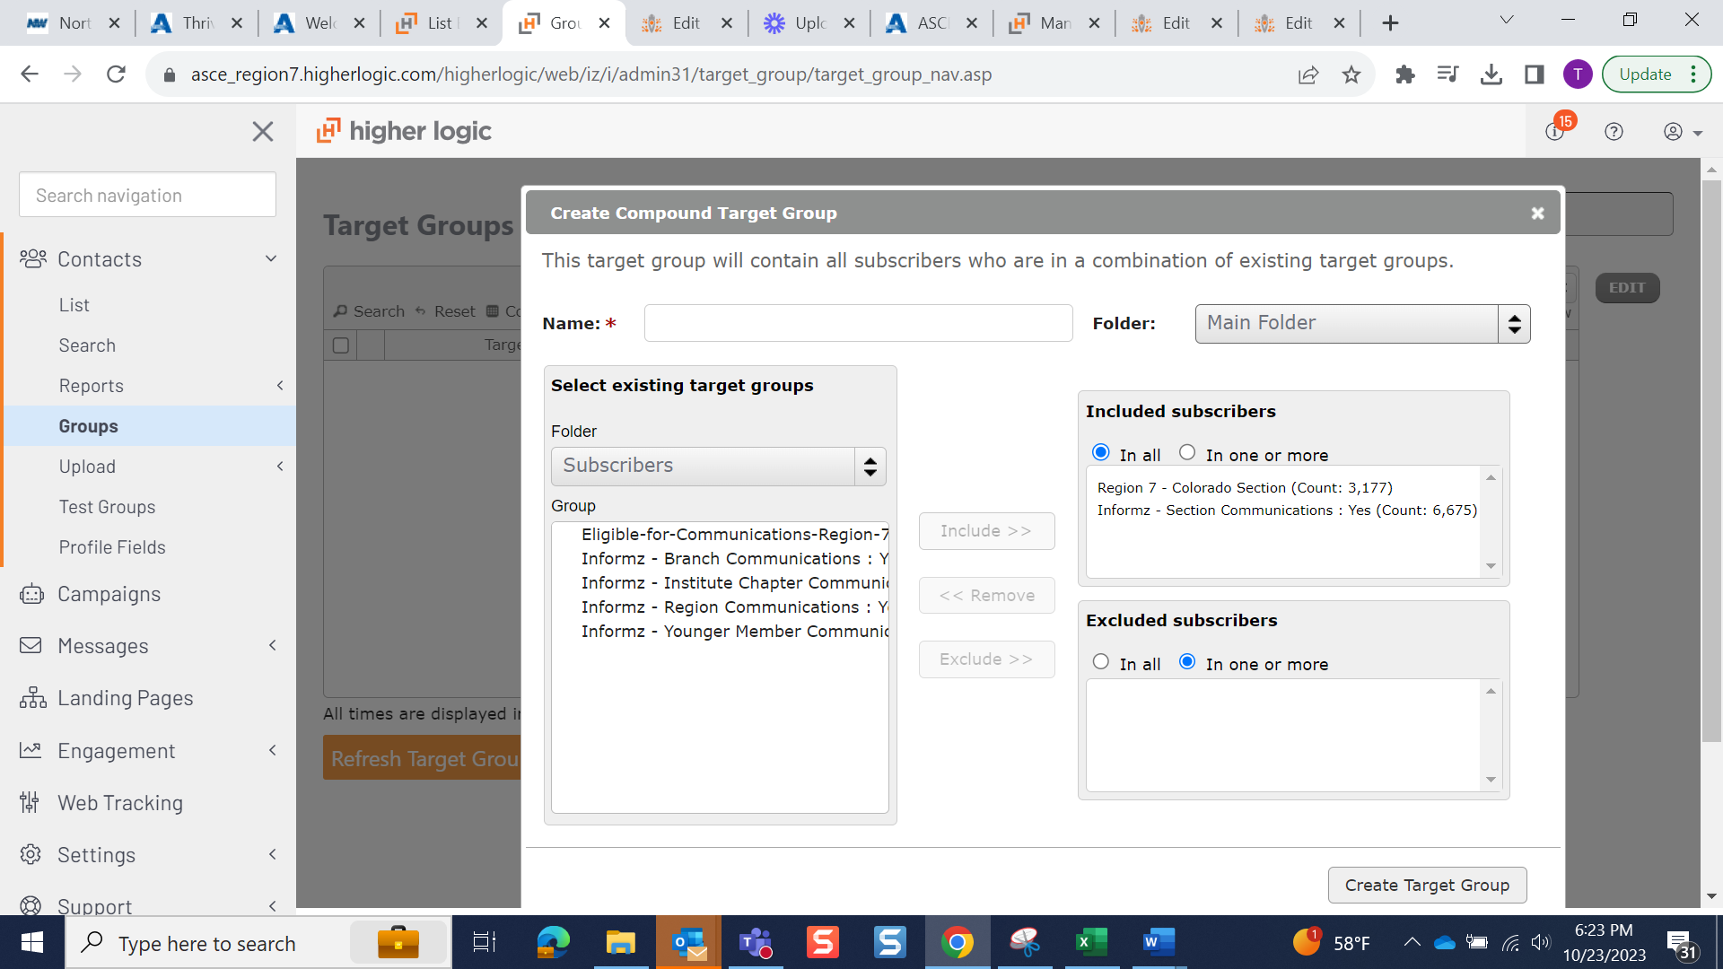
Add a name for the list. Best Practice would be Section Name Eligible Subscribers. Please the list in your already created folder.
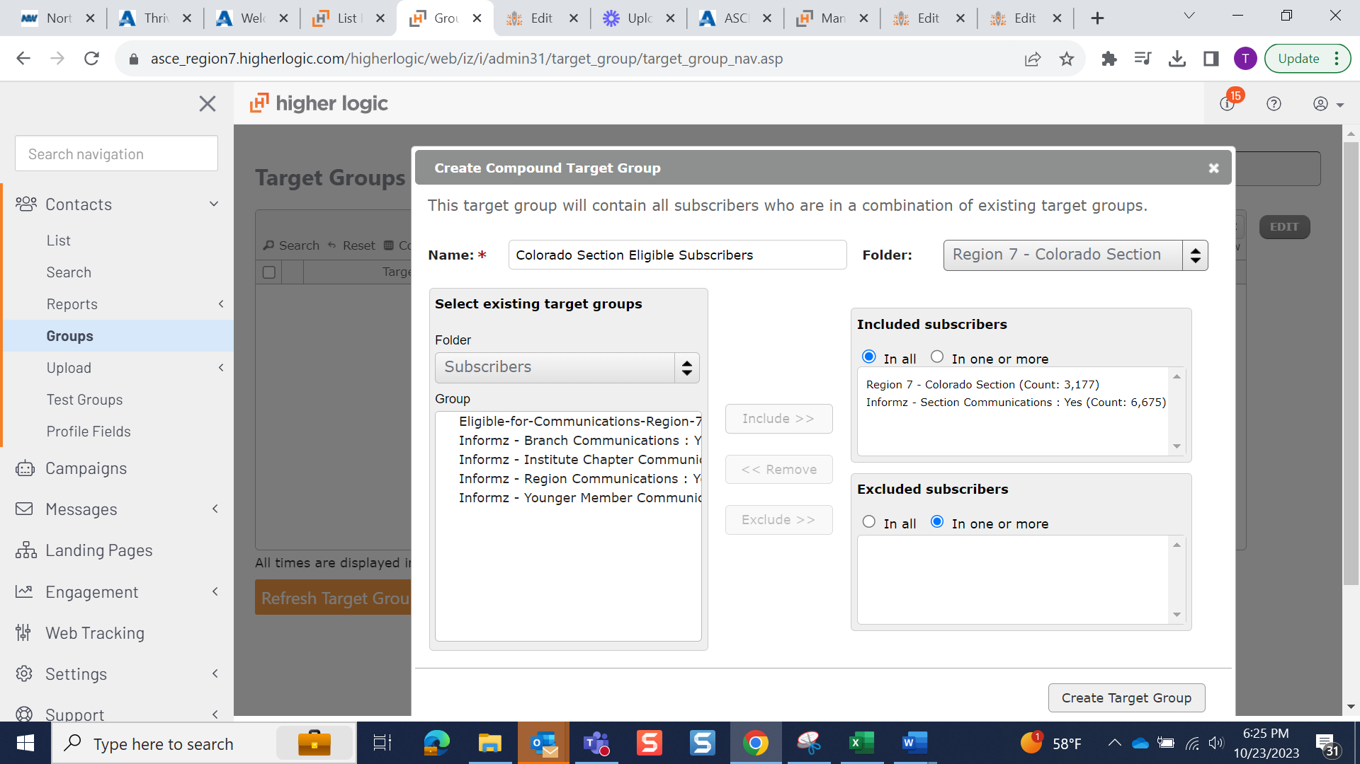
Select messaging > Properties > Targeting > Select your folder > Select the Eligible Subscriber List you have created as a compound list. You only have to create a compound list one to continue to send to that audience.
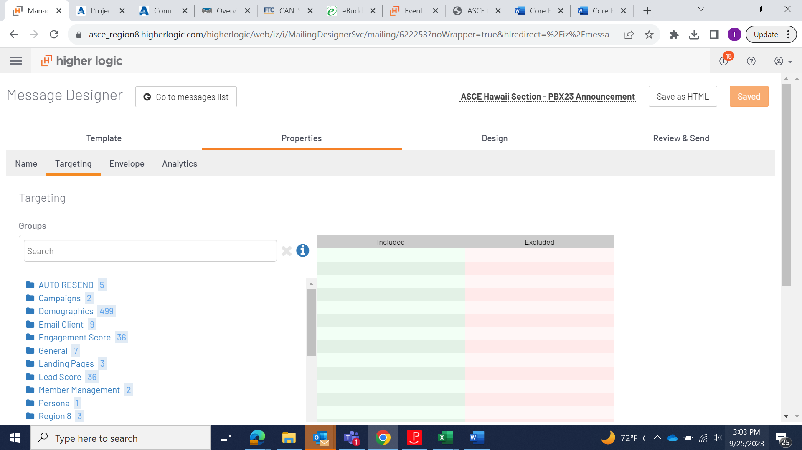
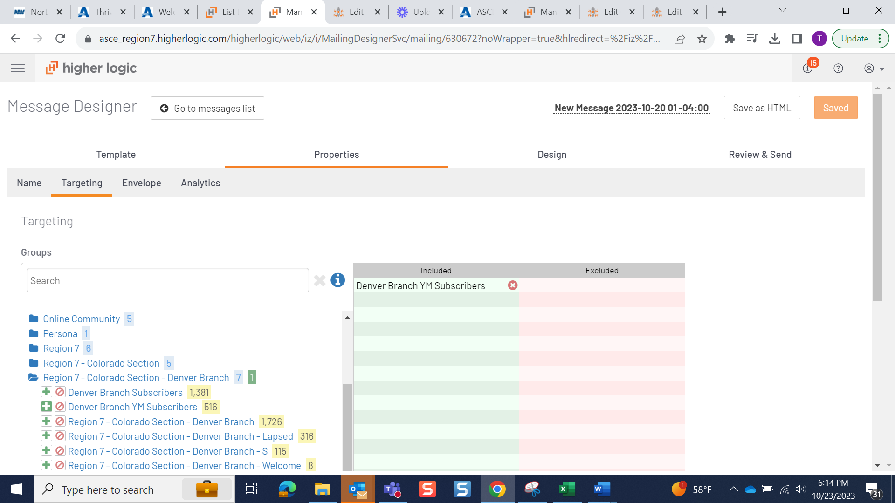

If you go to the review and send tab you can send a test or review the count of subscribers to receive the mailing.

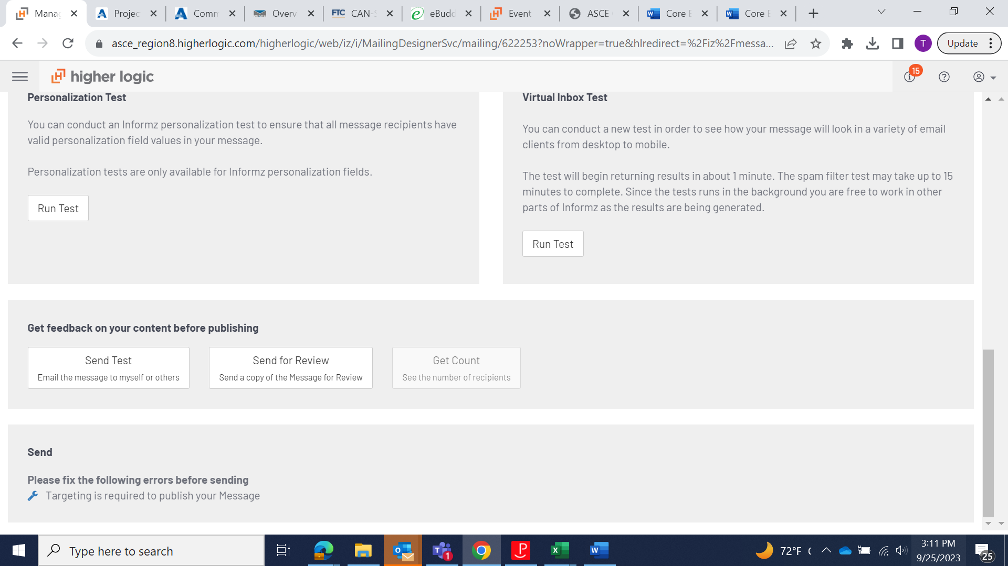

Uploading Prospect Lists
Local groups can upload lists or manage subscribers individually through the platform. You may want to import existing prospect lists from Constant Contact or add event attendee lists.
You can find more information about how to do that here.

Data Format
Best practice for Data Format is:
Email
First Name
Last Name
State
Country
The file will need to be saved as a TXT file to upload your list. You can find a sample file here
Under documentation.
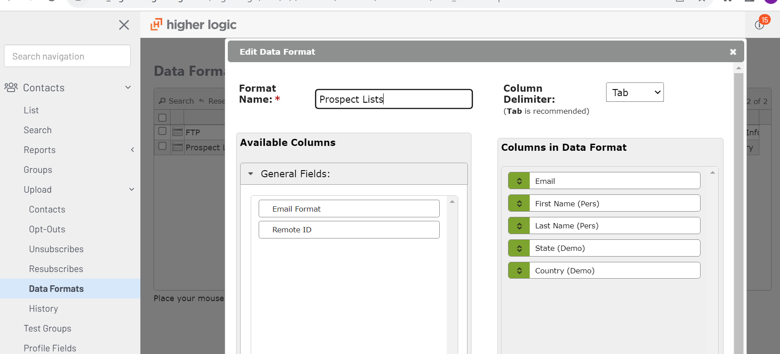

From Address
The from address must be an ASCE domain. ASCE has authenticated the localleaders@asce.org domain for all local groups to use. If you chose to use your own ASCE domain best practice would be to authenticate it through the system. Localleaders@asce.org is the default for the ASCE branded templates.
****The system will not let you send from a free email address domain (gmail/hotmail). This is part of DMARC regulations.

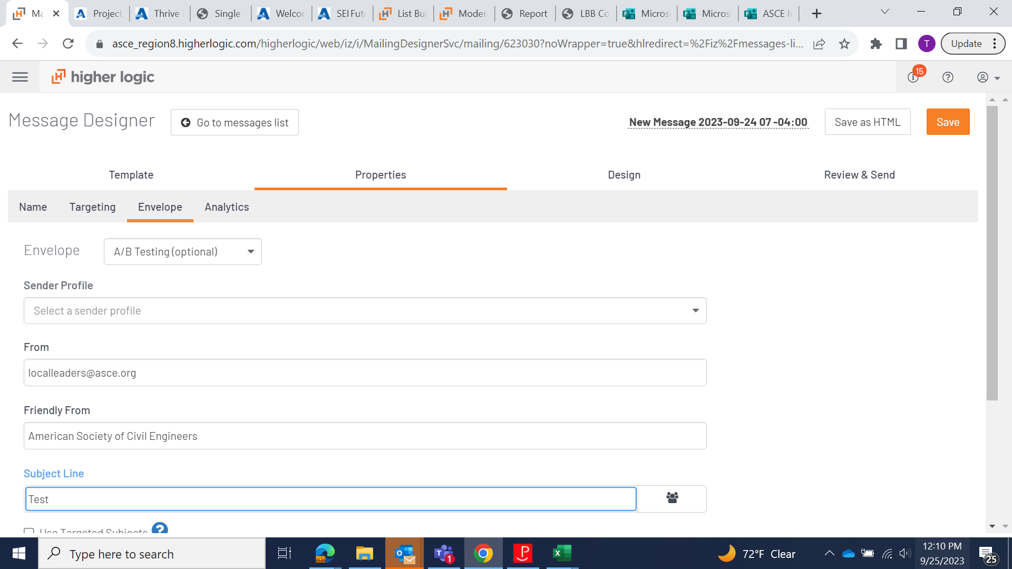

Authentication
To authenticate your ASCE account go to Settings > Email Authentication. Add your domain and then click get instructions. If you have any questions about the instructions, please feel free to contact taustin@asce.org.
Best practice to improve deliverability is for all accounts to authenticate.

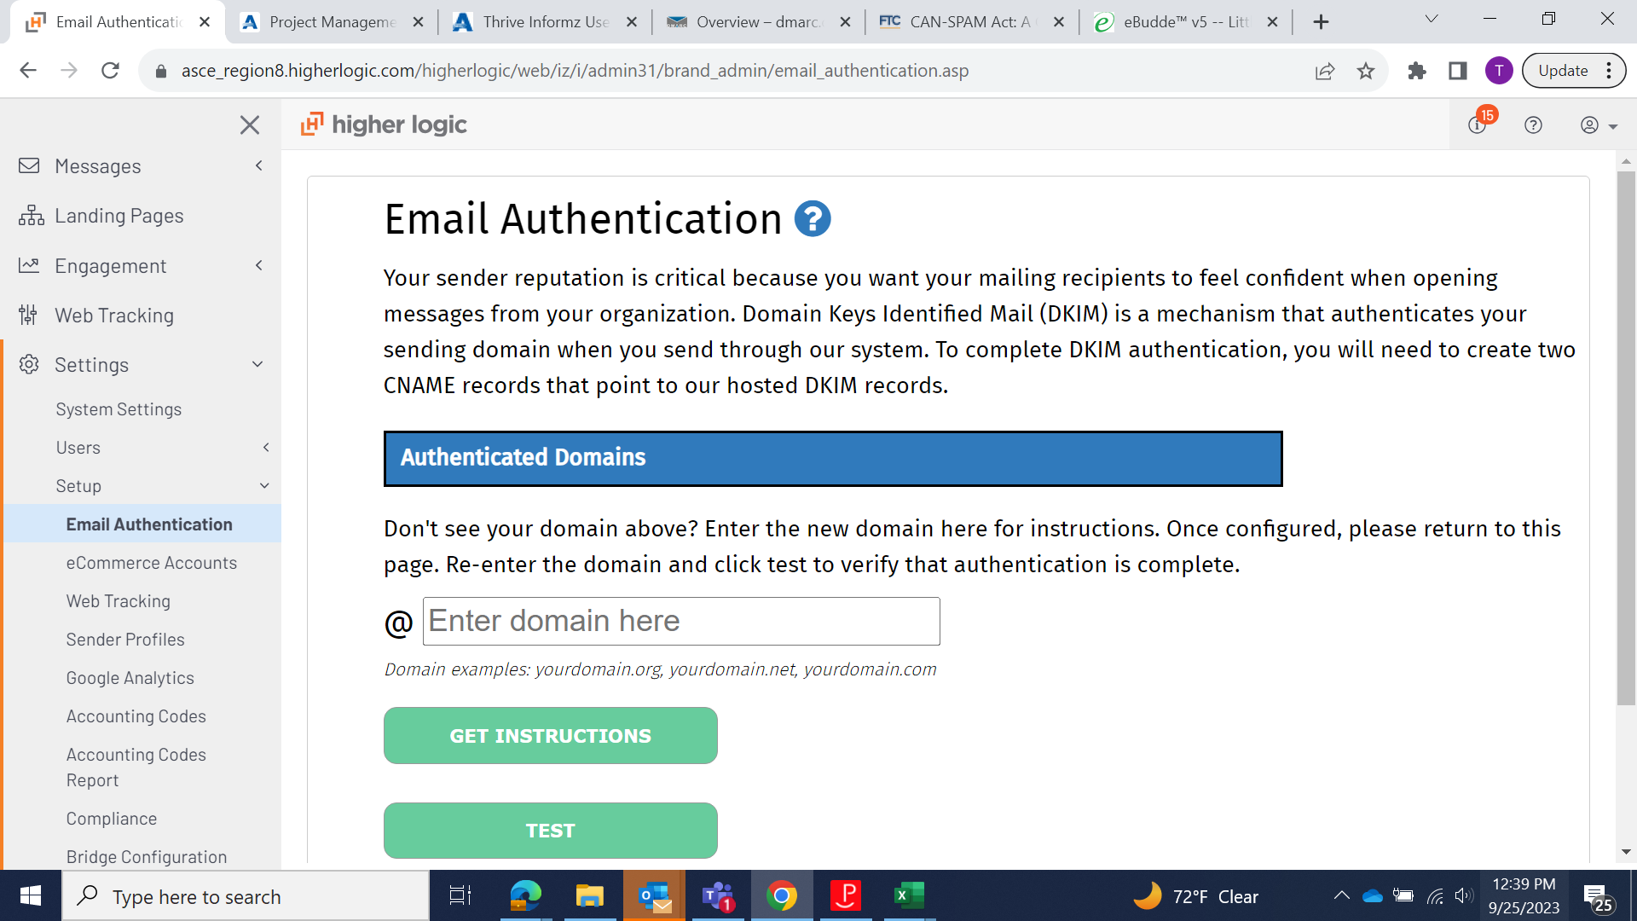

Friendly From
The Friendly From and subject line should be personalized so members know it is coming from your local group but also associated with ASCE.
Example
Phoenix Younger Members – American Society of Civil Engineers
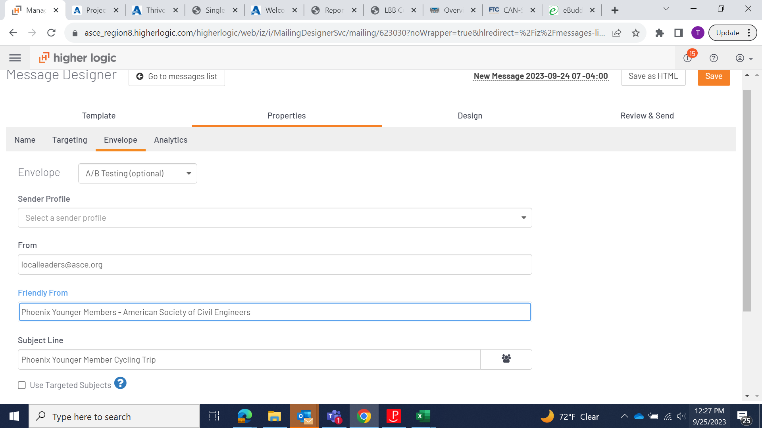
Reply to
The Friendly From can be ANY address where you would like to receive response. Best practice is an inbox where officers can frequently monitor and reply to concerns.
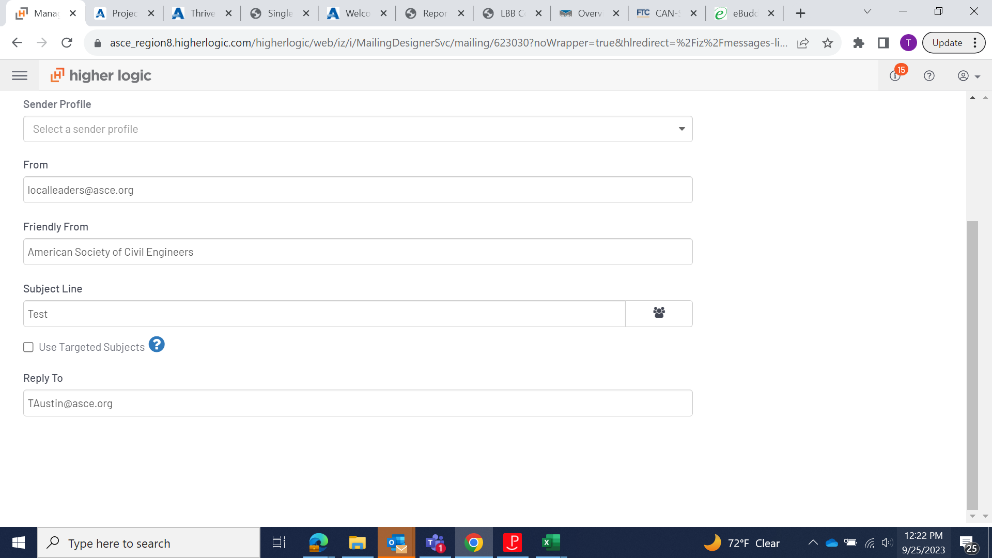

Folders
Folders can be created for
- Target Groups
- Templates
- Messages
- Landing Pages
- Assest Manager
- Campaigns
Most functionality within the platform allows you to create folders. You will see some have already been created for your local groups. Best practice is to create as many folders as you need to stay organized.
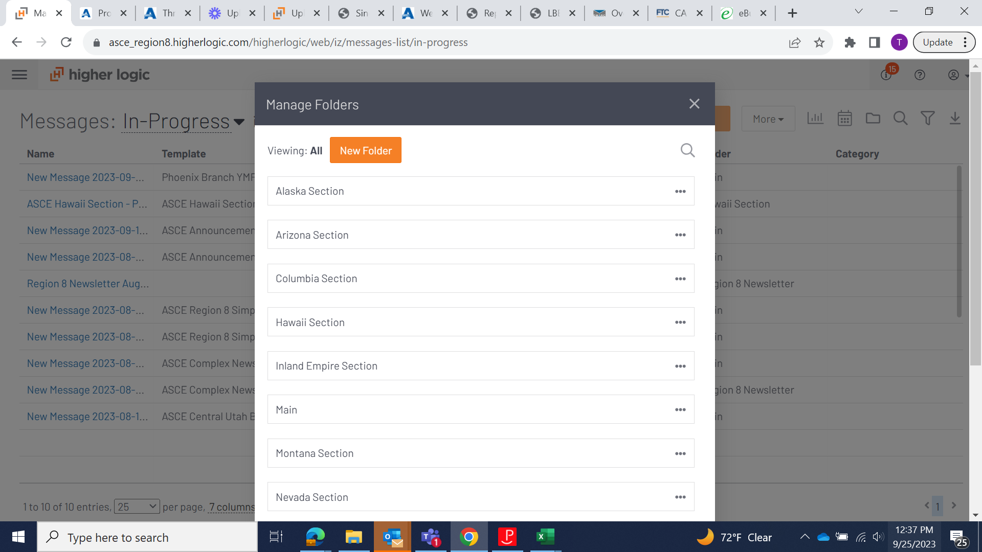

Footers
CAN-SPAM compliance requires an unsubscribe link and a physical address. ASCE templates already have the Unsubscribe link and a physical address. You must keep the unsubscribe link to stay compliant. The URL is https://info.asce.org/section-branch-email-preferences
You will also want to add your own personal physical address or keep ASCE’s HQ address.

Managing inactive users
The platform will automatically unsubscribe users who consecutively hard bounce four times and consecutively soft bounce seven times.
Image Suggestions
Left-aligned images preferred for accessibility and consistency when stacked in mobile view.
• 250x250px suggested size for standard story images (i.e., Image with Text content block)
• 250x250px suggested size for 2 column story blocks
• 125x125px suggested size for 3 column story blocks
• 100px suggested height for signatures, depending on handwriting style
• 75x75px suggested size for icon use
• 650x100px suggested size for advertising banner
• 650x175px size for header banner
• 650x300px suggested size for full-width dominant image (recommended height to reduce scrolling and/or blank screen if images are not loaded)
Member Onboarding
Headquarters recommends you communicate the following:

- Inform members about the switch through a Constant Contact Email

- Ask members to whitelist the IP address

- Inform members about ASCE Collaborate Communities where the events will be posted

- Ask members to manage their email preferences

As you transition from Constant Contact to Informz to communicate with your members a week before you start sending from Informz. Here is an email template we recommend. We also recommend you post in your ASCE Collaborate and Section/Branch website. If you plan on uploading lists we recommend you make the download lists before you switch to Constant Contact.

Email Template:
The platform you’ve been receiving Section and Branch communication from is switching to a new platform that integrates with ASCE Collaborate.
Here’s what this means to you:
- Emails will come from (insert your “from name”) and (insert domain name)
- New email preference center. You can update your notifications settings here: https://info.asce.org/section-branch-email-preferences
- Different IP address. To ensure you still receive communication, we recommend you whitelist 205.201.40.61 and 205.201.40.49
- Emails may look different

Please let us know if you have any questions or concerns.

Local Leader onboarding
Please review the following resources. Any questions? Contact Tirza Austin at taustin@asce.org
Training Videos: https://collaborate.asce.org/welcome-thrive
Request Access to the Thrive User Group Community: https://collaborate.asce.org/communities/community-home?CommunityKey=6eb5ef45-0549-4878-9887-0185f5b147bd

