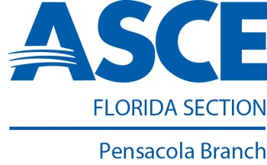

Pensacola Branch
January 2015 Quarterly Report
Branch Updates – October 2014 through December 2014

Pensacola Branch Board Members for 2014-2015
- Heath Jenkins, P.E. – President
- Kelli Rice, P.E. – Vice President
- Lowry Denty, P.E. – Treasurer
- Michael Gund, E.I. – Secretary

October
- ASCE Luncheon: Speaker – Heath Jenkins, P.E., Benefits of ASCE and Building the Pensacola Branch

November
- No Activity

December
- ASCE Toys for Tots Social – O’Riley’s Downtown

Plans for Next Quarter
January
- ASCE Lunch Meeting “Escambia County School District Mentoring” – Speaker: Sally Bogash, Program Coordinator

February
- E-Week at the MESS (Math, Engineering, Science Stuff) Hall – ASCE Sponsor

March
- ASCE Lunch Meeting “Time Management” – Speaker: Alana Turner, Profectus Coaching and Consulting, LLC

