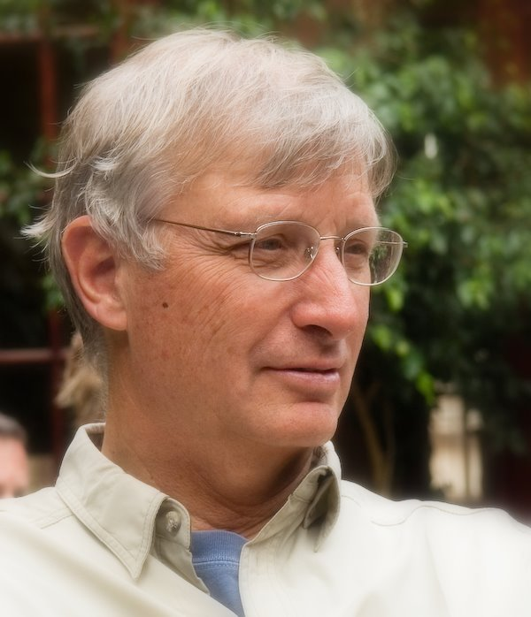
William A. Wallace, F.ASCE, ENV SP
32433 SW Lake Drive, Wilsonville, OR 97070
(970) 819-2188, bill.wallace@wallacefutures.com
William A. (Bill) Wallace is a recognized leader in the field of sustainability, serving on several national and international professional society committees and operating a successful consulting practice. His book, Becoming Part of the Solution: The Engineer’s Guide to Sustainable Development, has been a “best seller” for the American Council of Engineering Companies (ACEC).
Bill is the inventor and lead designer of the Envision® sustainable infrastructure rating system. This system helps project owners and engineers determine the extent to which their infrastructure projects contribute to sustainability. Envision is managed by the Institute for Sustainable Infrastructure (ISI), located in Washington, DC. ISI was founded by the American Society of Civil Engineers, the American Public Works Association and the American Council of Engineering Companies. Also, ISI is partnered with the Zofnass Program for Sustainable Infrastructure at the Harvard University Graduate School of Design. Currently, there are over 5000 ENV SPs in the U.S., Canada and 21 other countries. To date, 23 projects have received Envision awards and more are in the Envision awards pipeline. Also, the City of Los Angeles voted to use Envision as a policy for measuring the sustainability contributions of its infrastructure projects.
For this work, Bill received Engineering News-Record’s 2013 Award of Excellence, and the American Society of Civil Engineers (ASCE) President’s Medal in 2014. He was also nominated by ASCE for the U.S. National Medal for Technology and Innovation.
Bill has over 40 years of professional experience, including 30 years in the field of environmental engineering and management. He spent 21 years at CH2M, holding various senior management positions including a three-year term on the board of directors. Bill directed the firm’s hazardous waste management group and helped it transform into a national leader in hazardous waste site remediation. On multiple occasions, he was invited to give testimony to U.S. Congressional Committees on the use of innovative technologies in hazardous waste site cleanup. At CH2M, Bill started the firm’s sustainable engineering practice, and led its foray into the Olympic Games. CH2M provided environmental and engineering support services to the Olympic cities of Atlanta, Sydney, Salt Lake City, Beijing and London.
Bill is currently an adjunct lecturer for the University of Florida’s distance learning graduate education program (EDGE), teaching “Principles of Green Engineering Design.” In addition, Bill has designed and delivered ASCE’s new 25 module on-line course, “Engineering for a Sustainable Future: Principles and Practices for the Built Environment”. This course is the central part of the ASCE’s Sustainable Infrastructure Education (SIE) program.
Bill chaired ASCE’s first International Conference on Sustainable Infrastructure (ICSI), held in Long Beach, California, November 6-8, 2014. He is also a member of the Conference Advisory Committee for the follow-on Conferences in Shenzhen, China (2016) and New York City (2017).
Bill is currently a member of the Board of GeoEngineers, Inc. In the past, Bill served as a Liaison Delegate to the World Business Council for Sustainable Development, an international organization of over 200 multi-national companies, all with a shared commitment to sustainability. He also served as the President and member the Governing Board of Engineers Without Borders-USA.

