FFA Template
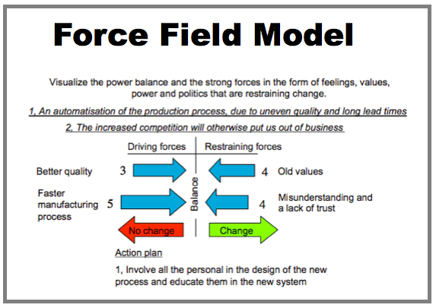
- Model 1 - Force Field Analysis
Create Force Field Analysis examples like this template called Model 1 - Force Field Analysis that you can easily edit and customize in minutes.

https://www.smartdraw.com/force-field-analysis/examples/model-1-force-field-analysis/

