Special Thanks to Our Event Sponsors!
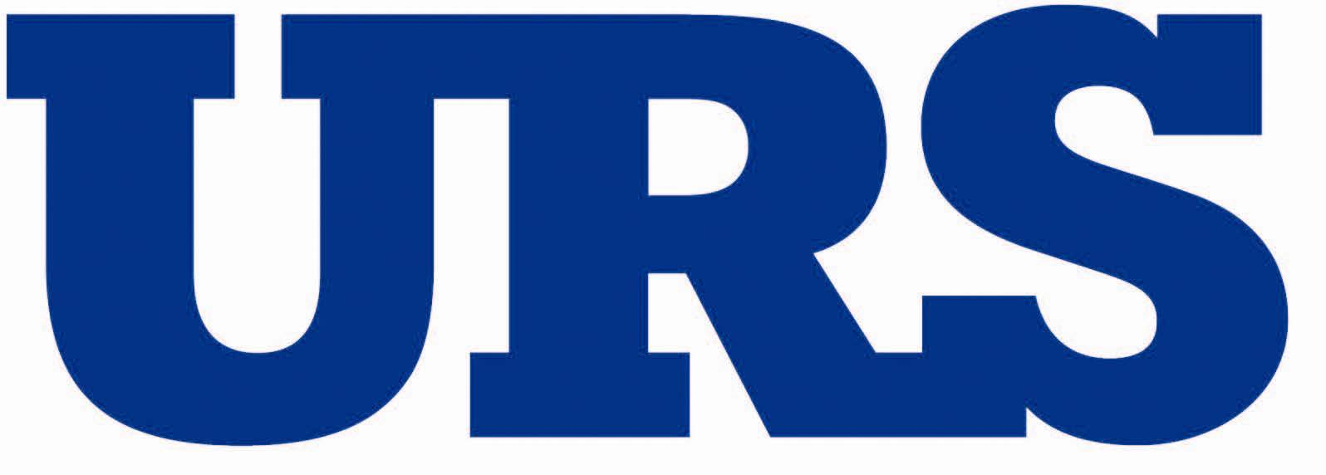

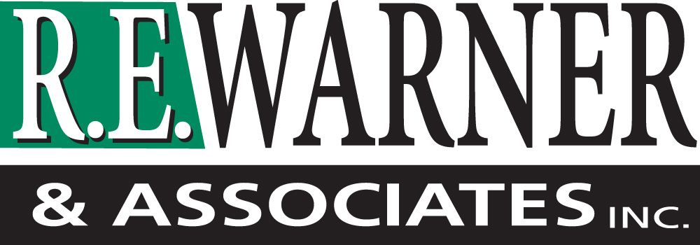

The ASCE Cleveland Section thanks you for supporting the civil engineering profession and attending this event.

For information on future events and how to get involved please visit our website:
sections.asce.org/Cleveland

The 38th Annual G. Brooks Earnest Award and Lecture
Gary Chock, S.E., F.SEI, F.ASCE, D.CE
is the 38th distinguished recipient of the ASCE Cleveland Section’s G. Brooks Earnest Award for his outstanding leadership and inspiration to the profession of civil engineering.

Mr. Chock's lecture is entitled:
The Development of Tsunami Design Provisions for the ASCE 7-2016 Standard

Thursday Evening
October 9, 2014
Hyatt Regency Cleveland at The Arcade
420 Superior Avenue East, Cleveland, Ohio

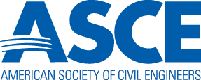

Cleveland Section

Gary Chock, S.E., F.SEI,
F.ASCE, D.CE

Gary Chock has been engaged in structural engineering since 1980 and his work includes the tallest buildings in the State of Hawaii. For the past 20 years, he has also been the principal investigator for the firm’s research work on hazard analysis and planning. His work has involved tsunami and hurricane hazard research, building assessments, hazard mitigation, seismic research, coastal flooding hazards, building codes, and emergency response planning. Mr. Chock performs Blast Effect Analysis and Anti-Terrorism Force Protection for military installations using FOUO methodologies of the US Army Corps of Engineers Protective Design Center. Gary Chock was selected by Engineering News Record as one of the 25 Top Newsmakers of 2011 for his work on developing a national standard for tsunami-resistant design and for leading the ASCE reconnaissance of the March 11, 2011 Tohoku Tsunami. His was the first group from the US to comprehensively survey the tsunami damaged Tohoku coastline of Honshu, Japan.
THE G. BROOKS EARNEST AWARD

This award is given annually to an individual who has made an outstanding contribution to the profession of Civil Engineering.

G. Brooks Earnest was National President of ASCE in 1962 and President of Fenn College from 1952 until the school was sold to the State of Ohio for the formation of Cleveland State University (CSU) in 1964. Then, as consultant to the Cleveland State University Board, he planned facilities for the CSU School of Engineering. The conversion of Fenn College to a state university made higher education affordable to many students in the northeast Ohio area. G. Brook Earnest attended Case Institute of Technology (CIT), worked as a field engineer in the construction of the Terminal Tower complex and many other Cleveland area projects. He joined the faculty of CIT in 1930 and advanced to associate professor in 1942.

This award commemorates the service he has given to the profession and especially his leadership and inspiration in the education of engineers.

THE EVENING’S PROGRAM

5:30 p.m. Registration and Social Hour

6:30 p.m. Opening of the Meeting followed by Dinner

7:00 p.m. 38th annual G. Brooks Earnest Lecture

8:15 p.m. G. Brooks Earnest Award Presentation

CLEVELAND SECTION’S
PAST RECIPIENTS OF THE
G. BROOKS EARNEST AWARD

1977 | Ralph B. Peck | 1997 | John W. Fisher
1978 | Charles E. Spahr | 1998 | Edwin H. Gaylord, Jr.
1979 | Fazlur R. Kahn | 1999 | T.Y. Lin
1980 | Ben C. Gerwick | 2000 | T.H. Wu
1981 | Harold L. Michael | 2001 | Charles Thornton
1982 | T. William Lambe | 2002 | Abba G. Lichtenstein
1983 | Elio D’Appolonia | 2003 | W. Gene Corley
1984 | Omer W. Blodgett | 2004 | Robert M. Koerner
1985 | Walter J. Weber, Jr. | 2005 | Raymond J. Krizek
1986 | Pat Choate | 2006 | Adel Saada
1987 | Milton E. Harr | 2007 | Patricia Galloway
1988 | Gerard F. Fox | 2008 | Robert D. Stevens
1989 | Francis C. Turner | 2009 | Frank Rausche
1990 | George F. Sowers | 2010 | Michael Duncan
1991 | Raymond C. Loehr | 2011 | William P. Henry
1992 | Gerald A. Leonards | 2012 | Henry Petroski
1993 | Kurt Rim | 2013 | H. Kit Miyamoto
1994 | James K. Mitchell | 2014 | Gary Chock
1995 | George Goble | 2015 | Paul Giroux
1996 | Terance Holland

