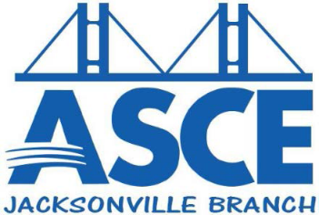

Jacksonville Branch
October 2014 Quarterly Report
Branch Updates – July 2014 through September 2014

Jacksonville Branch Board Members for 2014-2015
- Caitlin Cannon, E.I. – President
- Toan Nguyen, E.I. – Past President
- Danny Waltermyer, P.E. – Vice President
- Shane Whittier, P.E. – Treasurer
- Corey Chascin, E.I. – Secretary
- Kari Bishop, E.I. – UNF Student Chapter Practitioner Advisor

July
- ASCE/EWB Annual Bowling Tournament
  - Raised $1,100 for EWB

August
- 2014-2015 Officer Elections
- Jacksonville Engineering Societies Together (JEST) – Social at Intuition Ale Works

September
- Fall 2014 P.E. Exam Review (through October) with FES
- ASCE/FES Joint Monthly Luncheon – (FES Host): Speaker – Mark Monzo, P.E. on the “Southbank Riverwalk Replacement – Unique Design and Constructability Considerations and Solutions”
- Jacksonville Engineering Societies Together (JEST) – Social at BlackFinn American Grille

Plans for Next Quarter
October
- Peters and Yaffee BPG Food and Scholarship Drive
- ASCE/FES Joint Monthly Luncheon – Speaker: Jim Robinson, P.E., Director of Public Works, City of Jacksonville. Topic: TBD
- Jacksonville Engineering Societies Together (JEST) – Social at World of Beer

November/December
- ASCE/FES Joint Monthly Luncheon – speaker and topic TBD
- Jacksonville Engineering Societies Together (JEST) – Social TBD
- Jacksonville Building Industry Holiday Bash

