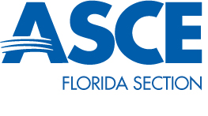
Committee Chair Crystal Markley, P.E.
Florida Section Vice President Rachel Haeseler, P.E.

EWB-USA Committee Report- January 2015

The University of Florida student chapter of EWB-USA was selected as the Premier Student Chapter for the Southeast Region. Premier Chapter awards for professional and student chapters are presented each fall to the finest chapters in each of EWB-USA’s seven regions. They demonstrate excellence in organization, fundraising, public relations, engagement in mentor/mentee relationships and chapter and regional participation. Congratulations to the University of Florida student chapter!!!
The EWB-USA National conference was held in Reston, VA October 31 to November 2. This conference focuses on mission centered training and collaboration related to executing sustainable community driven development projects worldwide. http://ewbusaconference.org/
GeoEngineers Principal Geologist David Cook was named president-elect of the EWB-USA board of directors at the board meeting in Panama City, Panama in October. David will be the first board president who is a board member and also a dedicated volunteer and mentor.
If you know people who would be interested in serving on this committee, please contact Crystal Markley @ cam@crystalmarkley.com or 904.463.4573.

