Friday, July 3, 2020
“No, that’s not what I meant.”

- What is abstraction in communication?

Abstractions are ideas that are not described in specifics. They cannot be physically sensed (seen, heard, felt, touched, or smelled). Abstraction lacks representational qualities. Abstract descriptions are in contrast to concrete descriptions.

- What is the ladder of inference?
The Ladder of Inference describes the thinking process that we go through, usually without realizing it, to get from a fact to a decision or action. The thinking stages can be seen as rungs on a ladder and are shown in figure 1.

- The Ladder of Inference

How to Avoid Jumping to Conclusions

. . . .. .. . More ---

Figure 1: The Ladder of Inference
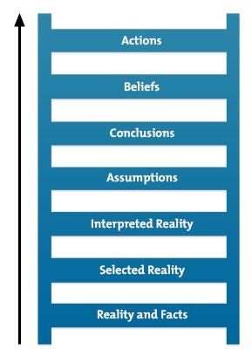
From Argyris, C., 'Overcoming Organizational Defenses: Facilitating Organizational Learning,' 1st Edition, © 1990. Printed electronically and reproduced by permission of Pearson Education, Inc., Upper Saddle River, New Jersey. and Sons, Inc.

“Anything worth doing is worth doing until you get it right!

N.B. If you embrace the above challenge, you will learn at the least,
three things:
- People don’t fail, their experiments do.
- I made a mistake and will ask now for the advice of others.
- Once I learn the lesson(s) waiting to be learned, I will go forward
doing the RTRFT.

- https://www.mindtools.com/pages/article/newTMC_91.htm downloaded 03JUL2020
Right Things Right the First Time.

