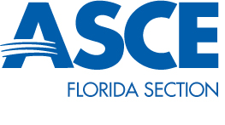
Committee Chair Robert Best / West Point Bridge Competition
Florida Section Vice President Rachel Haeseler

West Point Bridge Competition Quarterly Report

The 2015 Local Branch competition will be kicking off this month.
- Branch Presidents will be asked to forward me their WPBC Chairs’ contact information by Friday, January 16, 2015.
- The kickoff teleconference will be held on Friday, January 23, 2015. The National Competition’s registration starts Monday, January 12, 2015 and their Qualifying Round will run from January 13, 2015 to April 24, 2015. This will allow for the students represented by each Branch to both qualify for the Section’s competition and the National competition.
- The National Final Round will be July 10, 2015 to July 12, 2015 with a top prize of $5,000 top prize (Semi-Final Round is May 15, 2015). The Section Competition will be July 17, 2015.

For next quarter, the committee will be assisting those Branches with the Local competitions as needed.

