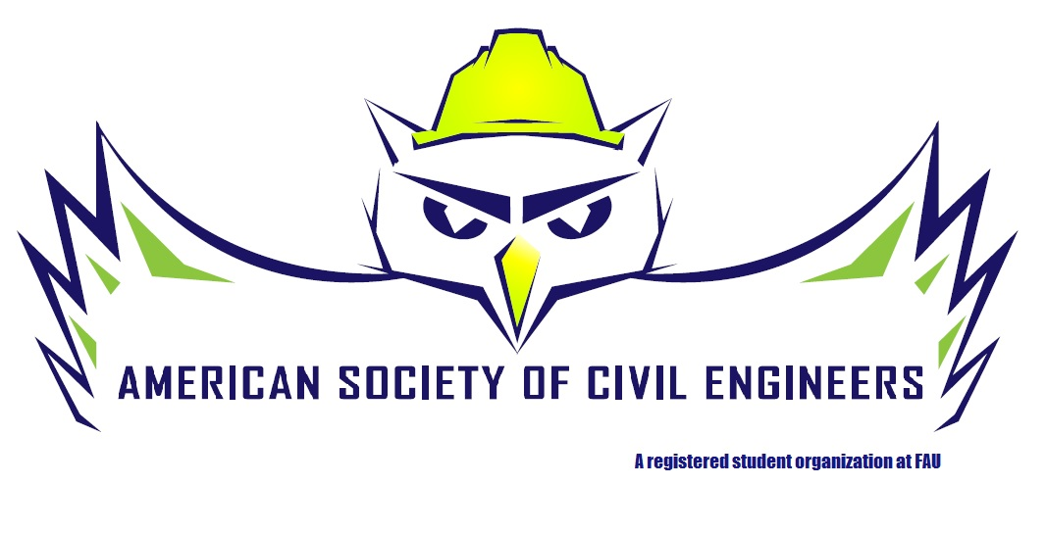

Quarterly Report: September 2014- December 2014
American Society of Civil Engineers
Florida Atlantic University Chapter
Prepared by: Daniela Alvarez, President

During the 2014 fall semester, our chapter has focused on the recruitment of new members and fundraising opportunities. Classroom visits were scheduled, where board representatives informed incoming freshman and other underclassmen of the benefits of joining the society. E-board meetings were held bimonthly to discuss other recruitment methods, as well as fundraising ideas and planning for the upcoming regional conference.
On October 23rd, we were pleased to host Infrastructure Night. This event provided an opportunity for the student to network with professionals from a number of companies including Stantec, Kimley-Horn, Parsons, Wantman Group, etc. They were also able to attend a presentation by FDOT secretary Ananth Prasad, where he discussed the growing demand for civil engineers in the field of transportation. The chapter was also able to host an interview session with Kimley –Horn in November 12 and 13. On the first day, Robbie Stansifer along with some of our alumni that are currently employed at Kimley-Horn were able to talk about the benefits of the company as well as the type of projects they specialize in. They also held a “Q&A” session where the students were able to ask questions regarding the interviewing process and the kind of qualities recruiters seek for in candidates. The following day, Mr. Stansifer held a series of personalized interviews for ASCE members. We were also able to host four general meetings where we began to introduce the new competitions taking place at the regional conference with the student body. Captains were elected and teams were formed. The chapter was also able to attend Sherwin Williams’ “More Than Paint Event” on December 10th at the Hard Rock Hotel. The event included a meet and greet as well as presentation by Rick Edelson, Chair of the ICRI 150 committee, titled “Introduction to the new ACI 562 Code for Evaluation, Repair and Rehabilitation of Concrete”. Mr. Edelson was able to provide insight on the new code and its affects and applications concerning in building restoration.
For this coming quarter, our goal is to prepare our chapter for the regional conference. This includes working on the competitions as well as creating fundraising opportunities in order to achieve our financial goal necessary to attend the conference. Both our Steel Bridge and Concrete Canoe captains are working hard and have been successful in obtaining sponsorships. A new policy was also implemented which requires all members attending the conference to perform 10 hours of community service in hopes to promote involvement in the community. The E-board has been working on contacting organizations in the area such as Habitat for Humanity, and the Lord’s Place to facilitate some of these opportunities. Moreover, a student chapter career-coaching event is in the works for the second week of January, by Aerotek. This event is projected to provide resume reviews, mock interviews/interview advice, and general career advice for Civil Engineers entering the job market.

