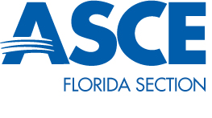
Student Chapter President Joey Hereau

Quarterly Report January 2015

The Florida Institute of Technology’s ASCE student chapter has continued to progress since the last quarter. In the past semester, the student chapter has increased membership, arranged several social events, and has been working closely with other student engineering organizations to further the engineering profession and raise interest in civil engineering specifically. We have held several open canoe paddling event, co-hosted a Habitat for Humanity seminar, had members attended a Habitat for Humanity build, and networked with the ASCE Cape Canaveral branch by attending their Mini-golf tournament and beach social. Our student chapter is also currently making arrangements with the Florida Institute of Technology’s Engineering Council to approve an ASCE booth and event during the 2015 Engineering Week at Florida Tech. We are also continuing to prepare for the 2015 ASCE student conference. All of these activities have moved us closer to our 2014–2015 goals of increasing membership, raising on-campus chapter activity, and accumulating more chapter community service hours.

