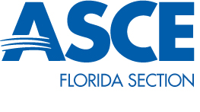
Committee Chair – Steven Goldstein
Florida Section President – Adnan Javed

Constitution & Bylaws Committee - Quarterly Report – Fall 2014

The Florida Section Operating Manual has undergone multiple revisions over the past several years, most recently in April 2014. As a result, the Committee is not aware of any pending revisions to the Section’s Constitution, Bylaws or Operating Manual.

Upon notification by the President that modifications to the Section’s governing documents have been proposed, the Committee will mobilize to produce draft documents for consideration by the Board.

