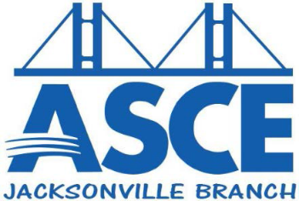

Jacksonville Branch
January 2015 Quarterly Report
Branch Updates – October 2014 through December 2014

Jacksonville Branch Board Members for 2014-2015
- Caitlin Cannon, E.I. – President
- Toan Nguyen, E.I. – Past President
- Danny Waltermyer, P.E. – Vice President
- Shane Whittier, P.E. – Treasurer
- Corey Chascin, E.I. – Secretary
- Kari Bishop, E.I. – UNF Student Chapter Practitioner Advisor

October
- ASCE/FES Joint Monthly Luncheon (ASCE Host): Speaker – Jim Robinson, P.E., Director of Public Works, City of Jacksonville.
- Peters & Yaffee – Build, Putt, Give sponsor

November
- ASCE/FES Joint Monthly Luncheon – (FES Host): Speaker – Chris Peterson, Vice-President and Managing Director, Titan Salvage. Topic – Raising of the Costa Concordia.
- Wine for Water sponsor

December
- ASCE/FES Joint Monthly Luncheon – (ASCE Host): Speaker – Don Robertson, P.E., President, Applied Foundation Testing, Inc. Topic – Statnamic Bridge Load Testing.
- Jacksonville Holiday Bash – Rock Your Ugly Sweater – raising money for Unity Plaza

Plans for Next Quarter
January
- FES Race for Relevance Sponsor
- ASCE/FES Joint Monthly Luncheon (FES Host) – Speaker: TBD. Topic: TBD
- Jacksonville Engineering Societies Together (JEST) – Social TBD

February
- Hosting E-Week Kick-Off Luncheon and Awards Ceremony
- North Florida E-Week 2/12- 2/21
- Jacksonville Engineering Societies Together (JEST) – Social TBD

March
- ASCE/FES Joint Monthly Luncheon (FES Host) – Speaker: TBD. Topic: TBD
- Jacksonville Engineering Societies Together (JEST) – Social TBD
- West Point Bridge High School Competition Starts

