Quarterly Report Photos (October 2014 – January 2015)
Prepared for: Prepared by:
ASCE Florida Section Board of Directors Meeting Chapter Secretary, Caitlin McHale
January 10, 2014 Chapter President, Franki Vallejo

Florida Section Student District Representative: Shawn Brown

Events Photos
________________________________________________________________________________________________________
I-275 widening project Skanska/AJAX
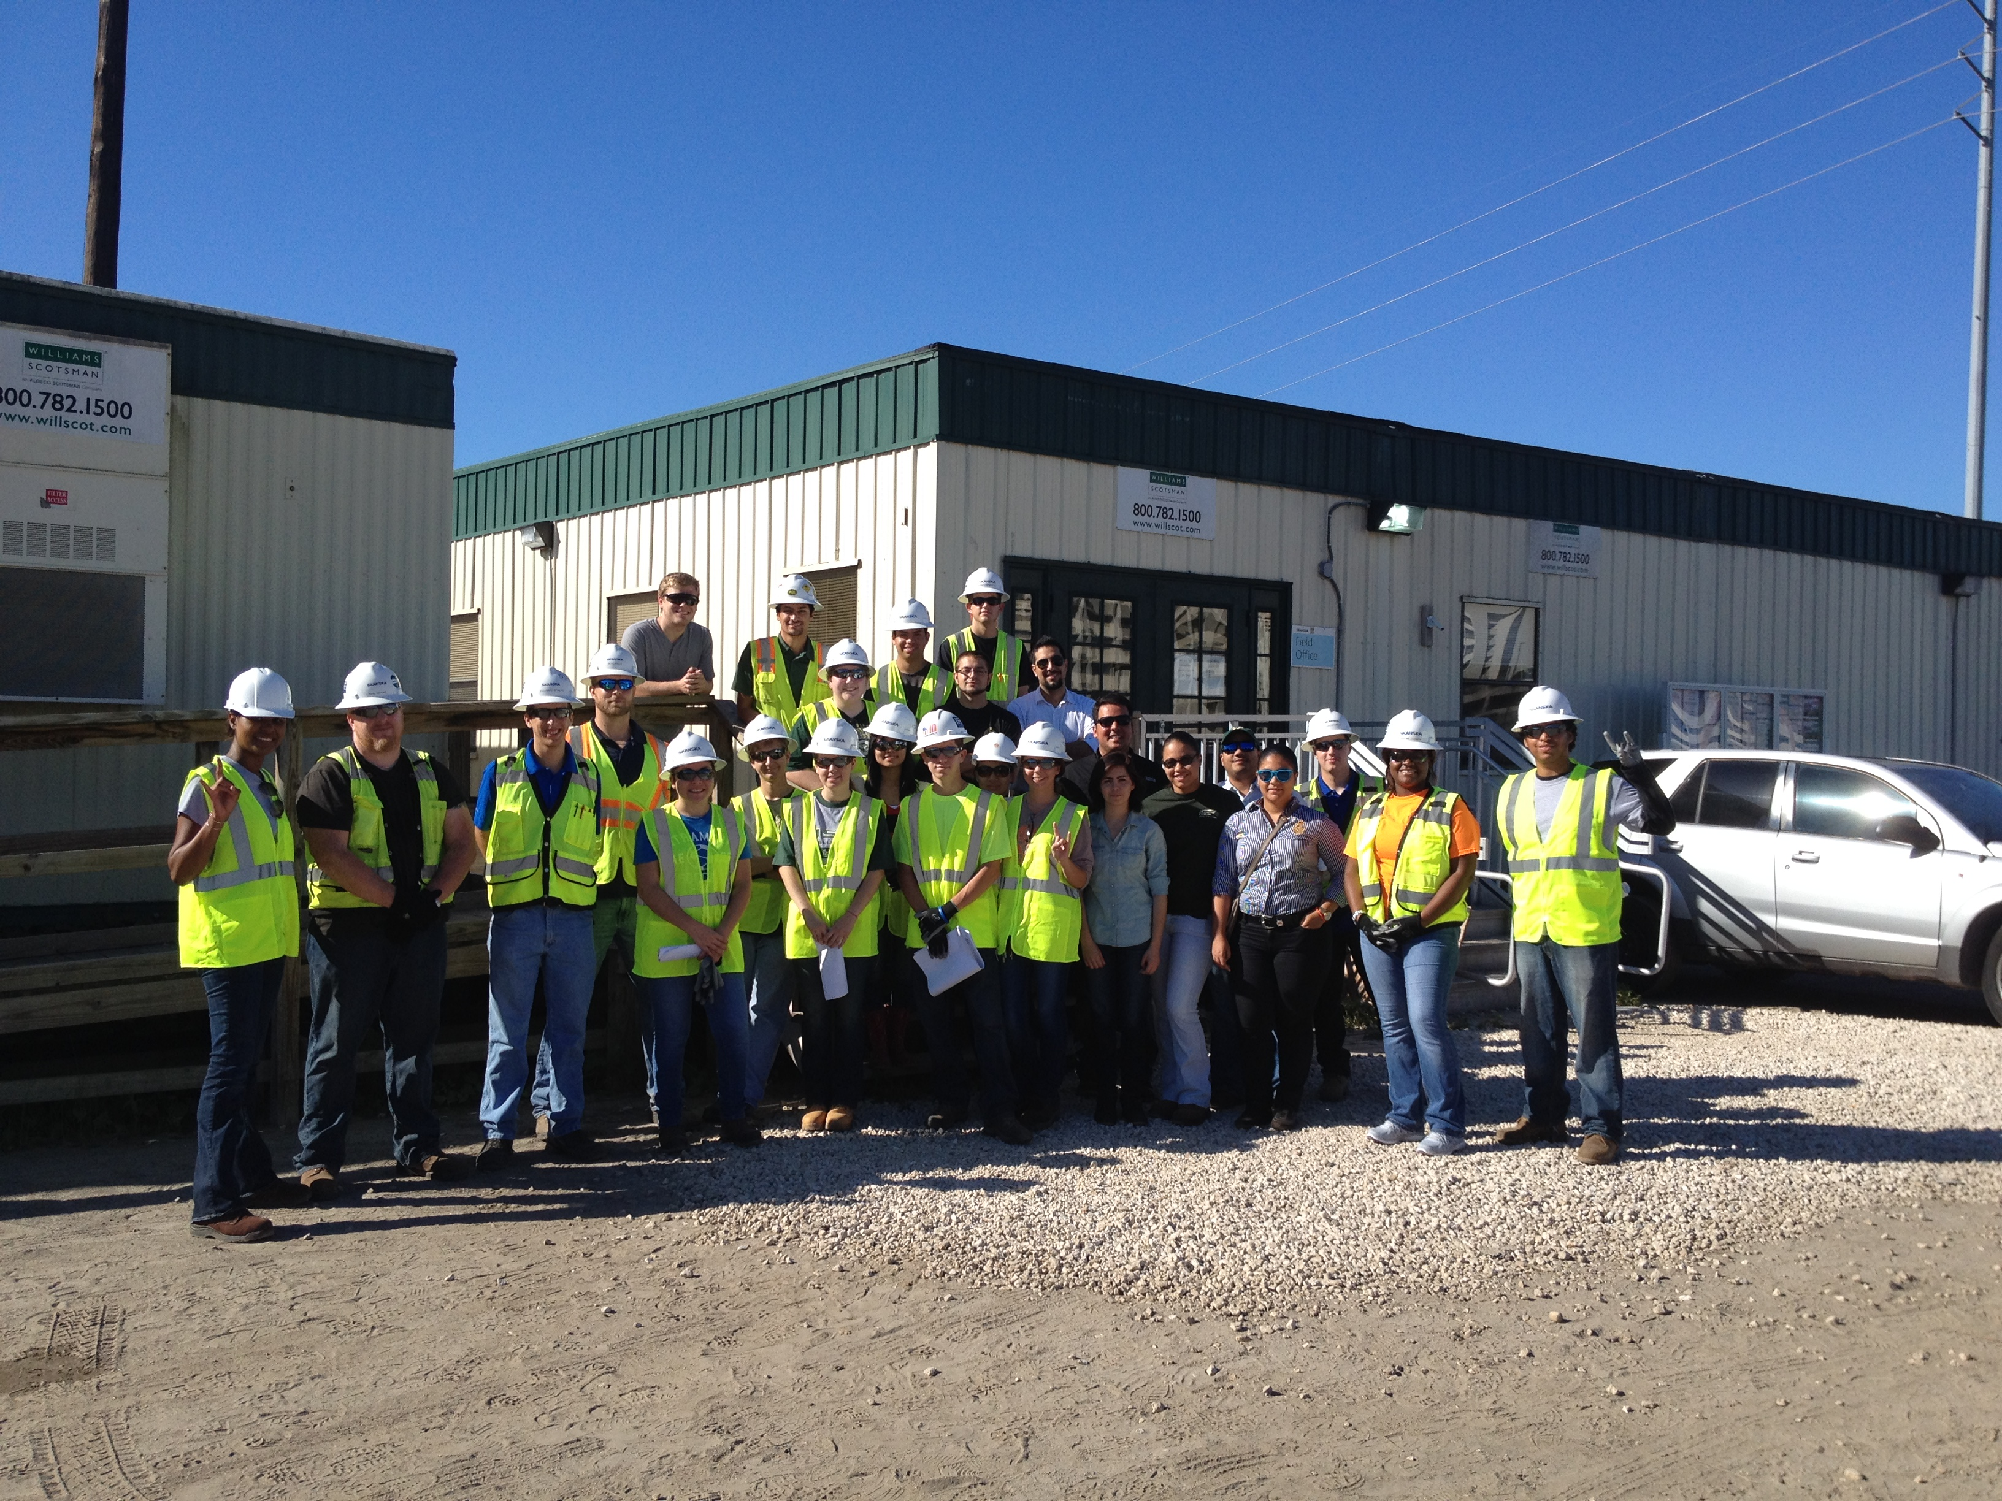

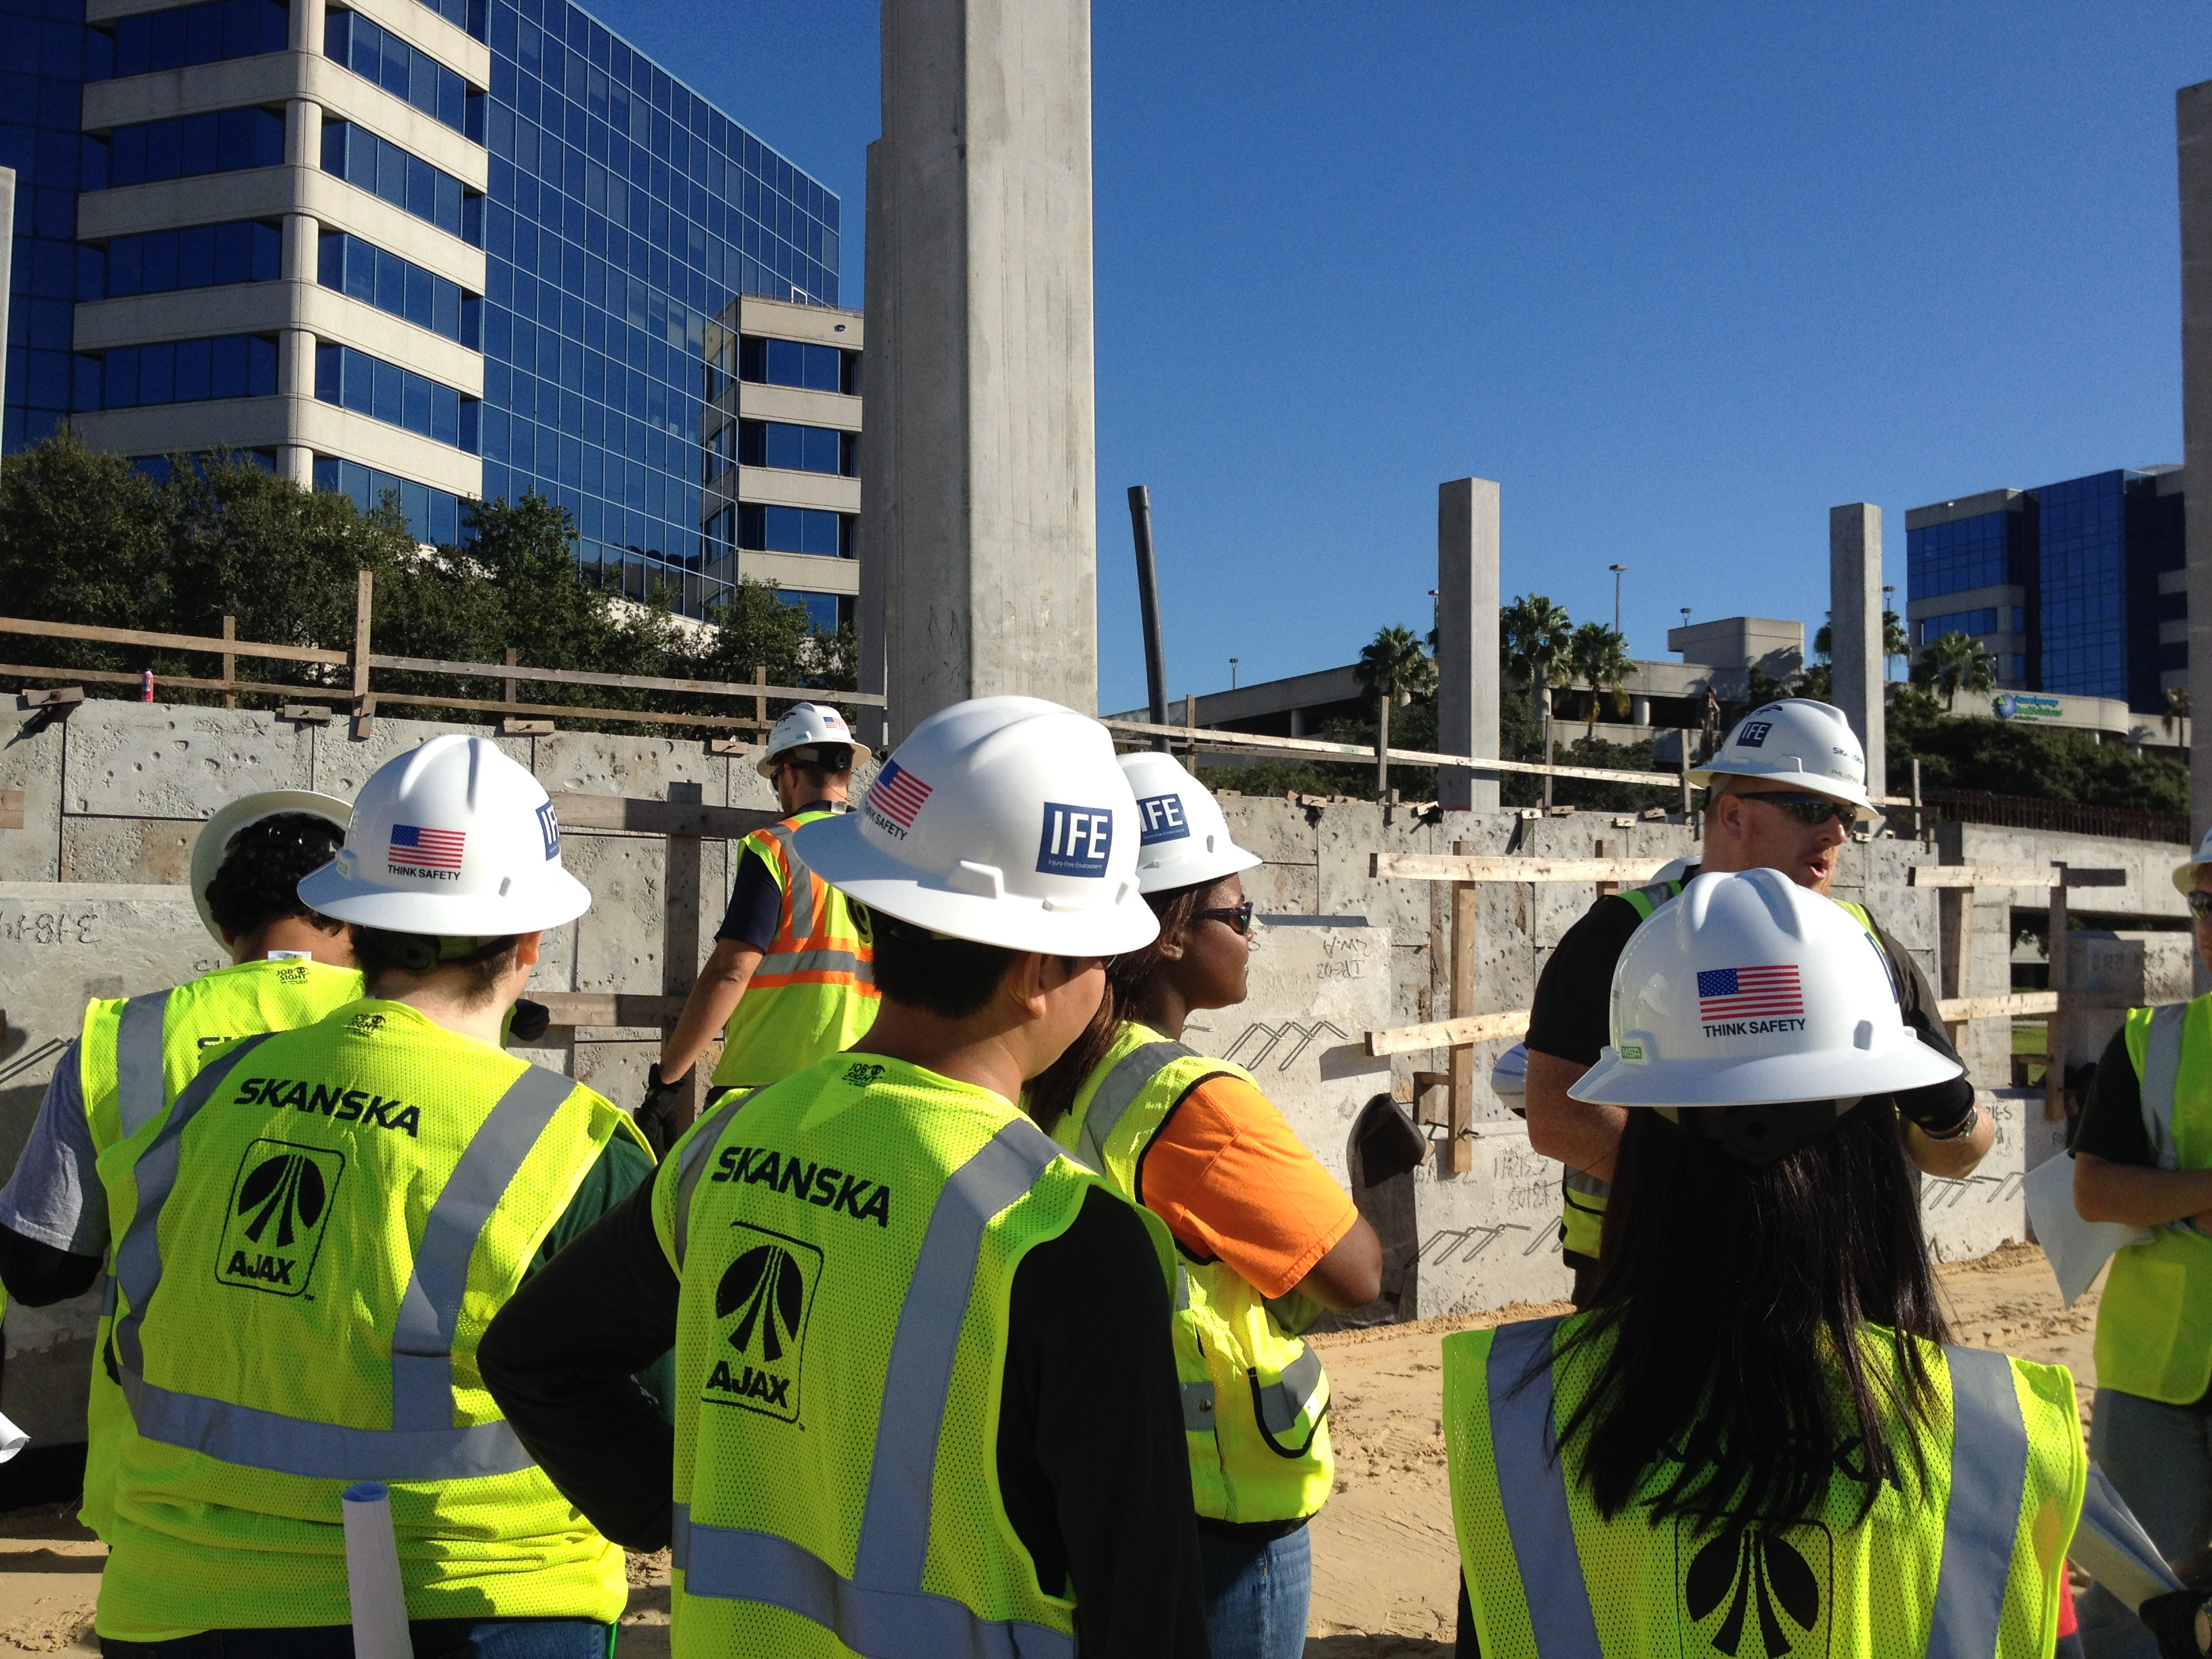

Shop Safety Walkthrough
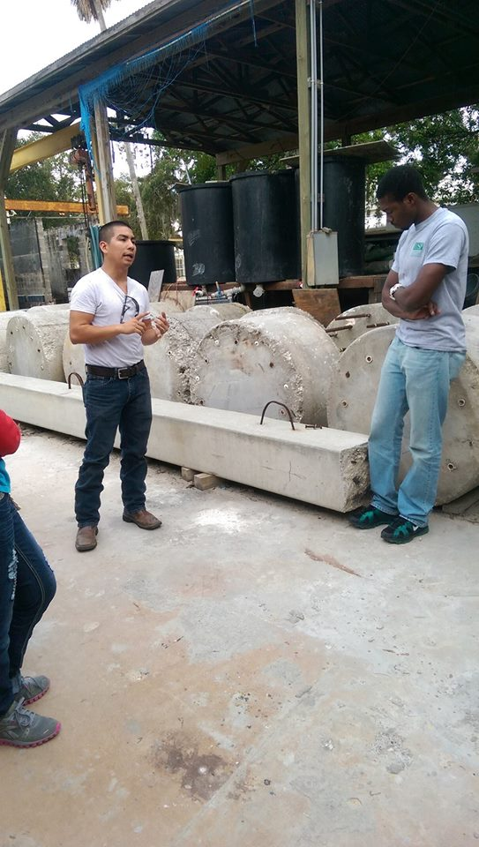

Student Chapter Social – Family and Friends BBQ
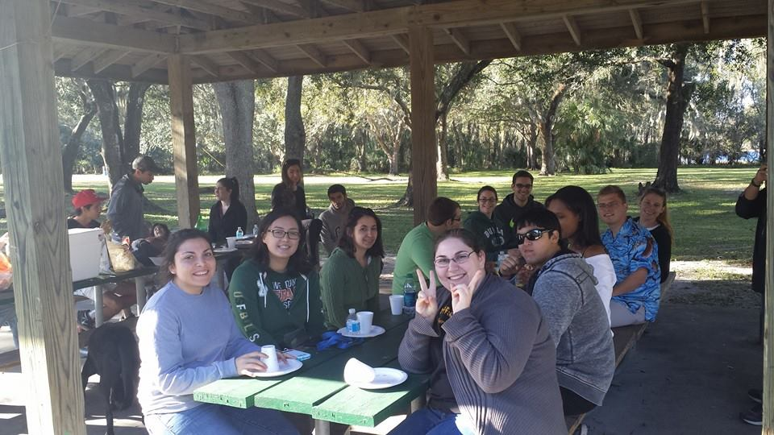

Wissa Lecture

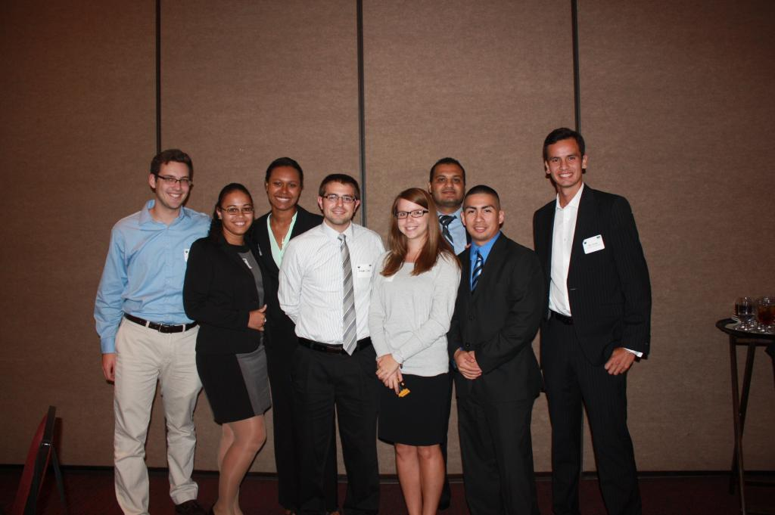
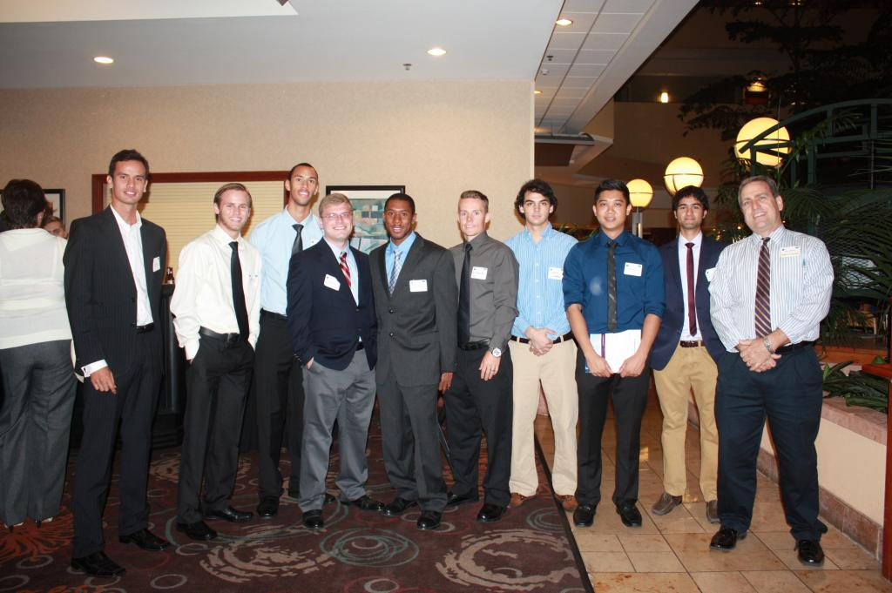

ASCE Aramark Concessions

