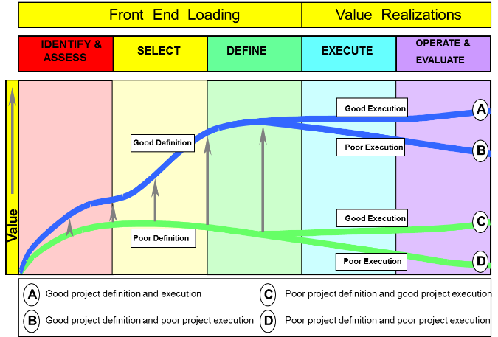

Source: https://www.triple-eee.com/index.php/cms_categorie/74836/content/categorie/id/74836/CurrentLanguage/3

