Q. HOW DO YOU KNOW IF YOU'VE MADE A GOOD DECISION?

Thanks Mitch for the “Head Scratcher!” challenge!
First, I suggest we lose the word “Good.”
Next, as I understand the application for this decision is in a somewhat uncommon, less anticipated situation, it suggests going forward with “Baby Steps” and lose any “Just do it!” mentality.
Seems like a valid approach to begin to better understand what this known-unknown is about would suggest use of the Deming Plan->Do->Study-> Act approach with the initial pilot.
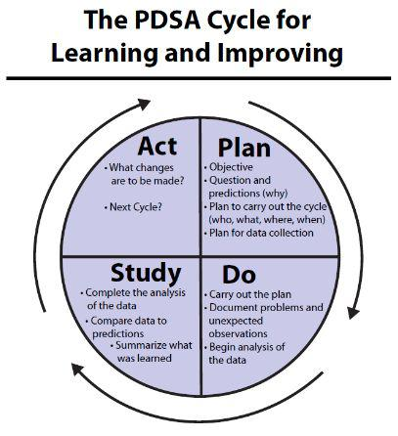

As the study group’s level of understanding increases, the boundaries for the PDSA application increase.
Stay Healthy1
Cheers,
Bill
p.s. The decision group’s usual people-challenge when working incrementally are the “I get it now, let’s just do it!”

