YouTube Live & MS Teams

Software/Accounts Needed:
- OBS Studio Encoder Software 64 bit (free)
- YouTube Account

Definitions:
- Scene: A screen set up for what your viewers will be seeing. Can be an image, a teams meeting, music, or much more.
- Stream Key: This is a unique code for each YouTube live that will connect your encoder to that specific YouTube live event.
- Unlisted Stream: This YouTube live event will only be available via a link. No link, no watching.
- Private Stream: Nobody but you can see this stream.
- Public Stream: This YouTube live event will be available on your channel, and by a link you can share.
- OBS Program vs Preview view (within Studio Mode): The “program” side is what your viewers are currently seeing. “preview” is the on deck side, so you can prepare what you want your viewers to see next.

OBS Set Up
- Download OBS Studios.
- Within OBS, create your “Scene”. Make an “intro scene” and a “teams scene”
  - Click the “+” Button to add a new scene.
  - Add a name for the scene
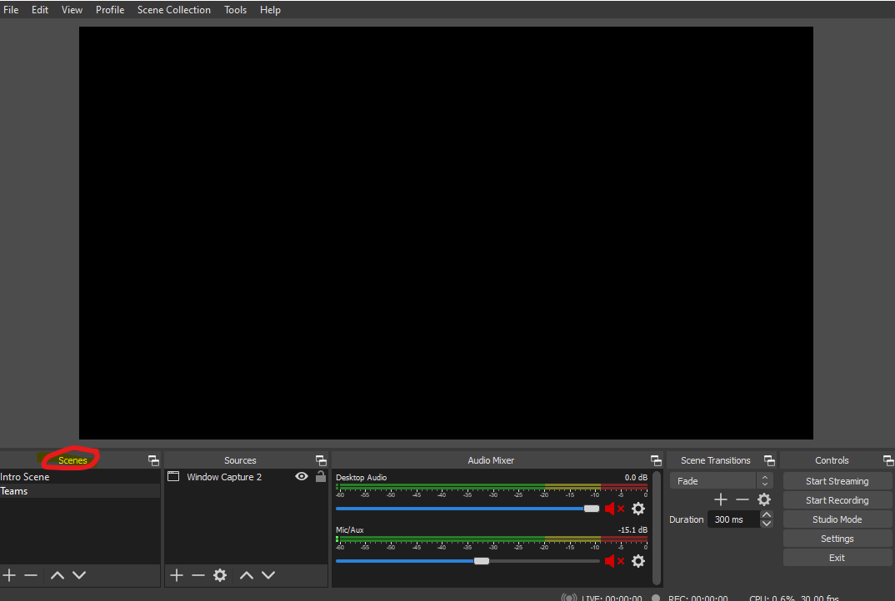
- Add a Source to your Scenes.
  - For the intro scene:
    - Make an image (I use Canva), that you want your viewers to see before you go live.
    - Click the “+” button within the sources box. Select “Image” and then pick the image you’d like to use on the screen. (Had trouble naming before going to the browse select feature. I was a little confused.)
    - Resize the image on the box to fit the whole screen.
    - If you want music(this is just extra):
      - Click on the “+” within the source box, and pick VLC player.
      - Then, select the music from your computer.
      - Click apply
      - Note: You may play music from a browser window and use the “desktop audio” instead of downloaded music, but ANY audio that comes out of your speakers will also get transmitted, so if you are on the call that is going to get broadcasted, that audio will also play. It is easier and more straightforward to just download the music and add it via VLC.
  - For the “teams” scene
    - Click the “+” button within the sources box. Select “window capture” ->”Create new”->OK.
    - On the “window” drop down, select the “teams” window you would like to use. (Now that teams is putting calls outside of the main teams window, you may have to adjust this selection to the call window before going live) (I’m just seeing one Teams link. It shows the entire Teams window.) We should look into how this works so just a specific call can display without the whole desktop.
    - Press OK
    - The window will grab whatever size the window is on your screen, so make sure your teams is full screen and not minimized.
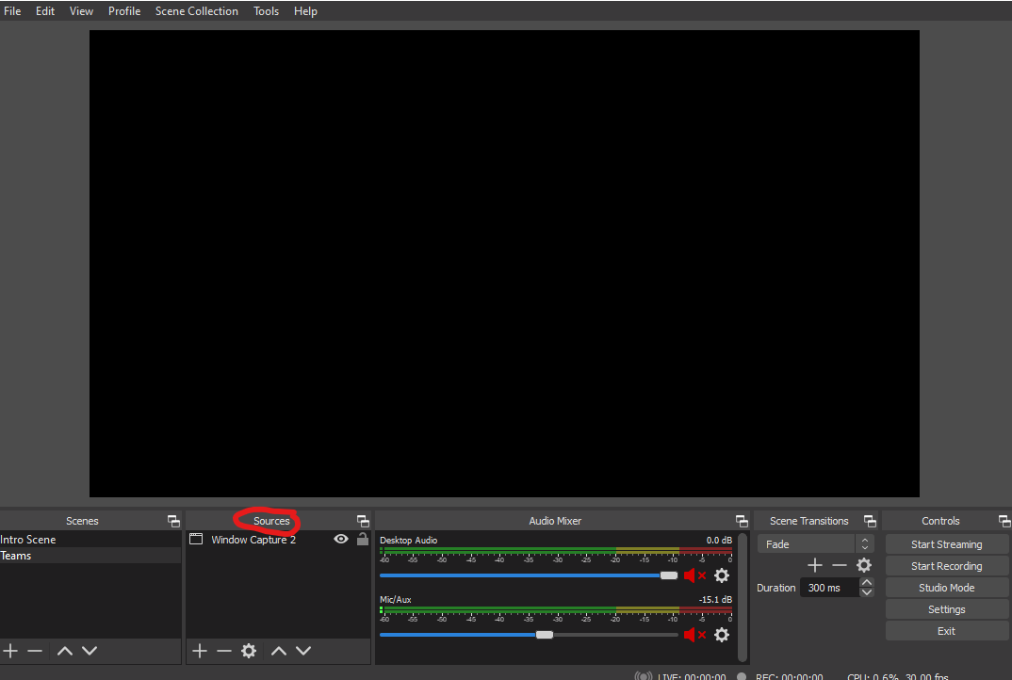

YouTube Set up
- Log in to your YouTube Account.
- Click on the camera create button at the top and select “go live”
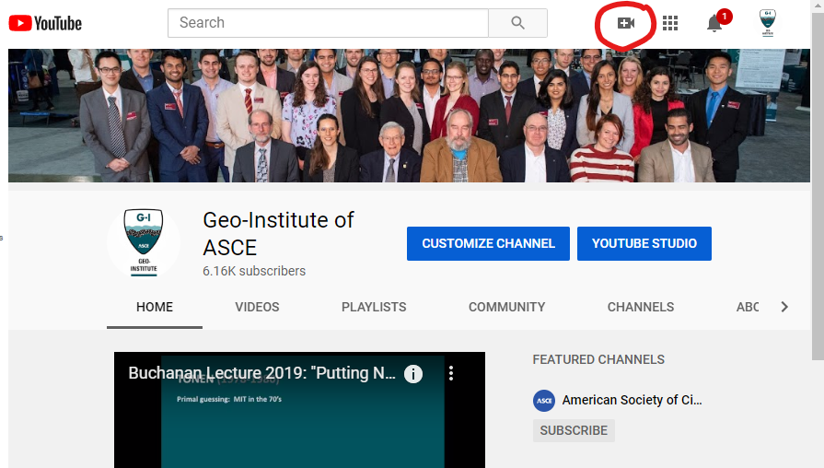
- From YouTube studio, you can either stream right now, or schedule a YouTube Live event in the future.

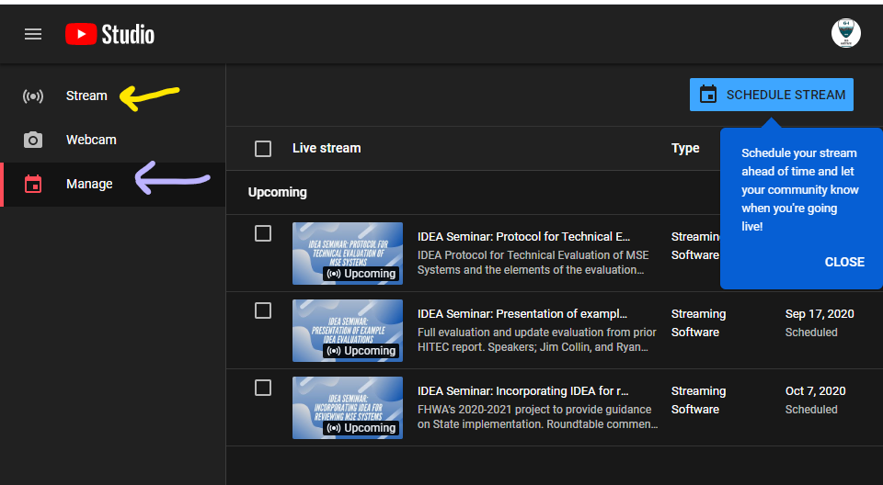
  - To go live now:
    - Click “Stream” on the menu on the left of the screen.
    - Add in any information you would like: title, description, thumbnail image. Make sure that your visibility (unlisted, public, private) is correct for your event.
    - Click “save”.
    - Follow the “go Live” instructions further down on this sheet.
  - To Schedule a live:
    - Select “manage” on the left hand menu
    - Click “Schedule stream” and fill out all fields.
    - Before you go live, follow the “go Live” instructions further down on this sheet.
- If you want to share the link before you go live, click on the live you wish to share, and then click this button to get the link:
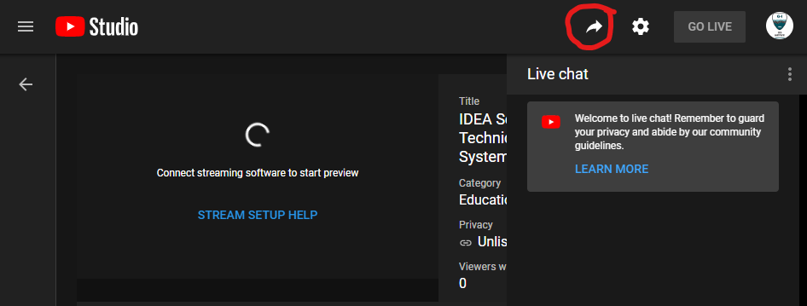

Going Live
NOTE: When you go live it is best to make sure ALL other applications other than teams, your browser with YouTube and OBS are CLOSED. It is also best to make sure that you, and all people on your teams call have a hardwired internet connection to ensure that there will be no internet issues during the live. (But especially the person with OBS and that is controlling the live, if their internet goes out, the whole thing goes down)
- Copy the “stream key” within your “stream settings” within YouTube live event (Note: there is a different stream key for every single event, so you must do this step every time you want to go live)
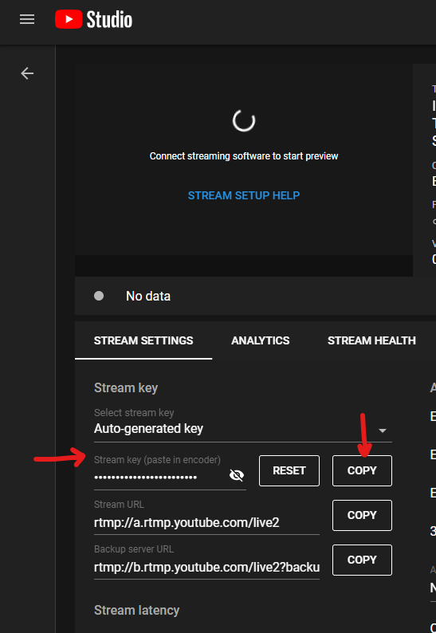
- Go to OBS Studio and select “settings” -> ”stream”
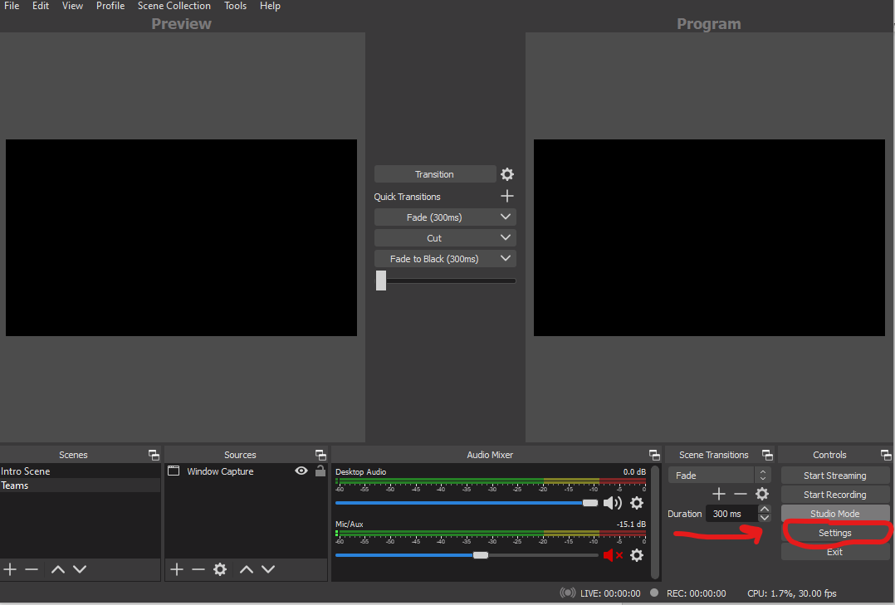
- Paste stream key into the stream key box and select apply and then OK. This means that OBS is now able to stream into your YouTube live event. (What server do I select?) You might want to clarify YouTube. I figured it out (as I should have). But still confused me for a minute.
- Change OBS into “Studio Mode” so the screen looks like this:
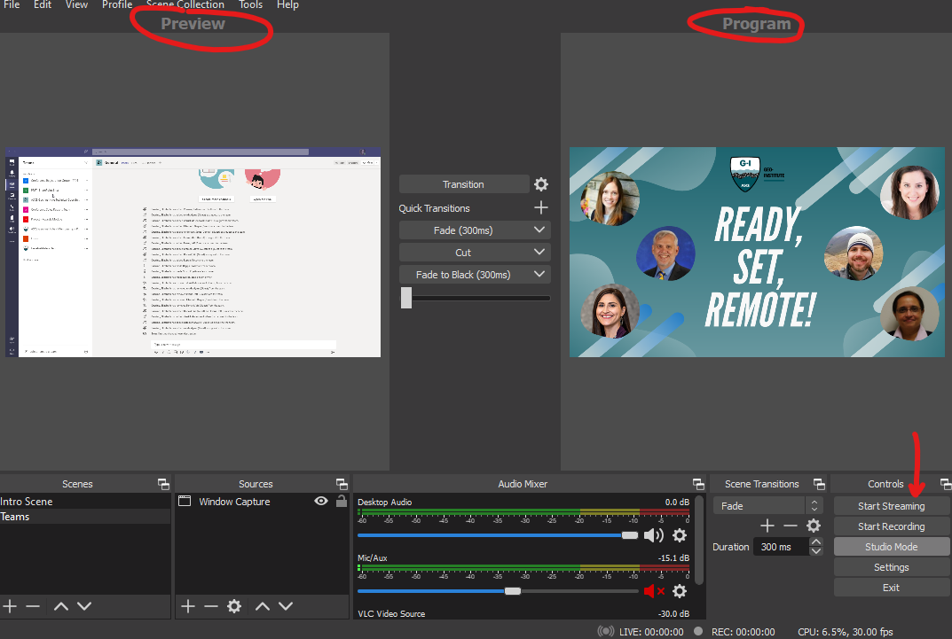
- Select your “intro screen” from the “Screens” box so it is showing on the “preview” side of the studio, and then select “transition” to make sure the intro screen is showing on the “program side. Then, select the teams scene so it’s showing in your preview.
- If you have music you’d like to play when you go live with your intro screen, make SURE your VLC video source in the audio mixer is unmuted, and “desktop audio” and “mic/aux” are muted. (Note: You may be tempted to mute OBS within your computer audio mixer so you don’t have to hear the music play- DON’T do this, because when you mute OBS the sound from it gets muted as it goes to YouTube, so you will have no sound on your YouTube live. Keep OBS unmuted.)
- Select “start streaming” within OBS studios. This is now broadcasting your “program” screen into YouTube. This DOES NOT mean you are live on YouTube yet.
- Go to the YouTube Studio where your live settings are, and make sure that your streaming software connected, and you are seeing your “program” screen on the preview. Check your stream health to make sure that your internet connection and everything is good.
- When you are ready, hit the “GO LIVE” button on the YouTube screen, and you’re live! I never selected this option but it looked like I started going live.
- When you are ready to have your teams meeting go live, go to OBS, and select “Transition”. This will switch your “preview” to your “program” screen. When you select this, unmute the “desktop audio” and mute “VLC Video source”
- You’re live! Good job!
- When you’re done, end the live from you YouTube browser first, and then select stop streaming within OBS. This will now be recorded as a regular YouTube Video.
The window I shared was still black even though I was in the Teams meeting. Not sure what I was doing wrong.

General Suggestions & Notes:
- The person doing the YouTube live should be doing nothing else on their computer. This is not only to devote the CPU to the program, but because the mouse will show up on the screen that goes live. If you are moving your mouse all around the screen everyone will see it.
- It’s a good idea to have someone moderating the YouTube live chat while going live. Say hello, encourage questions and comments. (again, it can’t be the person orchestrating the live due to the mouse) The moderator can also take questions to the people presenting. It’s easiest for meeting participants to look at only the chat in teams rather than looking at the youtube chat, so the moderator can take questions from YouTube and put them in the teams chat.
- You can easily test this by getting on a call with someone and going live on a private stream, or just on an unlisted stream. Nobody will know and it’ll make you feel better about it
- OBS can be touchy, if something is going wrong or looks strange, just restart the program. It usually will fix itself.
- There is about a 1 minute or less lag on the live. This was never enough for an issue to arise, but it is good to be aware of it.
- For the “thumbnail image” I normally use the same image I use for the “intro screen”

