“Silent” Project Start-up Questions.
“To understand how to improve you’ve got to know where you’re failing first.”
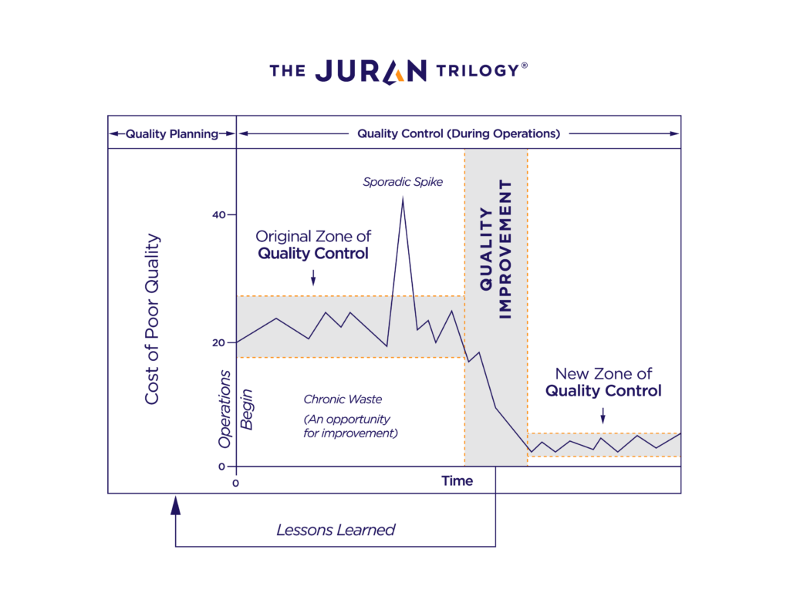
First consider project behaviors common to far too many projects that result in
unacceptable outcomes . . for your clients, your project staff, and your firm.
As the above graphic of the Juran Trilogy illustrates, the road to improvement starts with first bringing your current practices under control, i.e. Quality Planning.
What follows is Quality Control.
Once in place, one can then move into Quality Improvement.
Note the graph illustrates the value-added by bringing knowledge of specific lessons-learned back to the front of the process to be applied to your next project.
Now so far, I do not think for a moment that you consider these notes “News!”
And yet despite the profession’s knowledge of such, we still have far too many projects budgeted with 15 to 30% profit realizing 2 to 5 % at project completion.
To understand how to improve
you’ve got to know where you’re failing first.

Those project phase failure-zones that appear to be “Common” are:
- Project Proposal Language.
- Negotiation Balanced Tradeoffs.
- Contract Language Specifications
- Project Startup Meeting.
In my opinion, the very last opportunity to frame the success of your project is in the phase “Project Startup Meeting.”
Your Reality Check Dialogue For Assurance of Success at Your Project Startup Session:
- Why is this project important for our client? For our Client’s Client?
For our firm’s portfolio?
- What Phase-Gate reviews are scheduled now?
- When and how will the members of this project’s technical staff meet to clarify, confirm, and coordinate their individual and group work packages?
- How many hours per week, on average, does this role require?
- How does the team communicate? How often?
- How is information shared among team members?
- Who will my other teammates be?
- How will this project be queued within other projects?
- What routine communication schedule and form does our client wish?
And for each question above, as well as others that will surface,
faithfully apply the HDYK (How Do You Know) litmus test.
Challenge those who answer “Great question, just get out there and start, I’ll get back to you later.”
Respond to them with “Great! How much of our firm’s resources and reputation will be at risk until you provide the HDYK validation?
- Epilogue
If the above process occurs collaboratively within the first 3 to 5% of the project's schedule, the “Cost” will be almost inconsequential when compared to what your experiences are when such information is not addressed and communicated.

Stay Healthy!

Cheers,

Bill
p.s. Consider engaging a facilitator to run the first 5 to 7 Project Startup Meetings.

https://www.juran.com/approach/

