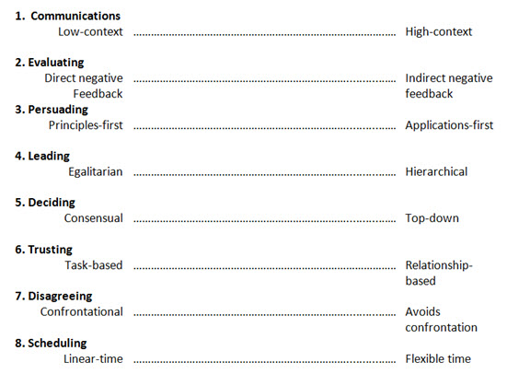

<>===================================<>

THE CULTURE MAP: Breaking Through the Invisible Boundaries of Global Business

https://www.preferrednet.net/media/1284971/know-your-culture-map-kimberly-blanchard.pdf 14APR2020

