State of Wisconsin Publishes Clean Energy Plan
(Opinion by Public Affairs Chairman, Gregory Schroeder, P.E, M. ASCE)
On August 19, 2019, Governor Tony Evers signed executive order #38 creating the Governor’s Office of Sustainability and Clean Energy. I don’t think this was particularly prescient, because energy was already a longtime hot issue, but benefits are now coming to light. The Office has just published its first report, the state of Wisconsin Clean Energy Plan. The executive order and the CEP have goals of reducing GHG emissions, reducing the $15 billion dollars Wisconsin pays to other states for fossil fuel each year, and growing renewable energy jobs here in the state.
Recent events on the world stage have lifted the importance of executive order #38. Putin’s invasion of Ukraine has caught Europe flat-footed and in urgent need of energy not from Russia. Fossil fuels as well as renewables are needed, and worldwide prices have risen dramatically. Inflation has risen for reasons related to covid, supply chains, labor shortages, and energy costs. Wisconsin needs to control energy costs and transition at the same time to a low carbon future.
My initial thoughts on the invasion of Ukraine were that we Americans could significantly and urgently conserve energy, which would help to control prices, allow more energy to support the Europeans, and result in less money going to Russia to support their war. Much to my chagrin, multiple sources told me emphatically that too few of us would sacrifice our individual use of energy even for such a worthy effect.
The Clean Energy Plan gives an important overview of energy and GHG emissions in Wisconsin. This report will be an important resource for the ASCE Wisconsin Section for the next infrastructure report card for the state because of the information it contains and the more holistic view of energy which balances transportation, agriculture, and other energy uses with the largest use, power generation.
The report includes two versions of transitioning from fossil fuels. One emphasizes solar and the other wind. If either version has potential, we have a lot of work to do. One key will be to bring on new-generation nuclear, and we are far from a consensus and commitment on this. Other important growth areas to meet the goals will include energy storage, carbon capture, and conservation.
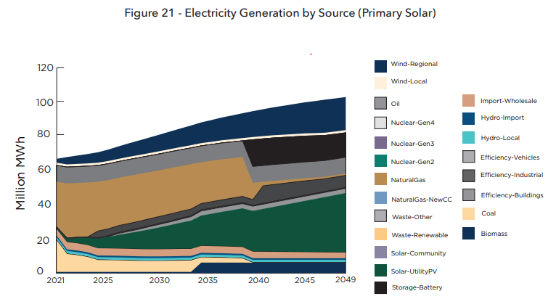
Source: State of Wisconsin Clean Energy Plan 2022
In the specific area of residential and industrial building energy, the report’s projections show that we will all heat our homes with electricity by 2050! This seems like a stretch to me, but how else might we reach zero carbon? Does this mean that all new single-family homes should be installing heat pumps as the main heating source?
We have all heard that dairy cows produce a lot of methane. Have you heard that this ‘emission’ can be greatly reduced by the addition of a small amount of a specific seaweed to the cow’s diet? Here is a solution to a problem that should be pursued, but what will motivate a farmer to increase their cost with no financial incentive? Regulations will be needed at the federal level, so the playing field is level for all farmers.
More generally, a so-called carbon tax or GHG tax will be needed at the federal level to provide free markets with the correct economic incentives to reduce GHG emissions. My favorite example is the new business of space tourism. If kerosene is the rocket fuel, and I pay a quarter of a million dollars for a ten-minute joy ride then I should also pay for the environmental damage that I am inflicting on every other human on earth. I can only see three alternatives.
- Promulgate individual regulations for every GHG generating industry and activity.
- Implement a general carbon or GHG tax.
- Delay action until impacts are untenable and costs ballooned.
The first alternative is not feasible, so the second is obviously needed. Unfortunately, we are still choosing #3, delay action.
An important concept for transitioning our energy sources is that of stranded utility assets. Utilities have built fossil fuel power plants with a promise that customers will purchase the energy in the future and those dollars will pay for the investment in the plants. Abandoning a power plant prematurely has remaining (stranded) costs that must be borne by someone. Adding carbon capture would keep these plants used and useful, but the carbon capture technology is not yet competitive with alternatives. We must ramp up support for research and development.
Wisconsin’s Public Service Commission is led by only three commissioners. By comparison, Florida has nineteen commissioners. Nineteen seems excessive and unwieldy, but perhaps a few more commissioners on our team could add balance, diversity, depth, expertise, and consistency.
As engineers and scientifically minded citizens, we need to speak up and encourage beneficial actions by our fellow citizens and our government representatives. There are too many flaws in the media narratives. Oversimplifications are rife. For example, electric vehicles charged from a coal-fired powerplant do not have zero GHG emissions. If you need a new vehicle, electric may be the right decision, but even if left in the garage, the decision to replace your car with an electric vehicle has created significant environmental impacts in its manufacture.
We must share our knowledge and wisdom, and not only via a letter to the editor of our local newspaper, but also where more communication happens now. This is via social media like Twitter and TikTok with the incredible limitations and dangers of those new public spheres of influence.
We would like to hear from you. Please log in to ASCE Collaborate and share your thoughts. Comment and reply to this article here: WI Section on ASCE Collaborate

The opinions expressed here are those of the author only, and do not necessarily represent the views of his employer, the Wisconsin Section, or ASCE.

