Scholarship Sponsors
Gold:

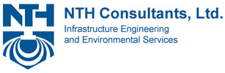
Silver:

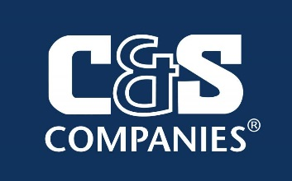
Bronze:

Individual: Jamie Hain, Matt and Maria Benovic

ASCE CLE Initiatives
Civil Engineering Club: Eva Vargas (Eva.D.Vargas@SBCGlobal.com)
Infrastructure Report Card: Gina Beim (Gina.Beim@MCDAConsulting.com)
Scholarship Committee: Matt Benovic (MBenovic@REWarner.com)

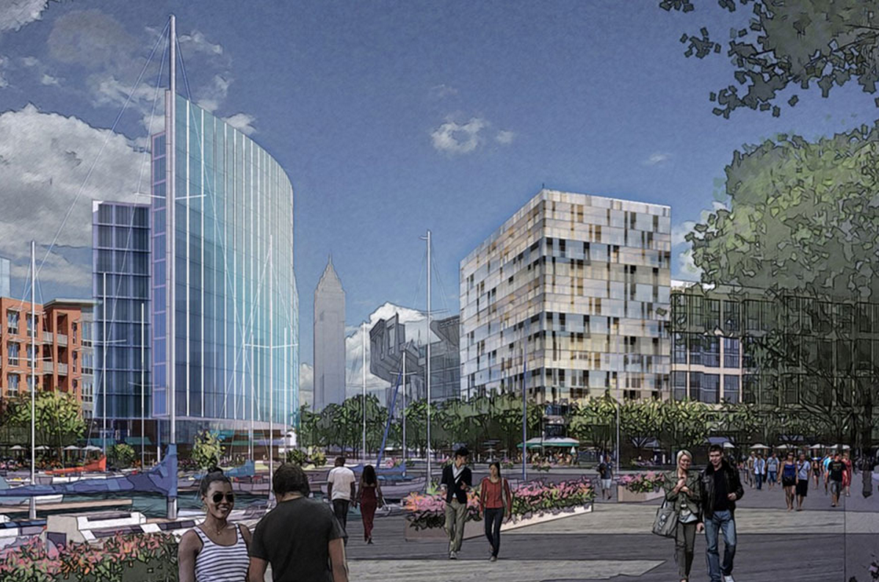
Cleveland Lakefront Development

ASCE Cleveland
2017 Annual Meeting

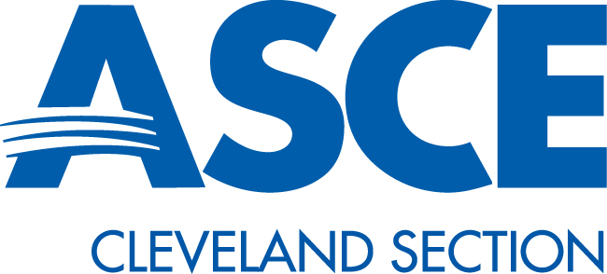
ASCE 2017 Annual Dinner Program
CLE Beyond the RNC
ASCE Cleveland
2016 Annual Meeting

5:30-6:30 | Registration and Social  Music by Northcoast Mix
6:30-7:00 | Dinner
7:00-7:30 | Annual Business Meeting
7:45-8:30 | Keynote Speaker:  Richard Y. Pace, A.I.A
8:25 | Adjourn/Band/Cavs

ASCE Section Officers

Position | CAK | CLE
President | Craig Hebebrand | Matt Benovic
Vice President | Matt Benovic | Ryan Butler
Treasurer | Ryan Butler | Kyle Nelson
Secretary | Ryan O’Hearn | Ryan O’Hearn

Upcoming Events
- November 17th – Orchard STEM School Volunteering Opportunity
- November 29th – Cleveland/Akron Joint November Dinner Meeting
- April 9th – 12th, 2018 - ASCE Biennial Earth & Space Conference in Cleveland
Additional event details available at:
sections.ASCE.org/Cleveland

Keynote Speaker
Richard Y. Pace, A.I.A. – President - Cumberland Development
Cleveland Lakefront Development

