Attachment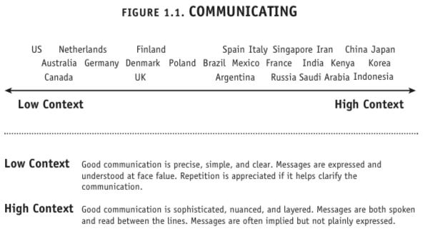

https://www.businessinsider.com/the-culture-map-8-scales-for-work-2015-1
- Meyer claims you can improve relationships by considering where you and international partners fall on each of these scales:
- Communicating: explicit vs. implicit
- Evaluating: direct negative feedback vs. indirect negative feedback
- Persuading: deductive vs. inductive
- Leading: egalitarian vs. hierarchical
- Deciding: consensual vs. top down
- Trusting: task vs. relationship
- Disagreeing: confrontational vs. avoid confrontation
- Scheduling: structured vs. flexible

Communicating
Americans are the most explicit or low-context culture there is (low-context meaning their conversation assumes relatively little intuitive understanding). This is not surprising for a young country composed of immigrants that prides itself on straight-talking.

https://www.businessinsider.com/the-culture-map-8-scales-for-work-2015-1

