* [Dam Failures in the U.S.](http://npdp.stanford.edu/dam_failures_us#:~:text=Dam%20failures1%20in%20the,result%20have%20limited%20downstream%20impact.) [1]

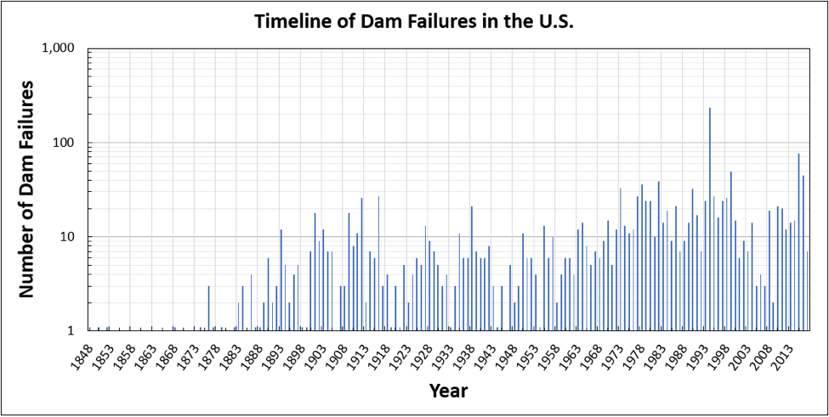

1. 1 <http://npdp.stanford.edu/dam_failures_us#:~:text=Dam%20failures1%20in%20the,result%20have%20limited%20downstream%20impact>.