The Economics of Water Main Failures

Failure Scenario 1
The first water main pipeline failure scenario is of a more routine nature. The failure of a small diameter (less than 6 in.) pipeline in question is more of a small section circumferential failure that is often detected as a growing leak from the distribution system. Initially, a small two-man crew would be dispatched to the site to evaluate the full extent of the required repair work. Evaluation of the failure indicated four workers were required to decommission the existing water main, excavate to the failed pipeline and install mechanical adapters and replace 4 ft of pipeline.
The crew that responded to the initial work order was able to isolate the section of water main pipeline relatively easily by locating existing valves that were still operational. The isolated section of water main pipeline only impacted four potable water customers so social impact was relatively minimal. Also, the water loss from the leak was also minimal so no efforts were made to quantify the water lost. No direct environmental damage was observed that was not easily restored by the crew. Therefore, the cost evaluation for the first scenario was primarily limited to man hour, equipment and material costs.
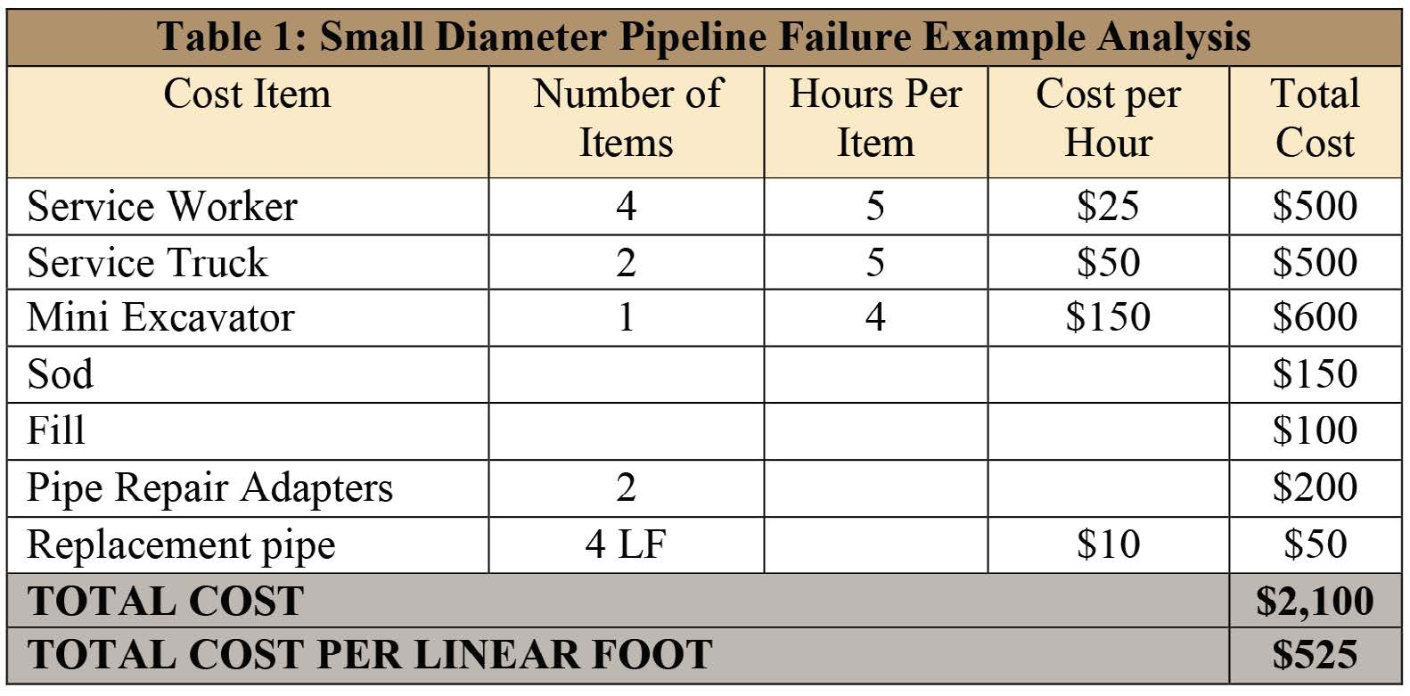

Failure Scenario 2
The second water main pipeline failure scenario is of less routine nature. The failure of a medium diameter pipeline (greater than 6 in. but less than 12 in.) in question is a larger more substantial water main failure. A full section of the medium diameter pipeline failed and isolation valves were not as readily available to shut down the water during the failure. This water main pipeline failure scenario required 10 service workers, five service trucks, a backhoe, a vacuum truck and a loader. The second scenario had more significant environmental and social impact and efforts were made to quantify these impacts. Economic analysis of the water main pipeline failure is provided in Table 2 below.
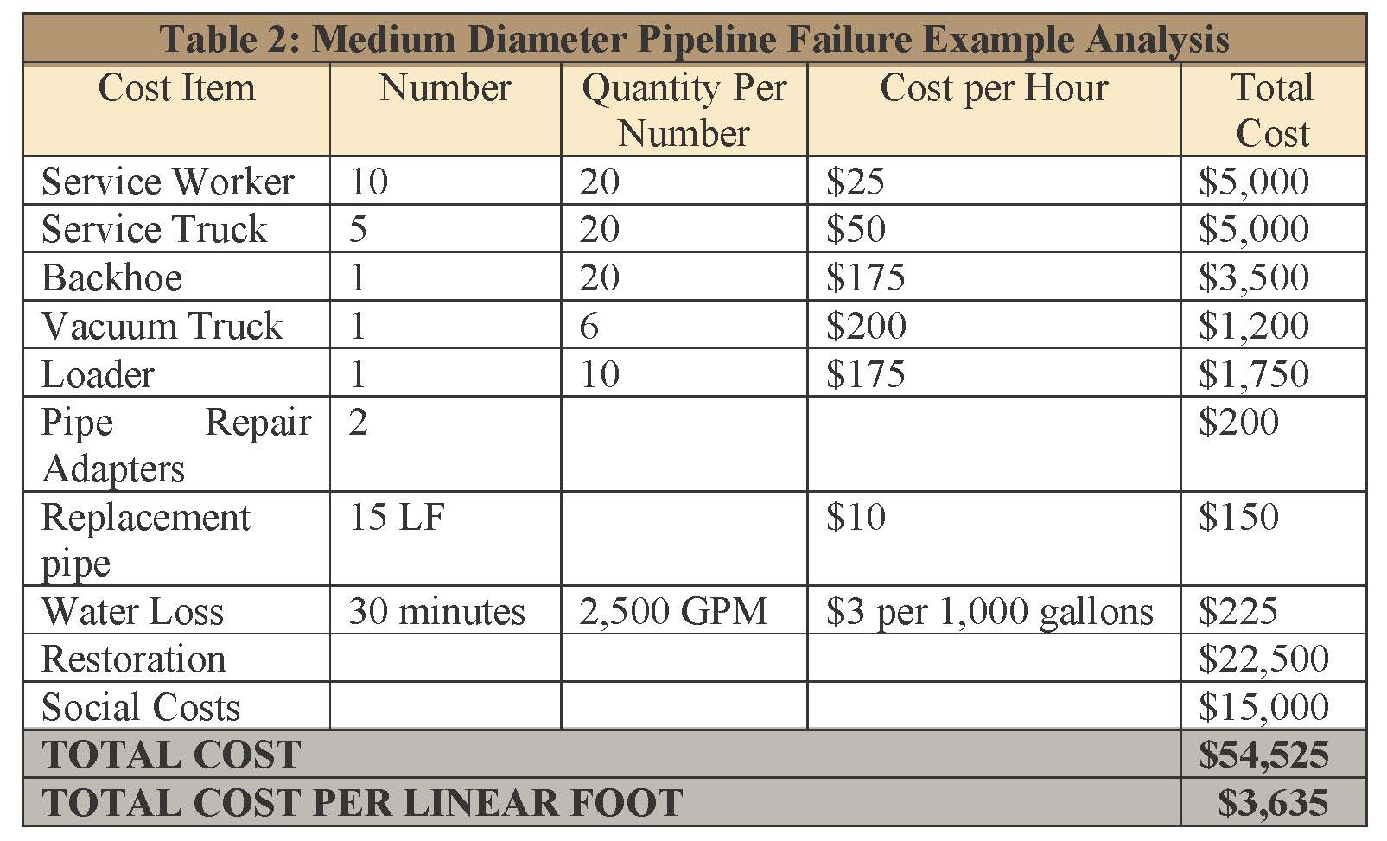

Failure Scenario 3
In this example, a 30-in. steel potable water main pipeline failure that was analyzed was a 2014 pipeline failure that occurred on the University of California–Los Angeles campus. This water main pipeline failure was a high-profile water main failure that attracted national news coverage and caused significant environmental, social and economic damage. The failed potable water main pipeline was 93 years old.
The crews that responded to the break required four hours to shut the water off to the section of pipeline due to inoperable and non-locatable valves. More than 160 firefighters responded to the water main break to search more than 200 cars in flooded subterranean parking garages, according to the Empirical Analysis paper. The social impact of the water main pipeline failure was enormous. A historical basketball court was flooded during the potable water main pipeline failure.
It was estimated that almost 75,000 gallons per minute of water loss occurred for a total of approximately 18 million gallons of treated water released during the break. Evaluation of the economics of this scenario for potable water main pipeline failure was provided for lost potable water, cost and time to repair and return to service, travel delay for the surrounding public, supply outage and substitution costs, potential health risk and property damage are included in Table 3 below.
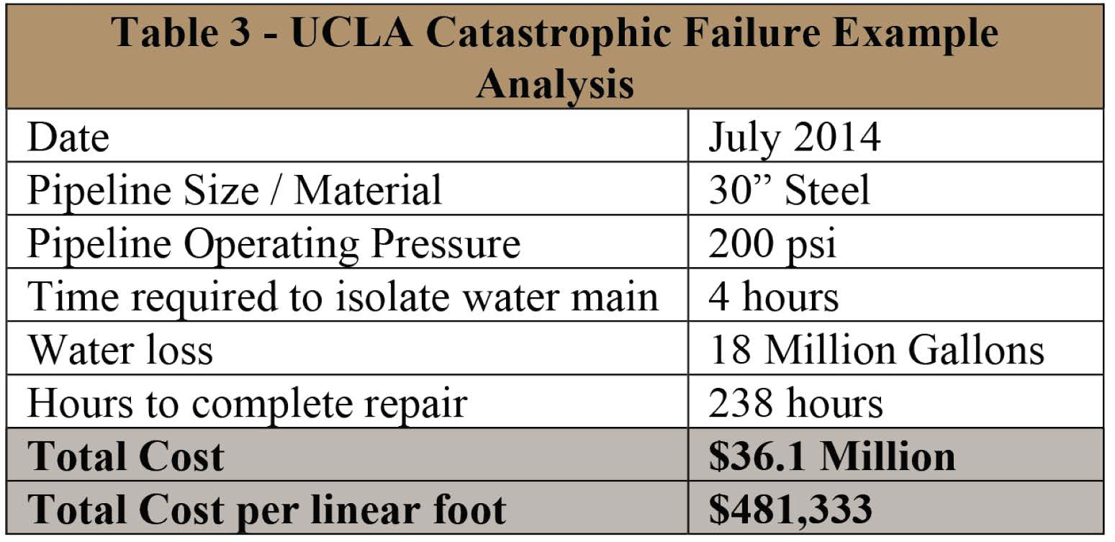
Unfortunately, additional crew time, restoration and social and environmental costs were not available to directly present the third catastrophic failure scenario in the same format as the first two scenarios. However, it was assumed that only 75 lf of the existing 30-in. steel water main pipeline was replaced. Therefore, the cost of replacement was $481,333 per lf. Construction costs for large diameter potable water main pipelines vary considerably based on reasons previously mentioned for small and medium diameter pipelines. Construction for a large diameter pipeline can vary from $500 per lf to $2,500 per lf or more. When the replaced amount is compared to a proactive approach to replacing the existing pipeline, it is easily observed that emergency replacement is simply not cost effective when compared to a proactive replacement program.

https://waterfm.com/the-economics-of-water-main-failures/

