- Standard Issues: The Next Level Of Success

The Benefits of Integrating QMSs And SMSs
Publication: “Quality Progress,” March 2021, Volume 54 Issue 3, pp. 56-58, Daniels, Alan,
Boeing Co., Seattle, WA, The copyright of this article is not held by ASQ.

Keywords: Risk management, Supply chain, Quality management system (QMS),
Process improvement, Safety management system (SMS),
Quality management system (QMS), Process improvement,
Safety management system (SMS)
Aviation, space and defense (ASD) organizations operate in a complex landscape of contractual, regulatory and statutory requirements. Understanding and managing these requirements and interrelated processes as a system contributes to an organization’s effectiveness and efficiency in achieving its intended results.
Creatively managing risk and change in an organization is key to meeting the ever-changing requirements and expectations throughout the supply chain. A quality management system (QMS) provides a way to manage these requirements collectively to optimize processes for effectiveness and efficiency.

Setting the stage
In many organizations, the relationship between a QMS and a safety management system (SMS) is nothing new—especially in ASD organizations. Going back to its origins, SMSs were designed to be used with QMSs. The terminology may be different in some cases, and the requirements often are more prescriptive and specific to product safety, but the parallels definitely are there. QMSs offer a foundational management system that can be aligned or integrated into a common SMS.
For many years, the International Aerospace Quality Group (IAQG) has acknowledged this relationship and, at one time, flirted with the idea of developing its own standard to get ahead of European regulations that were proposed by the European Union Aviation Safety Agency.
Instead of duplicating or rewriting SMS standards for its own use, however, the IAQG opted to add requirements to AS9100—Quality management systems—Requirements for aviation, space and defense organizations as a high-level bridge that easily would align with most SMS requirements. This was done primarily by adopting a few requirements from AS9110—Quality maintenance systems—Aerospace—Requirements for maintenance organizations, which has a greater focus on product safety, and adding requirements on product safety in AS9100 revision D. This worked out well because risk management, a primary piece of SMSs, was added to AS9100 revision C.
In addition, ISO 9001:2015, which provides the baseline requirements for AS9100, increased its focus on business processes being compatible with the context and strategic direction of the organization with several requirements in subclause 5.1.b-d:
b. Ensure that the quality policy and quality objectives are established for the QMS and are compatible with the organization’s context and strategic direction.
c. Ensure the integration of the QMS requirements into the organization’s business processes.
d. Promote the use of the process approach and risk-based thinking.¹
This set the stage for basic alignment of management systems, with the possibility of integration for organizations that desire to improve and move to the next level.
Quite often, ASD organizations have more incentive to change for compliance reasons than quality or safety performance. As harsh as that might sound, it often is believed that being in compliance brings with it acceptable levels of quality and safety. To address this, AS9100 has evolved beyond a customer satisfaction and compliance standard, with a significant increase in preventive and improvement-type requirements.
The reality is that, in some cases, QMS and SMS integration is entirely feasible while in others, there might be significant political and philosophical obstacles in the organization. In those cases, alignment is a better initial strategy.

Integration and alignment
Integrating a QMS and SMS can be relatively simple or made to be horrendously complex. When dealing with requirements, it can be helpful to take away titles and labels, such as QMS and SMS, and combine the applicable requirements with customer, business, regulatory and statutory requirements. If you really want to be adventurous, you can add other management systems, too.
The new common management system structure in Annex SL makes integrating International Organization for Standardization management systems much easier due to a common structure and vocabulary. There still are challenges associated with terminology among management systems, but that can be dealt with by finding the lowest level of commonality and noting the differences where they occur.
When integrating a QMS and SMS, focus on requirements, the processes that consume those requirements, and, of course, the documents or tools used to deploy them. This approach will surface duplications, overlaps and opportunities for improvement in streamlining processes and documents. This approach isn’t new, but with the emergence of SMSs in regulatory requirements, it has become a more enticing business strategy.
The fact is that, in the aerospace sector, SMSs continue to become more regulated as the Federal Aviation Administration prepares to levy its 14 CFR Part 5 requirements. Gradually, SMSs are inching into a more dominant role in organizations’ overall strategies. With this, leaders must direct their attention to how QMSs and SMSs can complement one another in the implementation and sustainment of their management systems. It is important to recognize that there is an inherent compliance risk to duplicating or overlapping processes and documentation, so alignment or integration is just good business.
Too often, we create programs to implement management systems and lose sight of how the requirements often are inputs to the same processes but perhaps with multiple outputs. For example, SMSs and QMSs have requirements for risk management, auditing and corrective action, so it wouldn’t make sense to duplicate processes when one can suffice with multiple outputs.
Table 1 provides an example of some of the similarities between QMSs and SMSs. There are four primary elements of an SMS in the left column and the corresponding QMS clauses in the right column. A full analysis can be done by listing all the SMS elements and the corresponding QMS clauses. For even more detail, it can be taken down to the requirement level.
TABLE 1
EXAMPLE OF QMS AND SMS USING SIMILAR PROCESSES
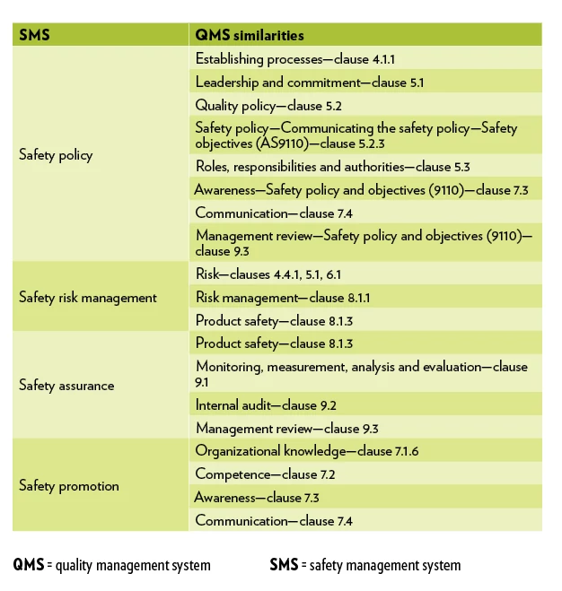
Organizations establishing an SMS must build on existing processes and documentation, particularly those established for quality management. SMSs focused on design, identifying safety hazards and mitigating safety risks only can create a more robust QMS. The structured approach provided by a QMS ensures that these processes and procedures operate as intended, correct nonconformances when they don’t and continually improve their effectiveness, making a more robust SMS.
While an SMS provides the mechanisms for an organization to perform its operational functions in a framework of safety risk-based decision making, a QMS ensures that this framework is operating in a structured, repeatable fashion and can meet its intended objectives. When it can’t, it provides the means to take action to improve. They both must be planned and managed, depend on measurement and monitoring, involve a multifunctional approach and strive for continuous improvement. Thus, QMS and SMS processes can be highly complementary and will support the achievement of the overall organizational goals without compromising safety.
Benefits of QMS and SMS integration or alignment include:
- Makes it easier to manage.
- Streamlines processes and documentation.
- Reduces compliance risk.
- Leverages the fact that the many SMS requirements are in the structure of a QMS.
- Enhances the QMS and SMS.
- Provides a consistent message to employees about the importance of a QMS and SMS partnership.
- Makes business and financial sense.
Just as the scope of a QMS goes well beyond monitoring compliance with safety requirements, its alignment with an SMS extends the scope of safety management beyond ensuring the conformance of working practices with safety requirements toward thoroughly identifying and proactively mitigating hazards.

Better together
Quality and safety are fundamental for an organization to attain its goals. It isn’t surprising that in ASD, more often than not, quality and safety are referred to collectively and, in some cases—though not entirely correct—interchangeably.
A QMS cannot achieve a high level of quality without safety, and safety cannot achieve its goals and objectives without quality. By aligning or, better yet, integrating systems, ASD organizations can advance to the next level of success.
© 2021 Alan Daniels

REFERENCE
- International Organization for Standardization (ISO), ISO 9001:2015—Quality management systems—Requirements, subclause 5.1.b-d.

Alan Daniels is the manager of quality management system strategies and industry standards at Boeing Co. in Seattle. He also is chair of the U.S. Technical Advisory Group to ISO/TC 176, chair of ISO/Technical Committee (TC) 176 subcommittee 1 and participates in the ISO Joint Technical Coordination Group. Daniels leads the International Aerospace Quality Group and AS9100 standards and requirements, and the Americas Aerospace Quality Group.

https://asq.org/quality-progress/articles/standard-issues-the-next-level-of-success?id=442e634b7e4a4b1eb4d5b265ecb635ff

